QUICKBOOKS ONLINE Client Training
Course 4
Reporting

Copyright
Copyright 2017 Intuit, Inc. Intuit, Inc.
All rights reserved. 5601 Headquarters Drive
Plano, TX 75024

Trademarks
©2017 Intuit, Inc. All rights reserved. Intuit, the Intuit logo, Intuit ProLine, Lacerte, ProAdvisor, ProSeries and QuickBooks, among others, are trademarks or registered trademarks of Intuit, Inc. in the United States and other countries. Other parties’ marks are the property of their respective owners.

Notice to Readers
The publications distributed by Intuit, Inc. are intended to assist accounting professionals in their practices by providing current and accurate information. However, no assurance is given that the information is comprehensive in its coverage or that it is suitable in dealing with a client’s particular situation. Accordingly, the information provided should not be relied upon as a substitute for independent research. Intuit, Inc. does not render any accounting, legal or other professional advice, nor does it have any responsibility for updating or revising any information presented herein. Intuit, Inc. cannot warrant that the material contained herein will continue to be accurate nor that it is completely free of errors when published. Readers should verify statements before relying on them.

Table of Contents
About the Author 2
Training at a Glance 3
QuickBooks Online Test Drive 4
Topic 1: The Benefits of Reporting 5
Introduction to Reporting 5
Topic 2: Reporting Capabilities 10
QuickBooks Online Simple Start: 20+ Reports 10
QuickBooks Online Essentials: 40+ Reports 11
QuickBooks Online Plus: 65+ Reports 12
Common Report Settings 13
Browser Settings 14
Print Wide Reports 14
Topic 3: Reporting Methods 15
Identify Functionality of Grouped Reports 15
The Report Dashboard 16
Business Overview 17
Manage Accounts Receivable 23
Review Sales 26
Manage Accounts Payable 31
Review Expenses and Purchases 34
Manage Payroll 36
Manage Sales Tax 36
Manage Products and Inventory 36
Accountant 37
List Reports 39
My Custom Reports 41
Export Reports 44
Send Reports 45
Course Conclusion 47

About the Author

Esther Friedberg Karp, MBA
President, EFK CompuBooks Inc.
Esther Friedberg Karp is an internationally-renowned trainer, writer, business consultant and speaker who was named one of the Top 10 QuickBooks ProAdvisors in the world, with the title Top International ProAdvisor.
Based in Toronto, Canada, Esther has the unique distinction of holding ProAdvisor certifications in the United States, Canada and the United Kingdom. She is advanced certified in both QuickBooks Desktop and QuickBooks Online. Esther has authored materials and delivered educational and certification courses for Intuit in all those countries, as well as Australia where she conducted live QuickBooks Online training. She has spoken at Scaling New Heights, QuickBooks Connect and other conferences, as well as those of various accounting and professional organizations and written countless articles for Intuit Global.
Esther counts among her clients companies from around the world, as well as accounting professionals who seek her out on behalf of their own clients for her expertise in various countries’ editions of QuickBooks Desktop and Online, and for her talent in customizing QuickBooks usage for different industries.
Esther holds a BSc from the University of Toronto in Actuarial Science and Mathematics, and an MBA in Marketing in Finance from York University’s Schulich School of Business.
She can be reached at esther@e-compubooks.com or 416-410-0750.

Training at a Glance
Use this as a guide to select specific activities you want to cover.

Topic | Content
THE BENEFITS OF REPORTING | - Why use reports?
REPORTING CAPABILITIES | - Compare versions of QuickBooks Online  - Common report settings  - Browser settings (in Chrome)
REPORTING METHODS | - Grouped Reports  - Business Overview  - Manage Accounts Receivable  - Review Sales  - Manage Accounts Payable  - Review Expenses & Purchases  - Manage Payroll  - Taxes Reports  - List Reports  - Custom Report Tools  - Other Reporting Tools

QuickBooks Online Test Drive
Exercises contained in this handbook can be completed using a QuickBooks Online “test drive” file. The test drive uses a sample company file called Craig’s Design & Landscaping Services. It can be accessed through the following link:
Craig's Design & Landscaping
You don’t have to create an account or sign in to access the test drive file; just complete the security validation and click Continue.
This test drive is designed for you to explore and try out new things without worrying you will break something or make a mistake. It is not designed to retain any changes you make. Once you close this QuickBooks Online test drive company, it is completely refreshed so remember to allow sufficient time to complete each activity. Don’t worry if you have to close the test drive before you are finished, you can always begin again.

Topic 1: The Benefits of Reporting

Introduction to Reporting
Reports are critical for feedback and specialized business activities. Their objective is to provide information about the financial position, and the performance and changes in the financial position of a company. Reports should be understandable, relevant, reliable and comparable. They show assets, liabilities, equity, income and expenses that are directly related to an organization's financial position.
The information provided by reports can impact an owner’s important business decisions that affect continued operations. They can provide management with a more detailed understanding of the figures. These reports are also used as part of management's annual report to the stockholders.
When you want to find information, the best place to start is a report. From basic financial reports to reports for specialized business activities, being familiar with what’s available allows you to locate the information you are seeking quickly. You can use the link on the left navigation bar to access the Report Center. From here, you can easily access report groups, including your customized reports.
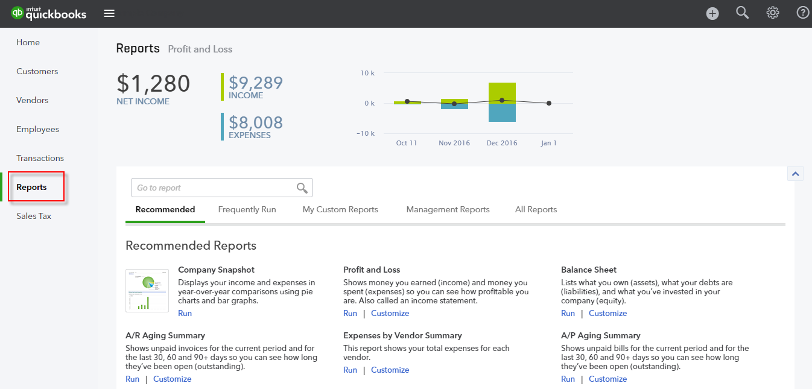

It's easy to customize QuickBooks Online reports so you can quickly develop report formats tailored to your unique business. Once you customize a report, you can save the customizations so you can run that customized report any time you wish without reconfiguring it. (This means the settings will be saved; however, the data may be updated when you run a saved report again in the future.) First choose a base report that is most like the report you are trying to create. Use the Customize button to access the changes that can be made.
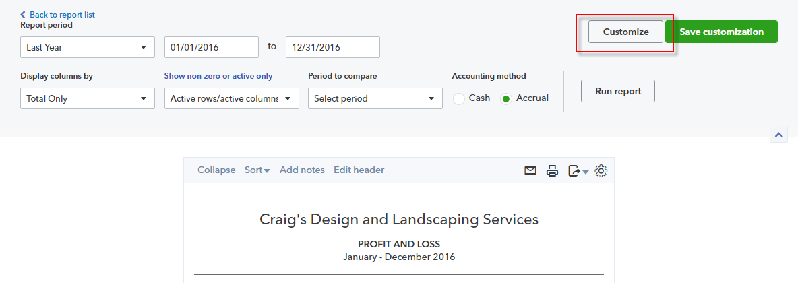

The QuickZoom® feature in every report shows the detail behind the reports and lets you drill down to the transaction level. Hover your mouse over a figure next to an account on the Profit and Loss report and it turns into a hyperlink you can click. This opens a Transaction Report listing all the transactions that add up to that figure.
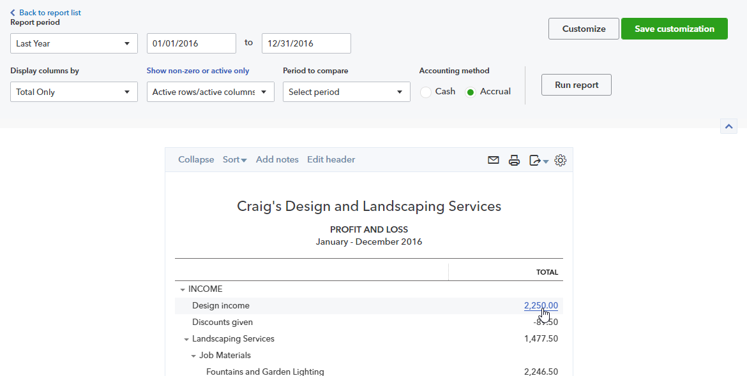
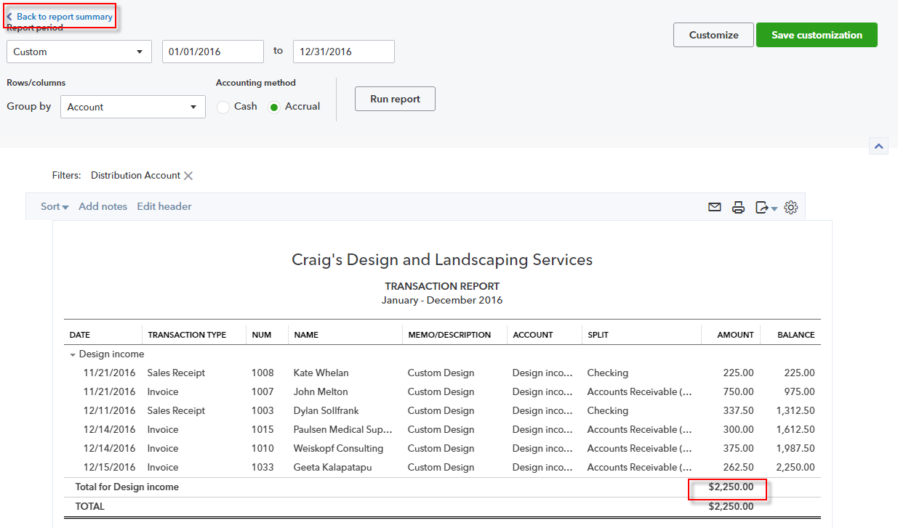

(You can click Back to Summary Report in the Transaction Report to return to the earlier report.)
You can display the original transactions and analyze the numbers behind the numbers. Once you are in a detail report, hover over the transaction you would like to open. When the transaction turns blue like a hyperlink, click the transaction.
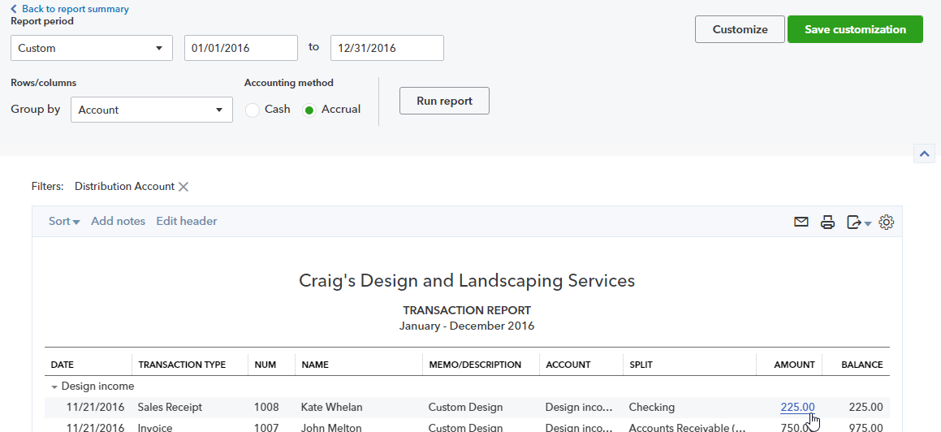

This opens the transaction in a new window so you can analyze, modify, delete or notate.
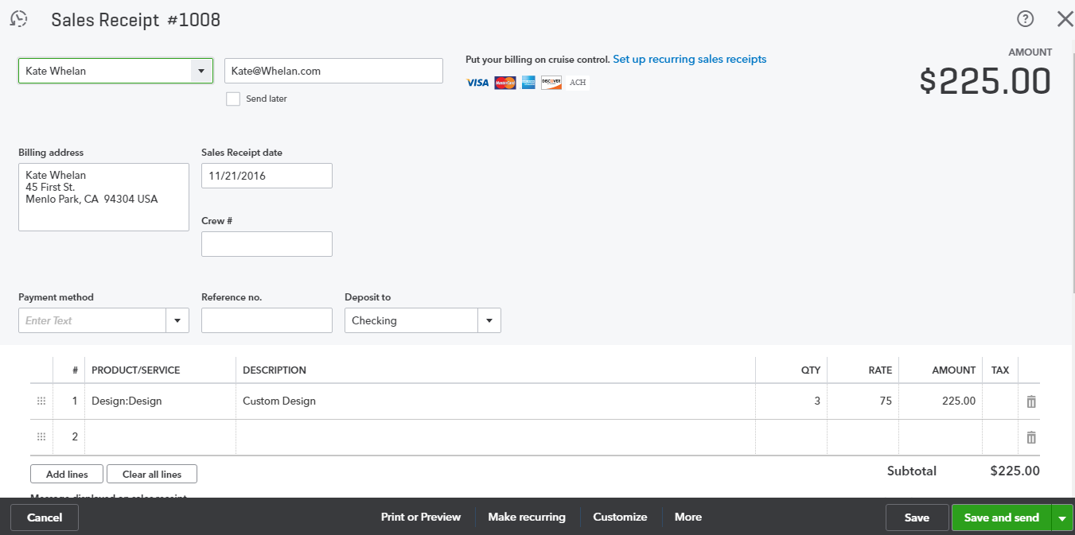

Topic 2: Reporting Capabilities
The three versions of QuickBooks Online offer different levels of reporting capabilities.

QuickBooks Online Simple Start: 20+ Reports
Simple Start, the most basic subscription level, allows for basic data entry to track your money in and money out as well as customer tracking and invoicing. The reports follow these same features and include basic financial and customer reports.
For QuickBooks Online Simple Start, here are some of the reports available:
- A/R Aging  - Account Listing  - Balance Sheet  - Check Detail  - Collections Report  - Customer Balance Summary  - Memorized Reports | - Taxable Sales  - Transaction List by Date  - Profit and Loss  - Reconcile Reports  - Sales by Customer  - Sales by Product/Service  - Statement of Cash Flows

QuickBooks Online Essentials: 40+ Reports
In QuickBooks Online Essentials, you can run vendor reports, product reports and have more insight into the company’s financial results. The number of reports doubles so you can run all the reports accessible in Simple Start as well as the A/P Aging, the Product/Services List, and the Company Snapshot and Scorecard.
For QuickBooks Online Essentials, you have access to all of the Simple Start reports as well as additional insight through reports such as these:
- A/P Aging  - Bill Payment List  - Company Snapshot  - Company Scorecard  - Customer Balance Detail  - Expenses by Vendor  - Income by Customer Summary  - Exchange Gain & Loss Reports | - Payroll Summary by Employee  - Product / Service List  - Profit and Loss Detail  - Terms Listing  - Unbilled Charges  - Unpaid Bills  - Vendor Balance

QuickBooks Online Plus: 65+ Reports
QuickBooks Online Plus opens all the features of QuickBooks Online and even more comparison reports for company financials, location and class reports, purchasing and inventory, time activities and more. With QuickBooks Online Plus you have access to all of the Simple Start and Essentials reports as well as more comparison and management reports such as:
- Budget Overview  - Budget vs. Actuals  - Class Listing  - Profit and Loss by Class  - Profit and Loss by Location  - Open Purchase Orders | - Purchases by Product / Service  - Purchases by Location or Class  - Sales by Location or Class  - Time Activities by Customer  - Time Activities by Employee  - Transaction Detail by Account
Note: The reports available in your company file depend on the features you are using. For example, if you’re using Class Tracking, then in the Report Center you’ll see Profit and Loss by Class, Sales by Class Summary, and Sales by Class Detail in the Business Overview and Review Sales report groups. Another example is if you have not turned on multiple currencies, you will not see reports related to currencies such as Unrealized Gains & Losses.
To compare the different versions of QuickBooks Online, visit www.quickbooks.intuit.com/online/compare. This is a great link to have bookmarked to make quick product selections and offers all the pertinent details to clients when they are deciding on an accounting solution.

Common Report Settings
To access the report settings and customizations, open a report and click the Customize button. The common report settings include but are not limited to the following:
- Accounting Method – Cash or accrual; found under General settings
- Number format – These settings offer options for displaying negative numbers, large numbers or can exclude zero balances; found under General settings
- Rows/Columns – These settings can hide or add columns by clicking the Rows/Columns button, if it is visible, depending on the report being customized. This can shorten the width of a report and make printing easier. (Instead of Change Columns, in certain reports such as a Profit and Loss, you will see a Columns drop-down menu that allows you to select one total column or multiple columns by timeframe such as by month or year.)
- Filter – These options are more complex; we will look at those more in the next topic
- Header / Footer – For text and alignment
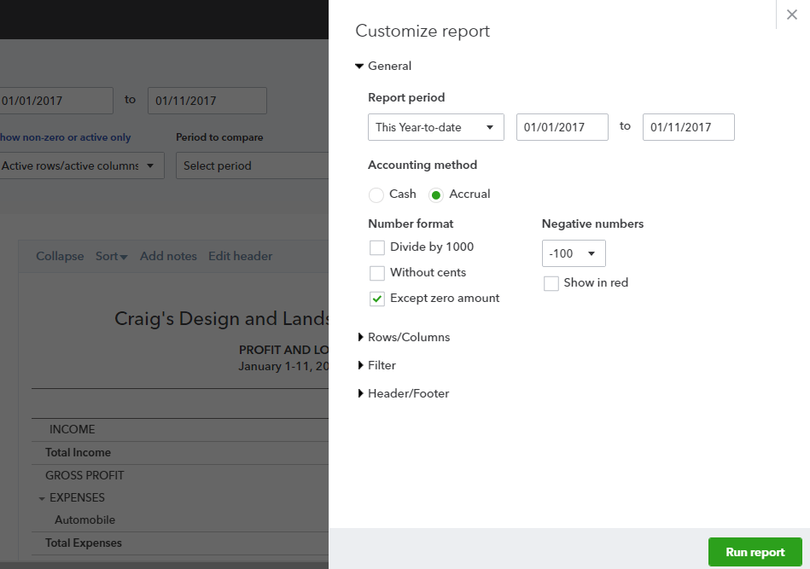
There are a few more settings that appear in this window when you are running transaction or detail reports, which we will see more of later in this module, along with saving customizations in reports so you do not have to use this window when you are accessing frequently-run reports.
NOTE: Accrual basis reporting is recommended so you can see the actual history and performance of the company in the applicable periods. Also look at your Profit and Loss from a cash basis to see how you are doing solely with cash in and out, which is what your tax situation will most likely reflect if you are a cash basis taxpayer.

Browser Settings
Depending on the browser you are using, you may have variations to the settings you can affect. Using Chrome, the following browser settings are available. You should be familiar with the settings in your browser as you prepare and print reports.

Chrome Menu ( ) Print
- Layout – Choose portrait or landscape. QuickBooks Online will send a suggested layout to each report but you can see the preview of how it would look otherwise
- Margins – Choose default, none, minimum or custom. This can help fit a report onto one page that is close to fitting but needs smaller margins
- Options: Headers and Footers – Print a header (today’s date, company file name and version of QuickBooks) and a footer (http address to the report and page x / x)
- Options: Background graphics – The QuickBooks Online color scheme can print on reports; uncheck this box and print the basic lines only of the background

Print Wide Reports
If some of the columns in your report do not print, try the following:
- Preview the appearance of a printed report  - Turn on text wrapping for reports  - Resize columns in a report  - Remove unneeded columns  - Make the margins smaller  - Change the orientation to landscape | - Print on legal-sized paper  - Scale the page by a percentage (check your printer setup properties to see if your printer driver supports scaling)  - Export the report to Microsoft Excel®. In a spreadsheet, you have more control over report formatting and print settings

Topic 3: Reporting Methods

Identify Functionality of Grouped Reports
In order to run and read reports effectively, you need an understanding of the fundamentals of reporting. The first thing to know is cash vs. accrual. Cash basis reports display income at the time it was received and expenses at the time they were paid (i.e., when the money changed hands), regardless of the dates on invoices or bills. Accrual basis reports display income at the time it was invoiced and expenses at the time they were incurred, based on the dates on invoices and bills. It is important to understand the differences between these reporting methods and the effect changing the basis can have on your reports. It is good to view accrual-based reports to see income earned and expenses incurred, but it can also be beneficial to view cash-based reports to gain perspective on cash flow.
We are now ready to explore the reports in QuickBooks Online. First we will introduce the Report Center, then discuss the Report Groupings. Finally we’ll dive into each group to get to know some of the reports themselves. The Report Center, or Report Dashboard, is where you find the report categories. Inside each of the categories are groupings of reports by topic.
From the left-hand navigation menu, click Reports. This brings you to the Report Dashboard where you can access multiple types of reports.
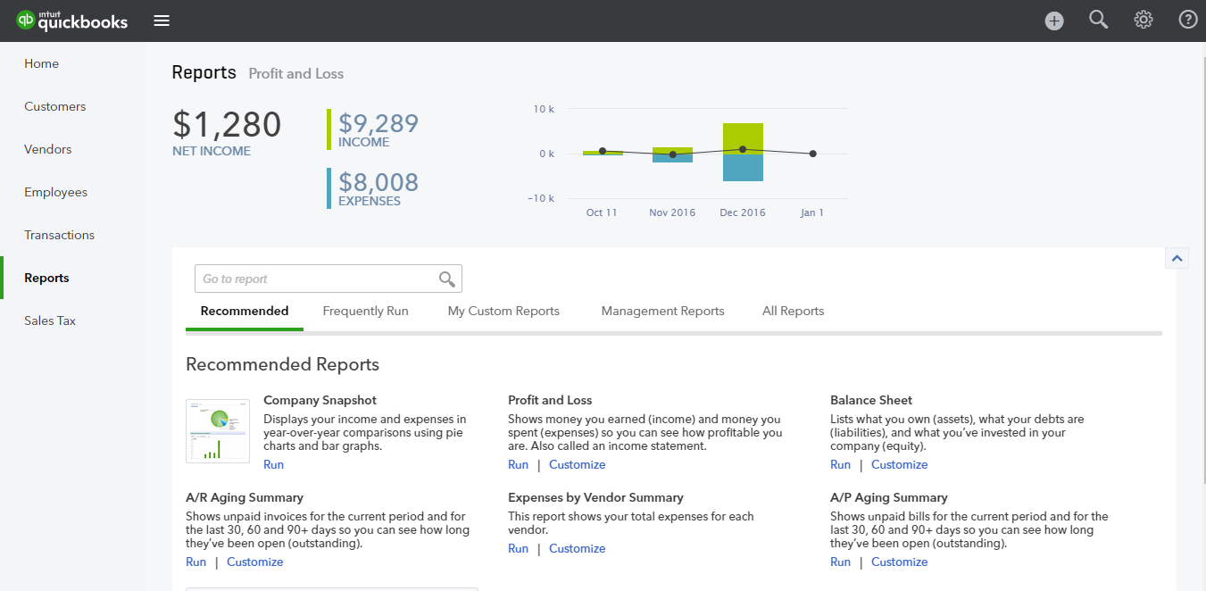

The Report Dashboard
The Report Dashboard first shows a graphical summary of the Profit and Loss, comprised of income and expenses. There is a box to search reports instead of clicking through the report groups. Then it breaks the reports into four tabs:
- Recommended – The most common reports business owners use are here in the Recommended Reports section. They include: Profit and Loss, Balance Sheet, Company Snapshot, A/R Aging Summary, Expenses by Vendor Summary, A/P Aging Summary. Each of these reports is in their respective report groups as well, but it is faster to access them from here.
- Frequently Run – This section starts out with no reports in it. It will recall those reports you run most often. It will allow you to access regular reports quickly and will change over time, depending on what you have run in the recent past.
- My Custom Reports – This is the list of reports for which you have asked QuickBooks to save your customizations. You can run the reports, distribute them or edit their settings in this section.
- Management Reports – This feature lets you easily customize a professional-looking package of reports, complete with cover page, table of contents, preliminary pages, reports, end notes and other custom content. Management reports are perfect for sharing a financial summary of your company with business partners. Three management report templates are ready to use: Sales Performance, Expenses Performance and Company Overview.
- All Reports – This is where you can access every preset report. The reports are grouped into main categories based on the purpose of the report.
As we dive into the different reports available in QuickBooks Online Plus, we will explore ways to customize reports to give more specific data.

Business Overview
Business Overview reports offer various perspectives of how your business is doing. Included in this group are your major financial reports: Balance Sheet Detail, Profit and Loss, and Statement of Cash Flows, with supporting reports Balance Sheet Summary and Profit and Loss Detail. Also in this group is your Company Snapshot, which provides graphical representations of your performance. You’ll also find the Profit and Loss by Month, Profit and Loss Comparison, Profit and Loss by Customer, Statement of Cash Flows and other reports. If multicurrency has been turned on, you will see Realized Exchange Gains & Losses and Unrealized Exchange Gains & Losses. Finally, you can access the Audit Log to see all that has happened in your company file.
First let’s look more in-depth at the financial reports. Simply put, they are reports indicating a company’s health. Reading a report is fairly easy. If you can read what ingredients are in a package of soup or baseball stats from the morning paper, you can learn to read basic financial reports.
Remember Cuba Gooding Jr.’s memorable line from the movie Jerry Maguire: “Show me the money!” Reports show you the money. They show you where a company’s money came from, where it went and where it is now.
There are three main financial statements:
- Balance Sheet – Shows what a company owns and what it owes at a fixed point in time
- Profit and Loss – Shows how much money a company made and spent over a period of time
- Statement of Cash Flows – Shows the exchange of money between a company and the outside world over a period of time

Balance Sheet

What is my business worth?
This report provides a financial snapshot of your company. It lists the balances for each asset, liability and equity account as of a specific date. It also calculates what your business is worth (the equity) by subtracting what your company owes (liabilities) from everything it owns (assets).
- Assets are things a company owns that have value. This typically means they can be sold or used by the company to make products or provide services that can be sold. Assets include physical property such as plants, trucks, equipment and inventory. It also includes things that can’t be touched but have value, such as trademarks and patents. And cash itself is an asset, as are the investments a company makes.
- Liabilities are amounts of money a company owes to others. This can include all kinds of obligations like money borrowed from a bank to launch a new product, rent owed to the landlord for use of a building, money owed to suppliers for materials, payroll a company owes to its employees, environmental cleanup costs or taxes owed to the government. Liabilities also include obligations to provide goods or services to customers in the future.
- Equity is the summary of the net worth of the business (assets minus liabilities) as well as the company’s interaction with the owners. Are the owners putting money into the business or taking it out, or did a new owner invest into the company? These transactions would be summarized in the Equity section.
- Step by Step: The Balance Sheet
- Reports Recommended Reports Balance Sheet.
Notice the list of assets and, below them, the list of liabilities.
- Click Customize Rows/Columns Period Comparison Previous Period (PP).
Click Run report.

Profit and Loss

How much money did I make and spend?
A Profit and Loss report is also called an income statement or a P&L. It gives a synopsis of the story. It summarizes your income and expenses for each income or expense account on your Chart of Accounts so you can tell if you're operating at a profit or loss. The important thing to remember about an income statement is it represents a period of time. This contrasts with the balance sheet, which represents a single moment in time.
To understand how Profit and Loss reports are set up, think of them as a set of stairs. You start at the top with the total amount of sales and income made during the accounting period. Then you go down one step at a time. At each step you make a deduction for certain costs or other operating expenses associated with earning the revenue. At the bottom of the stairs, after deducting all of the expenses, you learn how much the company actually earned or lost during the accounting period. This is called the bottom line.
Imagine a business owner who has designed a new product. He needs to set a few milestones and here are his goals:
- Goal #1: Make sales – The product he designed should be something that will be of value to someone else so he can receive income. That is the first section of the Profit and Loss — the Income/Revenues.
- Goal #2: Sell the product at a price that will pay for the cost to produce it – If it costs him $5 to create the product each time, then hopefully he is selling it for more than that. This is the next section of the Profit and Loss — the Cost of Goods Sold. This brings us to a gross profit amount, which is derived by subtracting the cost of goods sold from the total income.
- Goal #3: Sell enough of the product to cover the costs of running a business (overhead) – It costs money to have a business. The expenses he will have to pay for, regardless of selling one or 1,000 units of his products or services, are considered overhead. Overhead could be professional fees, payroll, office rent, bank service charges and many more. Net Operating Income shows whether or not this goal has been accomplished.
- Goal #4: Earn a profit so you can take some money home – Other things can happen like a theft or interest income that are not part of the company’s operations. The overall net income of the business shows whether this business owner has made any money. Then the owner decides whether to take some home or reinvest it in the company’s future.

- Step by Step: Profit and Loss
- Reports All Reports Business Overview Profit and Loss (also available via Reports Recommended Reports Profit and Loss).
Notice the listed income and, below that, the list of expenses.
- Click Customize. Change the Report Period to Last Quarter.
- Change Accounting Method to Cash Basis.
Click Run report.

Company Snapshot
The Company Snapshot report provides an overview of the money coming in and going out of your business, along with the ability to compare your business to others in your industry.
To access the report go to Reports All Reports Business Overview Company Snapshot.
If prompted, install the Adobe® Flash® Player plug-in (this will require you to close all browser windows) then try to access the report again.
When the report opens you will see the following:
- My Income – In the top left box you will see a graphical representation of the five income accounts with the most income for the selected period. All other accounts are lumped into a category called Other.
- My Expenses – The top right box will show a pie graph of the five expense accounts with the greatest expenses for the selected period. All other expenses are listed under Other.
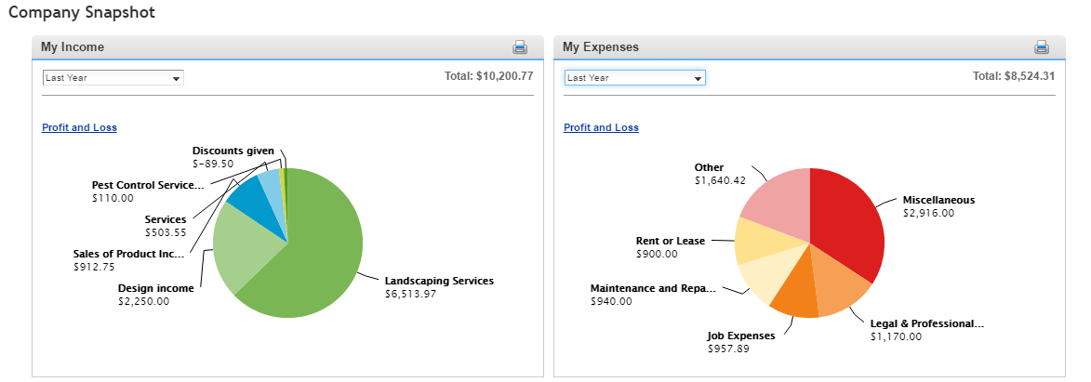
NOTE: Click on the Income and Expense pie charts to drill down to more detailed reports.
- Previous Year Income and Expense Comparison charts – These charts allow you to compare income and/or expenses from year to year. You can scroll your mouse over the bars in this chart to see a pop-up window showing the period and dollar amount. Click on a bar to see detailed data (in the form of a Transaction Report) used to make up the chart you see in this section.
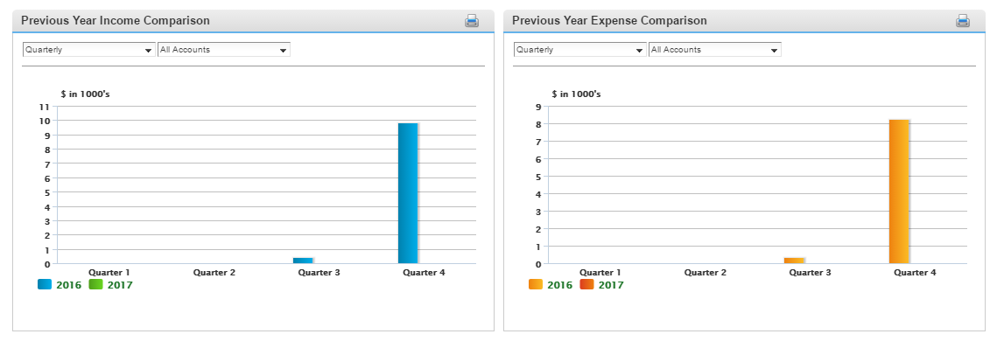
- Who Owes Me – The bottom left box lists all the customers who owe you money and their current open balance amount
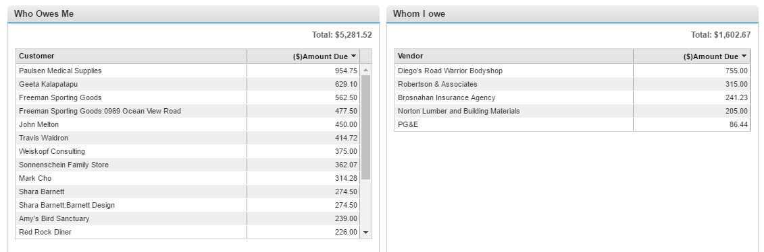
- Whom I Owe – The bottom right box shows all the vendors you owe money to and your current open balance with them
- Step by Step: Company Snapshot
- Reports All Reports Business Overview Company Snapshot.
- Previous Year Expense Comparison Change the Quarterly to Monthly.
- Change All Accounts to Utilities.
See a monthly comparison of the Utilities account last year versus this year.
Scroll over one month to see the exact dollar amount total.
Because of the unique nature of these charts, you will notice the following limitations:
- No filters other than the drop-down options in the top left of each graph
- No ability to export to Excel, PowerPoint, or to copy and paste into other applications
- Print one chart at a time by clicking the Print icon in the top right of each graph

Manage Accounts Receivable
Manage Accounts Receivable reports allow you to see who owes you money and how much they owe. The reports include: Customer Balance Summary and Detail, A/R Aging Summary and Detail, Collections Report, Invoice List and Statement List. As a business owner, collecting money that customers owe is one of the least favorite tasks. Use these reports to see what is happening and have direction on which receivables to pursue.

Customer Balance Detail

What's the detail behind what customers owe?
The Customer Balance Detail report lists the customers who owe your company money and how long ago since their invoice for payment. This report shows the unpaid customer balances grouped by customer and job. It can be very important information for you as a business owner, but it is useful to others as well. For example, your company’s bank may want to review your customer balance report if you are looking for a loan.
- Step by Step: Customer Balance Detail
- Reports All Reports Manage Accounts Receivable Customer Balance Detail Report.
Notice the columns showing customers, dates, amounts and balances.
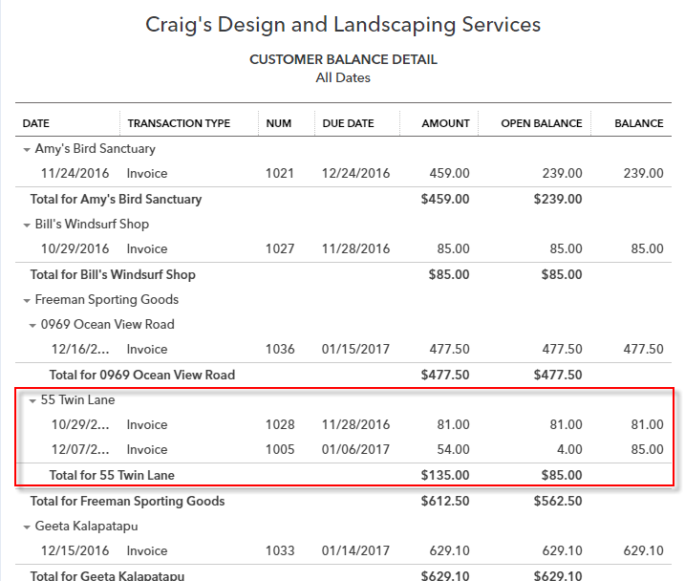

Collections Report

How do I collect overdue payments?
This report lists overdue invoices and unapplied credit memos grouped by customer. It includes when the invoice was due, the number of days past due and the customer's phone number. This report is set up almost identically to the Customer Balance Detail report because of the usability. If you are questioning the balance, you have all the details you need and can quickly click into the specific transaction if you need line item detail.
- Step by Step: Collections Report
- Reports All Reports Manage Accounts Receivable Collections Report.
Notice the columns showing customers, dates, past due amounts and balances.
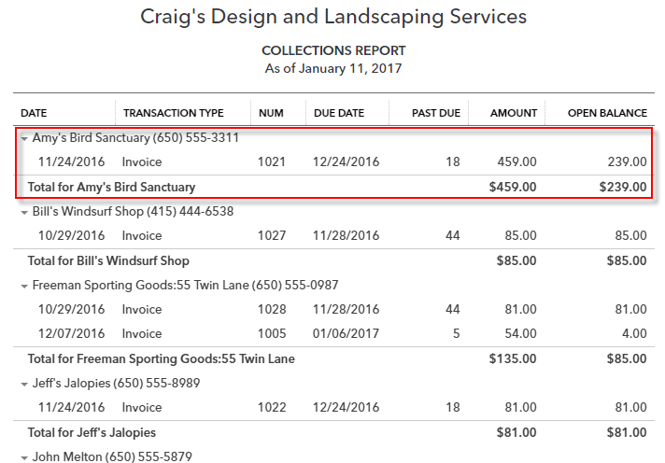
NOTE: Set up an automatic distribution for this report to be emailed once a week to the individual in charge of collections so they get the most recent list before beginning phone calls. Choose Excel and they can color code the results of those phone calls.

A/R Aging Summary

How long have I been working on collecting money from each customer?
The A/R Aging Summary lists each customer with an open balance and lists the open invoices in different columns based on whether they are current or how long they have been overdue (30, 60 and 90+ days).
- Step by Step: A/R Aging Summary
- Reports All Reports Manage Accounts Receivable A/R Aging Summary.
Notice the columns showing the customers’ timeliness and overall balances.
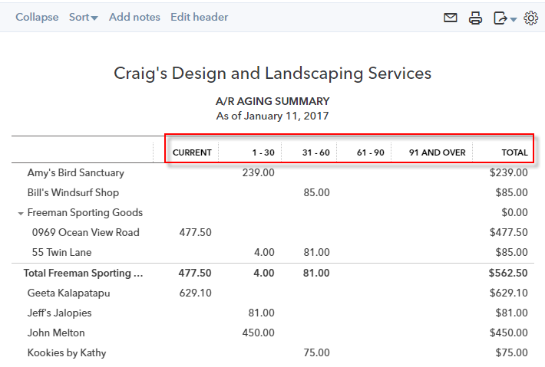

Review Sales
Review Sales reports allow you to see how you’re doing by analyzing your sales and where you make your money. The reports include: Sales by Customer Summary and Detail, Sales by Product/Service Summary and Detail, Product/Service List, Income by Customer Summary, Customer Contact List, Payment Method List, Terms List, Transaction List by Customer, Time Activities by Customer Detail, Estimates by Customer, Unbilled Time, Unbilled Charges and Deposit Detail. Business owners need to have visibility into the best (and worst) products so they know what to sell more of. They also need visibility into the customer by customer activity so they can market and/or reward the most valuable customers.

Sales by Customer Summary

How much has each customer purchased from me?
The Sales by Customer Summary report can be very valuable as you see those customers who contribute the most to the success of your company. It looks at the sales transactions for each customer for the period of time specified.
- Step by Step: Sales by Customer Summary
- Reports All Reports Review Sales Sales by Customer Summary.
- Customize Date: All Dates
- Click Run report.

- At the top of the report (above the report header), click on Sort Total in descending order.
Notice the top customers who have purchased products and/or services over time.
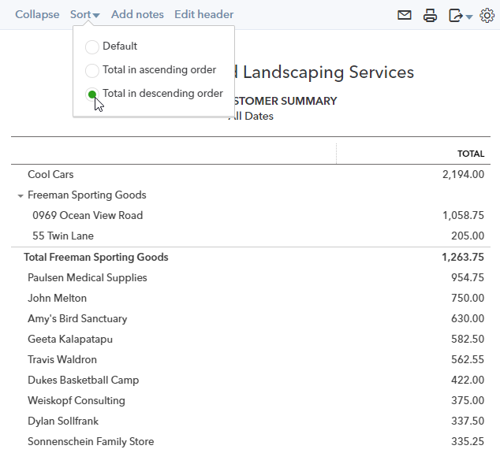
NOTE: When you click back to the Reports on the left navigation bar, it takes you to your last location while looking at reports. For instance, if you are in All Reports – Review Sales, you can click All Reports to go back to the report groupings.
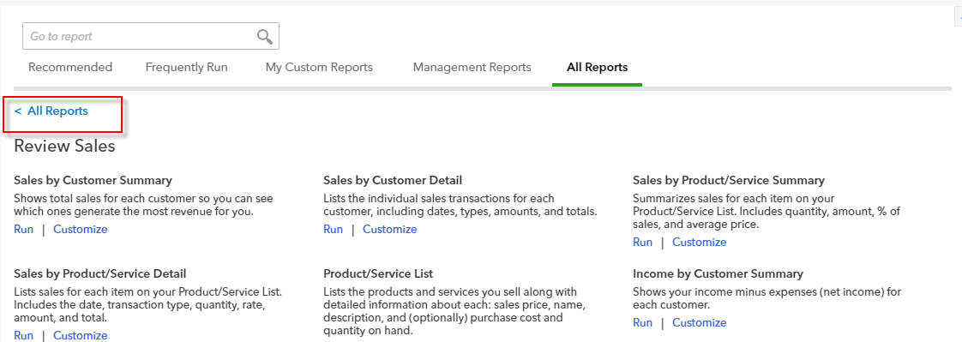

Sales by Customer Detail

What are the detailed sales by customer?
This report is a more detailed version of Sales by Customer Summary. In addition to revenue from each customer, this report lists the transactions that contributed to each total. Set the dates on this report to give you a complete history of what transpired with your customers over that timeframe.
- Step by Step: Sales by Customer Detail
- Reports All Reports Review Sales Sales by Customer Detail.
- Date range (at the top, as an alternative to changing it in the Customize screen): enter your own from and to dates, indicating from several months ago on the first of the month to the last date of the current month.
Click Run report.
Notice the columns showing Date, Product/Service, QTY, rate and Balance.
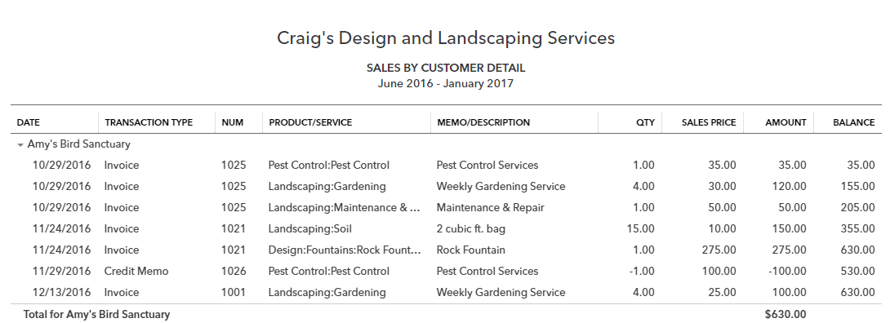
NOTE: The date ranges specified in the Activities can be adjusted until you find data. It is recommended that you expand your date range to be this year or last year or last quarter until you find some data. The sample file may have continuous data being added automatically, but be aware that it might not.

Sales by Product/Service Detail

What are the detailed sales by product or service?
This report is a more detailed version of Sales by Product/Service Summary. In addition to the unit and dollar sales for each product or service, this report lists the transactions that contributed to each total. See which products/services were the most popular or made the most sales during the timeframe you specify.
- Step by Step: Sales by Product/Service Detail
- Reports All Reports Review Sales Sales by Product/Service Detail.
- Date: Last Quarter.
Click Run report.
Notice the columns showing dates, products/services, customers, QTY, rates and balances.
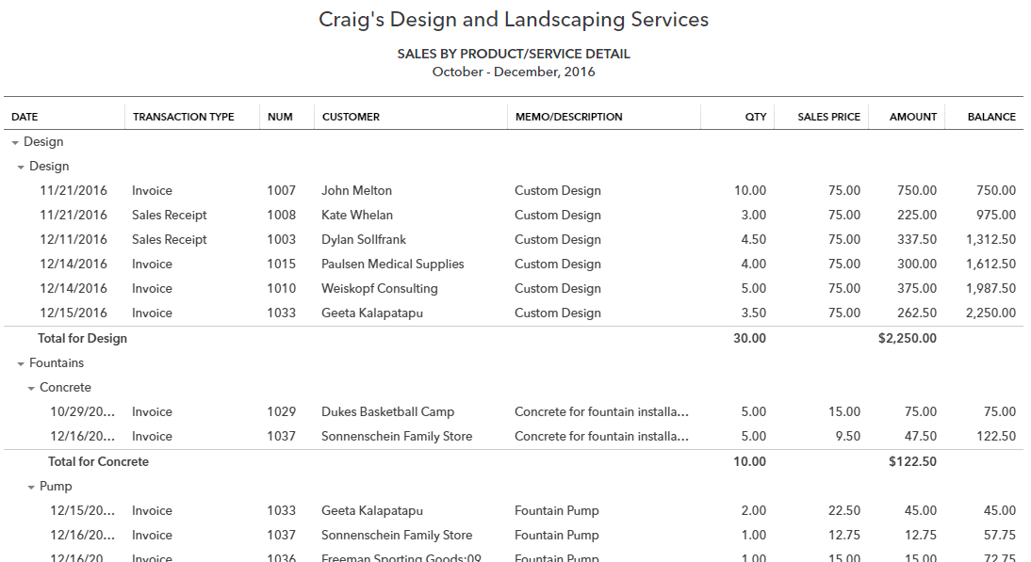

Unbilled Charges Report

For which charges do I need to create invoices?
This report lists transactions that were marked billable to a customer when the expense was entered, but they have not yet appeared on an invoice. For example, an IT company was helping a client with a new network setup. They needed to purchase a server on behalf of the client in order to continue with the job. The client now owes them reimbursement for that server. If they mark Billable on the credit card charge they used when they bought the server, and enter the client in the Customer field, then the server will show up on the Unbilled Charges report until the invoice is created.
- Step by Step: Unbilled Charges
- Select Quick Create Delayed Charge (you may need to click Show More).
- From the Customer drop-down, select Amy’s Bird Sanctuary.
- From the Product/Service drop-down, select Design. The description, quantity, rate and amount will pre-fill.
- Click Save and Close.
Reports All Reports Review Sales Unbilled Charges.
Notice your unbilled charge for Amy’s Bird Sanctuary.
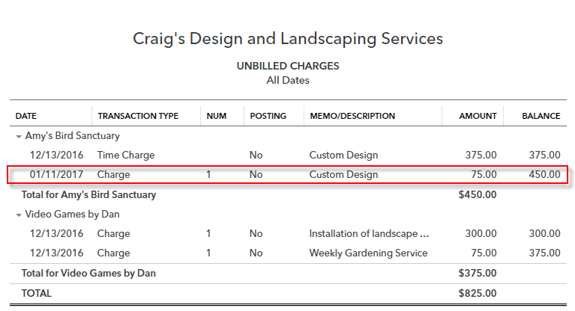

Deposit Detail

What individual customer payments make up each deposit?
The Deposit Detail report can help you identify missing or incorrect info related to bank deposits. When looking at this report, compare each line item to the deposit slip itself and make sure any customer payments received are booked as such instead of as additional income.

Manage Accounts Payable
Manage Accounts Payable reports show what you owe your vendors and when the payments are due, so you can take advantage of the time you have to pay bills but still make payments on time. The reports include: A/P Aging Summary and Detail, Vendor Balance Summary and Detail, Bill Payment List and Unpaid Bills. As a business owner, managing cash going out of the business is crucial. Weighing whether to pay something early, on time or late can only be considered if you know what is coming by running these reports.

A/P Aging Summary

How much do I owe to each vendor, and how much is overdue?
This report summarizes the status of unpaid bills and unapplied vendor credits. This report serves as a quick glance to see which vendors have bills that are the most overdue. When cash comes in, use this report to pay vendors strategically instead of just paying the first ones on a list of payables. If you owe a vendor who charges finance charges, then you don’t want to pay a different vendor’s bill that is still current (unless other factors influence that decision) when you could pay down the bill for which you’d be charged interest. For each vendor who is owed money, the report shows:
- Total bills that have been entered but unpaid in the current period (based on the due date of each bill)
- Overdue totals owed to the vendors from previous periods (again, based on the due date of each bill)

- Step by Step: A/P Aging Summary
- Reports All Reports Manage Accounts Payable A/P Aging Summary.
Notice the columns showing vendors, current, past due by days late and totals.
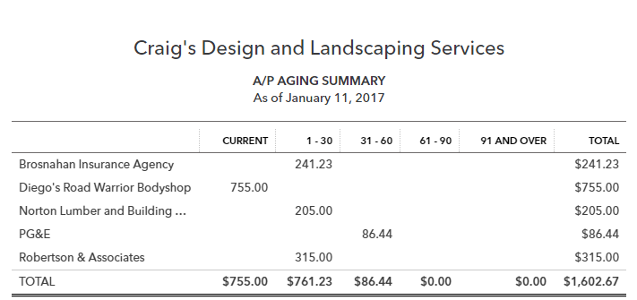

Vendor Balance Detail

What's the detail behind what I owe to vendors?
The vendor balance report lists the vendors to whom you owe money plus each bill’s due date and outstanding balance. This report shows the unpaid vendor balances. It can be very important information for a business owner, but it is useful to others as well. For example, your company’s bank may want to review your vendor balance report if you are looking for a loan. If a vendor appears on this report, that indicates there are open payables that need to be paid. This report gives you each instance where that is the case. Click through to see the detail behind the transaction.
- Step-by-Step: Vendor Balance Detail
- Reports All Reports Manage Accounts Payable Vendor Balance Detail.
Notice the columns showing vendors, dates, amounts and balances.
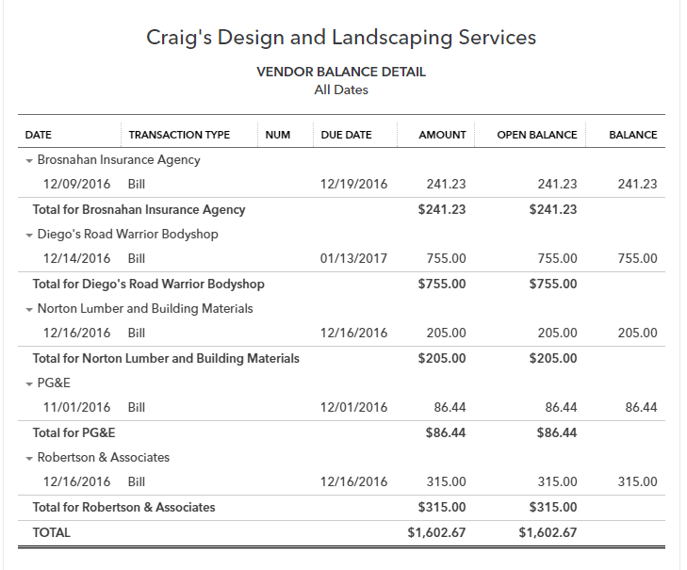

Review Expenses and Purchases
Review Expenses and Purchases reports allow you to see where you’re spending your money. The reports include: Expenses by Vendor Summary, Transaction List by Vendor, Vendor Contact List, Open Purchase Order List, Purchases by Vendor Detail, Purchases by Product/Service Detail and Check Detail. Business owners focus a lot of time and energy to evaluate how they can control and cut down on costs. Use these reports to facilitate better flow of information for more effective decision making.

Transaction List by Vendor

What have my interactions been with each of my vendors?
The Transaction List by Vendor report lists all interactions with each vendor during the date range specified. Transactions can include cash expenses, credit card expenses, bills, bill payments, checks and purchase orders. This report could be compared against a monthly transaction statement provided by the vendor to ensure all entries on both sets of books match up exactly. Any discrepancies can be identified and addressed with the vendor.

- Step-by-Step: Transaction List by Vendor
- Reports All Reports Review Expenses and Purchases Transaction List by Vendor.
- Select All Dates.
- Click Run report.
Notice the easy-to-follow layout, transaction type, memos and amounts.
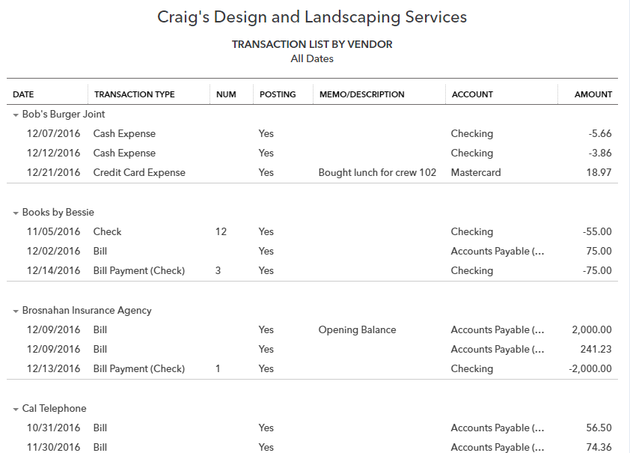

Vendor Contact List

How can I print a list of my vendors and their contact information?
The Vendor Contact List shows a list of vendors along with any contact info you have for each of those vendors. If you have additional info to add or if something needs changed, then you can click on the vendor’s name and the Vendor Setup screen opens for you to edit the info. Upon saving, you’ll need to refresh the browser so the report is updated.
NOTE: Customize the columns to display the info you would most like to see.

Manage Payroll
Manage Employees reports show employee activities and payroll. Whether you have payroll turned on or not, the reports include: Time Activities by Employee Detail, Recent/Edited Time Activities and Employee Contact List. See Course 5 for training on using the Payroll reports available when using QuickBooks Online Payroll. Business owners use the time reports to monitor employee activity and ensure timely entry of data. This report group is renamed Manage Payroll if you have the payroll module turned on in QuickBooks Online. When payroll is turned on, several additional reports appear in this group: Payroll Summary, Payroll Tax Liability, Payroll Tax Payments, Payroll Billing Summary, Payroll Details, Employee Details, Payroll Tax and Wage Summary, Workers’ Compensation, Total Payroll Cost, Payroll Deductions/Contributions, Paycheck List, Total Pay, Vacation and Sick Leave, Retirement Plans, Multiple Worksites and Employee Directory.

Manage Sales Tax
Manage Sales Tax reports allow you to manage the sales taxes you have collected then report and remit those taxes to the appropriate tax agencies. The reports include: Taxable Sales Summary and Detail, and Sales Tax Liability Report. All business owners must be aware of the potential for sales tax collection and payment in their place of business and as they deal with other locations. Based on the details entered in QuickBooks, Sales Tax reports help prepare monthly, quarterly or annual sales tax returns.

Sales Tax Liability Report

What did I collect in sales tax last quarter?
The Sales Tax Liability report lists each government entity and sales tax rate you have charged to your customers for the time period specified. Print this report to help with sales tax filings. For more information, click the Sales Tax center and see gross sales versus taxable sales to find out the amount of exempt (non-taxable) sales, which often need to be reported alongside the sales tax that was collected.

Manage Products and Inventory
Manage Products and Inventory reports help you understand how much inventory you have and how much you are paying for and profiting on each of your inventory items. The reports include: Inventory Valuation Summary and Detail, Product/Service List, Purchases by Product/Service Detail, Sales by Product/Services Summary and Detail, and the Physical Inventory Worksheet. Business owners are required to maintain accurate on-hand inventory records. For basic inventory tracking, QuickBooks Online provides the reports needed to track the inventory and have insight into the purchases and sales of those products.

Inventory Valuation Summary

How much inventory do I have on hand?
The Inventory Valuation Summary shows you how much quantity of each product you have as well as how much you’ve paid in total for those quantities, resulting in an average cost per product. The total asset value should match the balance sheet inventory balance as of the same date.
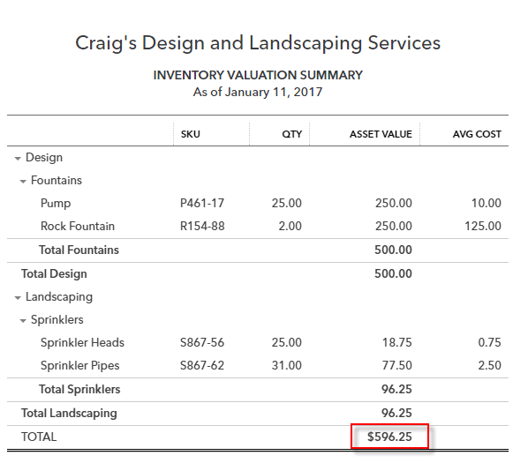

Accountant
Accountant reports include many reports that are in other groups, but also include reports of particular interest to accounting professionals and accounting-savvy business owners. The available reports in this group are Account List, Reconciliation Reports, Trial Balance, Journal, Profit and Loss, Balance Sheet, Balance Sheet Comparison, Transaction Detail by Account, General Ledger, Recent Automatic Transactions, Transaction List with Splits, Statement of Cash Flows, Transaction List by Date, Recent Transactions and Recurring Template List.

Trial Balance

What are the debit and credit balances in all my accounts?
As of the specified date, the Trial Balance lists all accounts in the Chart of Accounts with their associated debit or credit balance on that date. Total debits will always equal total credits.

Recent Automatic Transactions

What transactions were automatically added from my recurring transaction list?
Often recurring transactions are set up to be entered automatically on a certain date. This report shows which ones were automatically entered within the last four days. For instance, if you set 10 recurring transactions to automatically enter on the first of each month, this report should be run on the second or third of each month to capture those automatic transactions.
NOTE: Set this report as an automatic distribution on the second of the month to yourself and others who may need to see the automatic transactions, then there is no need to make sure you log in on the correct dates to run this report.

Journal

What actually happened behind the scenes with debits and credits this month?
The Journal report shows each transaction’s debits and credits during the specified date range and displays them chronologically. It is a great backup support when documenting the detail of the month or quarter for a tax return, audit or other financial statement.

List Reports
There are a few different ways to pull a list report in QuickBooks Online.
Click on the gear icon. Under the List column you can see a shortcut for All Lists, the Products and Services list, the Recurring Transactions list and Attachments. Click All Lists to see the option to access many different lists.
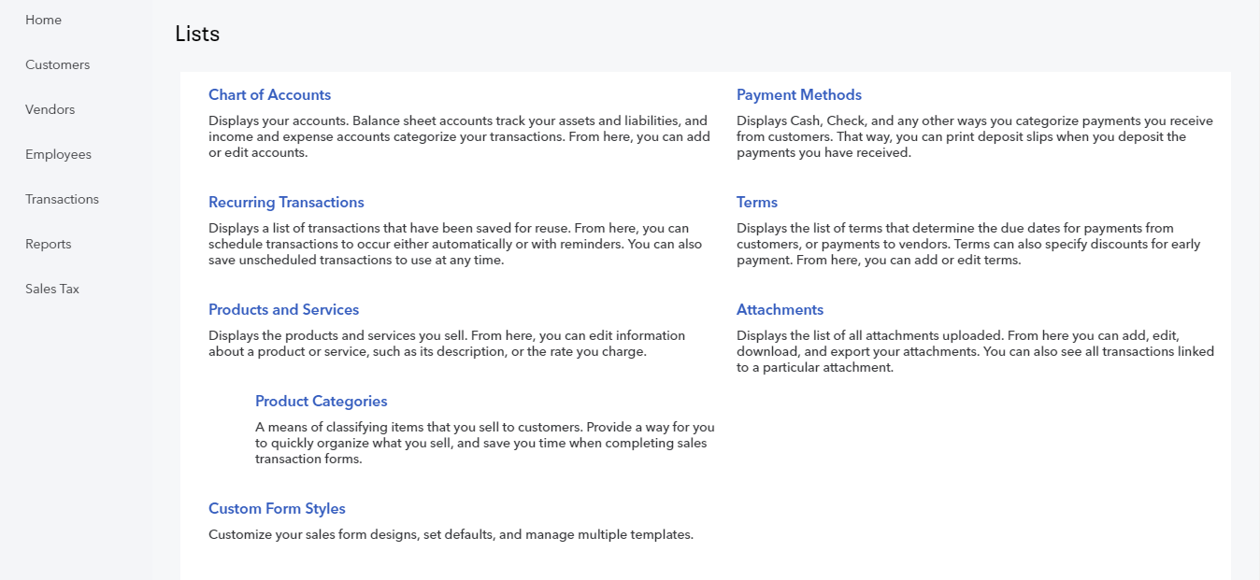
If you need to run a Vendor or Customer list, start with All Reports from the Report Center.

- Step by Step: Run a Customer List
- Open the Report Dashboard/Center.
- Click the All Reports grouping.
- Click Review Sales.
Click Customer Contact List.
- Step by Step: Run a Vendor List
- Open Report Dashboard/Center.
- Click the All Reports grouping.
- Click Review Expenses and Purchases.
- Click Vendor Contact List.

My Custom Reports
After you have performed all the customizing and filtering required to create a more useful report, saving those customizations saves time in the future when you must run the same report. You can decide whether you want to be the only one to see the report or if you want all users to be able to see the report (subject to the user permissions they have set up).
- Step-by-Step: Custom Reports
- Find and display the report you want to customize. To change what's in the report without displaying it first, click Customize.
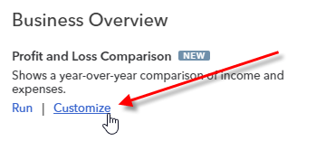
- Under Period Comparison, mark the box to add a subcolumn for Year-To-Date. Click Run report.
- Once the report is customized the way you like it, click Save Customization.
- Enter a descriptive name for the report in the Name of custom report field.
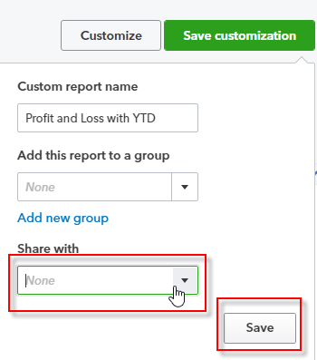
- Check the drop-down under Share with to elect to share it with all company users. If you do not select it, this custom report is available only to your user. Others with the user permissions to see this information can create this (or a similar) report for themselves.
Click Save.
NOTE: Adding reports to a group allows you to set a common email schedule for all the reports in the
group. The reports appear under the group name on your list of custom reports. If you add a report with an email schedule to a group that also has an email schedule, the newly added report will follow the group's email schedule.
Once you click Save customization of a report or group of reports, select Reports My Custom Reports to then run, export to Excel, edit or delete them from this list. You’ll see a list of all custom reports or groups of custom reports. Select the report or group of reports you want and click on the function in the top right.
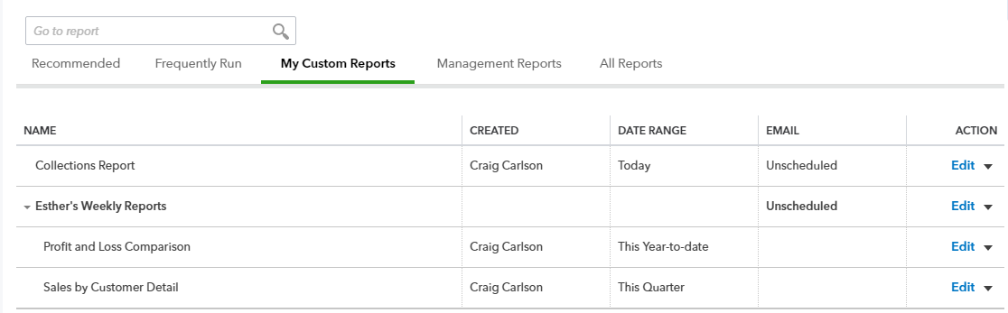
You can also set a schedule for automatically sending the report (by itself or with a group of other reports) by email in HTML format (it looks like the website in the email) or Excel format. You can have standard reports sent to you that will help monitor information, even if you haven’t logged in to QuickBooks Online.
If you have a standard set of reports that need to be sent, there may be zero customization required on some of them, but running the standard reports once and memorizing them into a group to be sent together will provide useful automation.
NOTE: If you change the settings on a custom report, you need to click Save Customizations again to save the changes.

- Step-by-Step: Automatic Distribution
- Reports My Custom Reports.
- Find the report or report group you desire. Under the Action column, click Edit in that report or group’s row.
Flip the switch under Set the email schedule to ON. More options will appear.
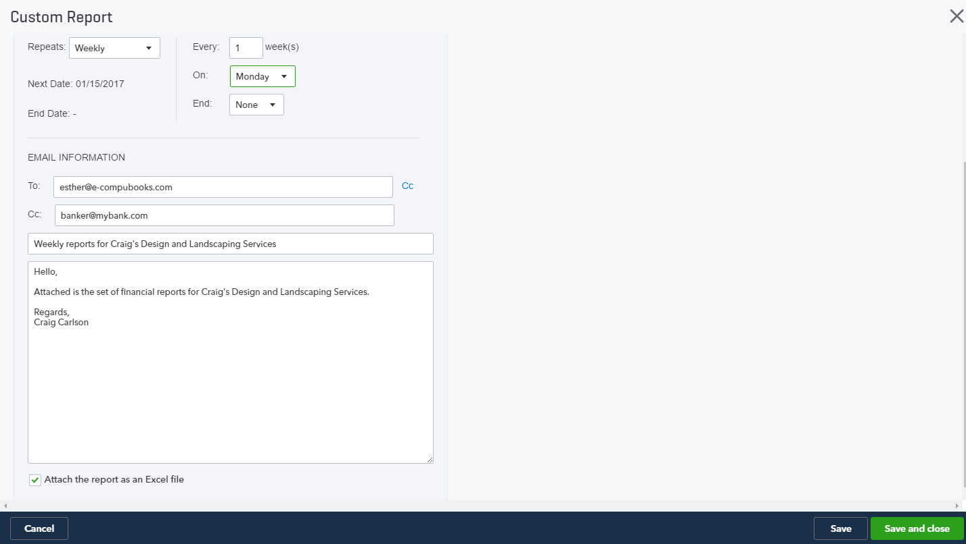
- Edit the schedule to set the desired timeframes (weekly and the day of the week you prefer to have it sent), and when, if ever, the schedule should stop.
- Enter the email information, separate multiple email addresses with a comma or semicolon.
- Enter a subject line and standard email message to be attached.
Check the box next to Attach the report as an Excel file (the default, if this box isn’t checked, is HTML in the body of the email). Click Save and close.
NOTE: One helpful use of the automatic distribution report is to select problem accounts about which you often receive phone calls. Customize a report and set the automatic distribution to email you the detail of this account on a weekly or monthly basis so you know when something needs your attention. This allows you to be proactive when you notice a build-up of issues that should be addressed.

Export Reports
You can export reports in QuickBooks Online by downloading the report in Excel format. This can be helpful for sending, modifying, printing and analyzing data.
- Step-by-Step: Export to Excel
- Open the report you would like to export.
Click the blue Export button (it looks like a document with a curved arrow coming out of it) from the top toolbar in the report and select Export to Excel.
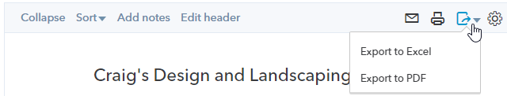
The report will download as an Excel file to your default downloads folder. You could also choose to export the report to PDF.

Send Reports
Sending reports from QuickBooks Online is a quick and easy way to share financial information. The default format for sending reports is as in-line HTML. You can send reports to multiple recipients and even include a note in your email.
- Step-by-Step: Send Report
- Open the report you would like to send.
- Click the blue Email button (it looks like an envelope) from the top toolbar in the report.
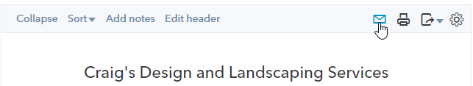
- The Print, email or save as PDF screen opens.
- Choose your print orientation (portrait or landscape).
- Select Email.
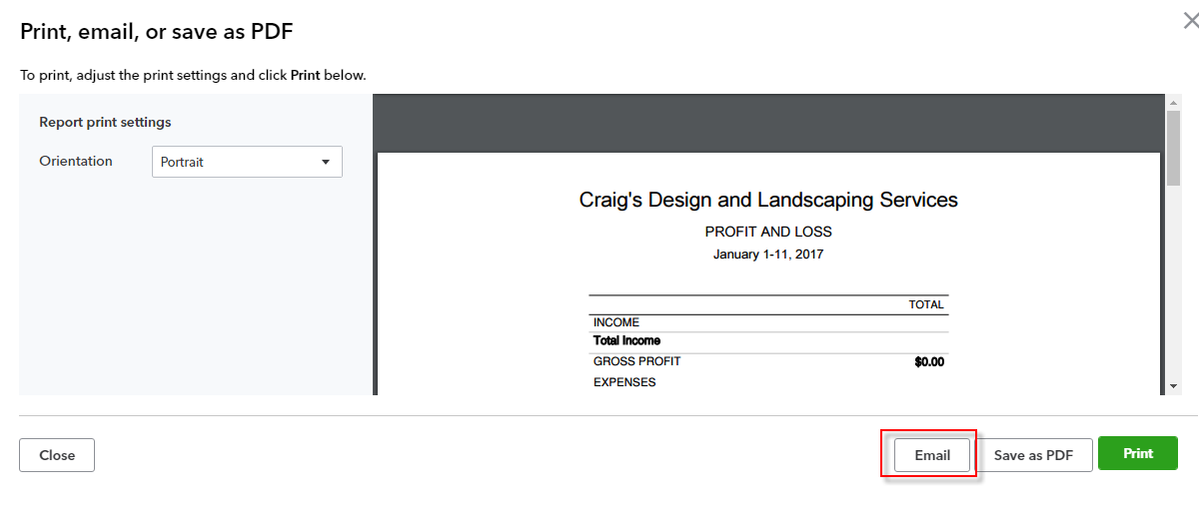
- Enter the email address(es), separated by a comma or semicolon, to which you would like to send the report.
- Add a note if you wish.
Press Send.
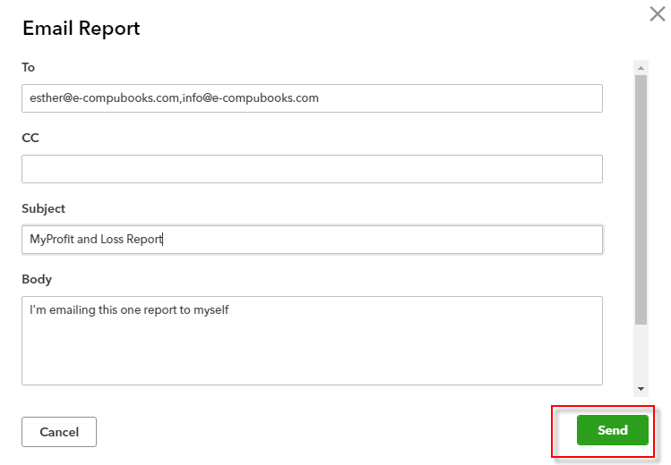

Course Conclusion
You have just covered Course 4 – Reporting. This course has been developed to help you train your clients how to use QuickBooks Online successfully.
By completing this module, your client should understand:
- The Benefits of Reporting
- Reporting Capabilities
- Reporting Methods

