QUICKBOOKS ONLINE client training
Course 3
Record Transactions in QuickBooks Online

Copyright
Copyright 2017 Intuit, Inc. Intuit, Inc.
All rights reserved. 5601 Headquarters Drive
Plano, TX 75024

Trademarks
©2017 Intuit, Inc. All rights reserved. Intuit, the Intuit logo, Intuit ProLine, Lacerte, ProAdvisor, ProSeries and QuickBooks, among others, are trademarks or registered trademarks of Intuit, Inc. in the United States and other countries. Other parties’ marks are the property of their respective owners.

Notice to Readers
The publications distributed by Intuit, Inc. are intended to assist accounting professionals in their practices by providing current and accurate information. However, no assurance is given that the information is comprehensive in its coverage or that it is suitable in dealing with a client’s particular situation. Accordingly, the information provided should not be relied upon as a substitute for independent research. Intuit, Inc. does not render any accounting, legal or other professional advice, nor does it have any responsibility for updating or revising any information presented herein. Intuit, Inc. cannot warrant that the material contained herein will continue to be accurate nor that it is completely free of errors when published. Readers should verify statements before relying on them.

Table of Contents
About the Author 2
Training at a Glance 3
QuickBooks Online Test Drive 4
Topic 1: Sales & Revenue Transactions 5
Determine the Appropriate Sales-related Settings 6
Recognize Alternative Entry Points to Enter Sales Transactions 15
Topic 2: Expense & Purchase Transactions 39
Determine Appropriate Expense-related Settings 40
Recognize Alternate Entry Points to Enter Purchasing Transactions 43
Topic 3: Additional Transaction Types 67
Identify Additional Transactions Initiated Using the Quick Create Menu 67
Topic 4: Other Tools 75
Course Conclusion 79

About the Author
Esther Friedberg Karp, MBA
Advanced Certified QuickBooks ProAdvisor
President, EFK CompuBooks Inc.
Esther Friedberg Karp is an internationally-renowned trainer, writer, business consultant and speaker who was named one of the Top 10 QuickBooks ProAdvisors in the world, with the title Top International ProAdvisor.
Based in Toronto, Canada, Esther has the unique distinction of holding ProAdvisor certifications in the United States, Canada and the United Kingdom. She is advanced certified in both QuickBooks Desktop and QuickBooks Online. Esther has authored materials and delivered educational and certification courses for Intuit in all those countries, as well as Australia where she conducted live QuickBooks Online training. She has spoken at Scaling New Heights, QuickBooks Connect and other conferences, as well as those of various accounting and professional organizations and written countless articles for Intuit Global.
Esther counts among her clients companies from around the world, as well as accounting professionals who seek her out on behalf of their own clients for her expertise in various countries’ editions of QuickBooks Desktop and Online, and for her talent in customizing QuickBooks usage for different industries.
Esther holds a BSc from the University of Toronto in Actuarial Science and Mathematics, and an MBA in Marketing in Finance from York University’s Schulich School of Business.
She can be reached at esther@e-compubooks.com or 416-410-0750.

Training at a Glance
Use this as a guide to select specific activities you want to cover.

TOPIC | CONTENT
SALES & REVENUE TRANSACTIONS | - Sales receipts  - Invoices  - Payments  - Deposits
EXPENSE & PURCHASE TRANSACTIONS | - Checks  - Expenses  - Bills  - Pill payments
ADDITIONAL TRANSACTION TYPES | - Bank deposits  - Transfers  - Journal entries
OTHER TOOLS | - Banking Center  - Bank reconciliation  - Closing the books

QuickBooks Online Test Drive
Exercises contained in this handbook can be completed using a QuickBooks Online “test drive” file. The test drive uses a sample company file called Craig’s Design & Landscaping Services. It can be accessed through the following link:
Craig's Design & Landscaping
You don’t have to create an account or sign in to access the test drive file; just complete the security validation and click Continue.
This test drive is designed for you to explore and try out new things without worrying you will break something or make a mistake. It is not designed to retain any changes you make. Once you close this QuickBooks Online test drive company it is completely refreshed, so remember to allow sufficient time to complete each activity. Don’t worry if you have to close the test drive before you are finished, you can always begin again.

Topic 1: Sales & Revenue Transactions
Whenever you set up a new area of QuickBooks, you need to review the Account and Settings related to that area. Before you go into Account and Settings, you need to make sure you understand the different types of sales and revenue transactions.
- Estimates are non-posting transactions that provide your customers with information on what you think you are going to charge them. Think of it as a quote or proposal.
- Invoice is the sales transaction used when you want the customer to pay on account. An invoice will increase accounts receivable and increase income.
- Payment is the type of transaction used to receive payment against an invoice. It decreases accounts receivable and increases either a bank account or Undeposited Funds.
- Sales receipt is a sales transaction used when you receive payment at the time of sale; it has no effect on accounts receivable. It increases income and also increases either a bank account or Undeposited Funds.
- Credit memos are used when a customer returns something or negotiates a lower price. This creates a credit in accounts receivable that can be used against future invoices.
- Refund receipts are also used when a customer returns something or negotiates a lower price, but with a refund receipt you are refunding their payment. It has no effect on accounts receivable.
- Delayed charges and credits are available in Essentials and Plus only and are non-posting transactions that reflect potential revenue increase or decrease. They can be used on future transactions.

Determine the Appropriate Sales-related Settings

Account and Settings
Click the gear icon to access the Account and Settings under Your Company.
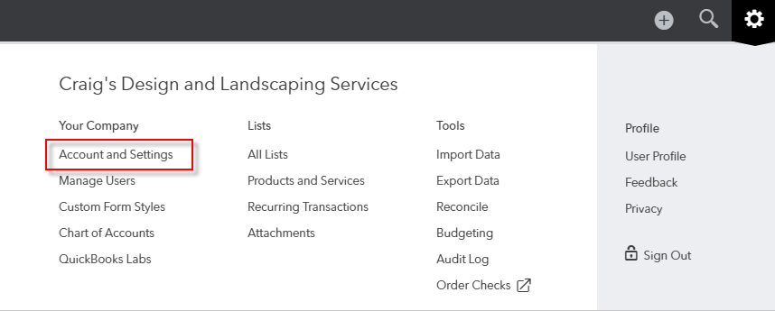
There are four tabs down the left side to set the preferences you want to use with the company file. The Sales tab is its own category, but there are also sales-related settings under the Advanced tab.
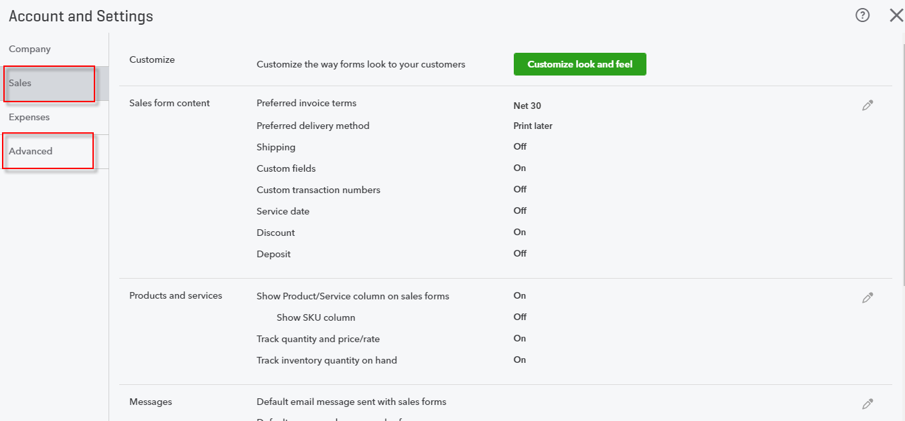

Customize Sales Forms
The first setting under the Sales tab allows you to customize the sales forms. Click Customize look and feel. Click New Style, then select if you are going to create a new style for an Invoice, Estimate or Sales Receipt.
In the Design tab you can rename the title of this sales form, choose your template, upload a logo, add color and your font.
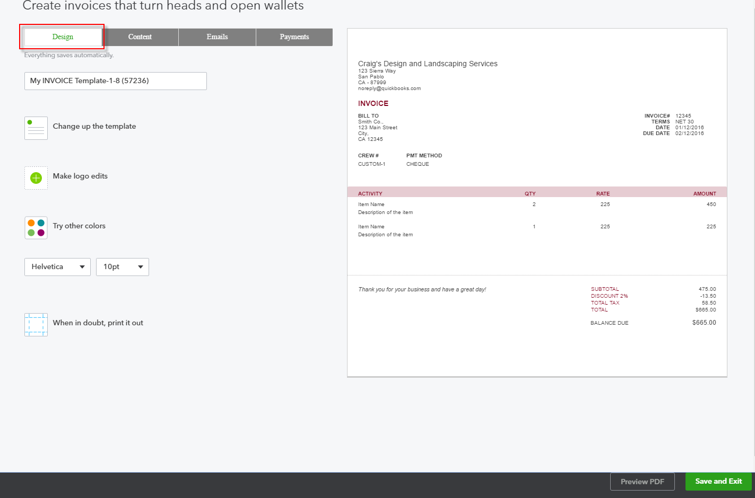

Click the Content tab. Click on the pencil icon in any area (e.g., Header, Display) to review and edit the content in each area; you can also edit labels, column widths and so forth. Make sure to look at billable time and expenses if you invoice based on time and expenses. When you invoice for time you can include the employee name on the form, as well as group activities by time period or type and have the groups subtotaled.
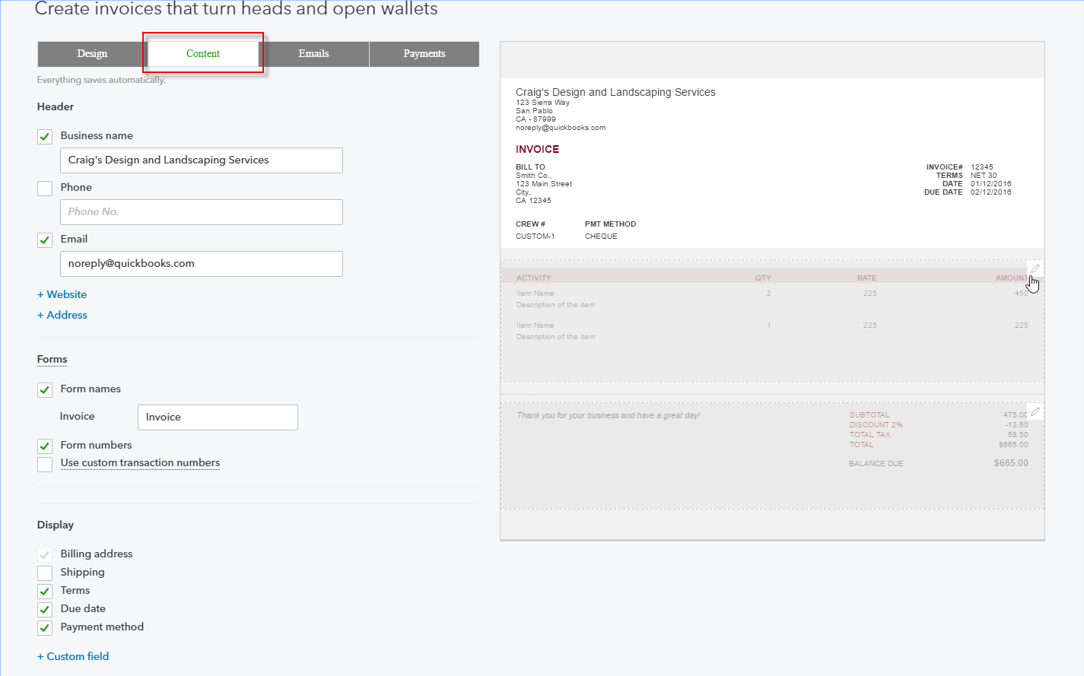

The Emails tab allows you to set the default email subject and message that accompanies the sent form, as well as the format of any reminder emails you might send.
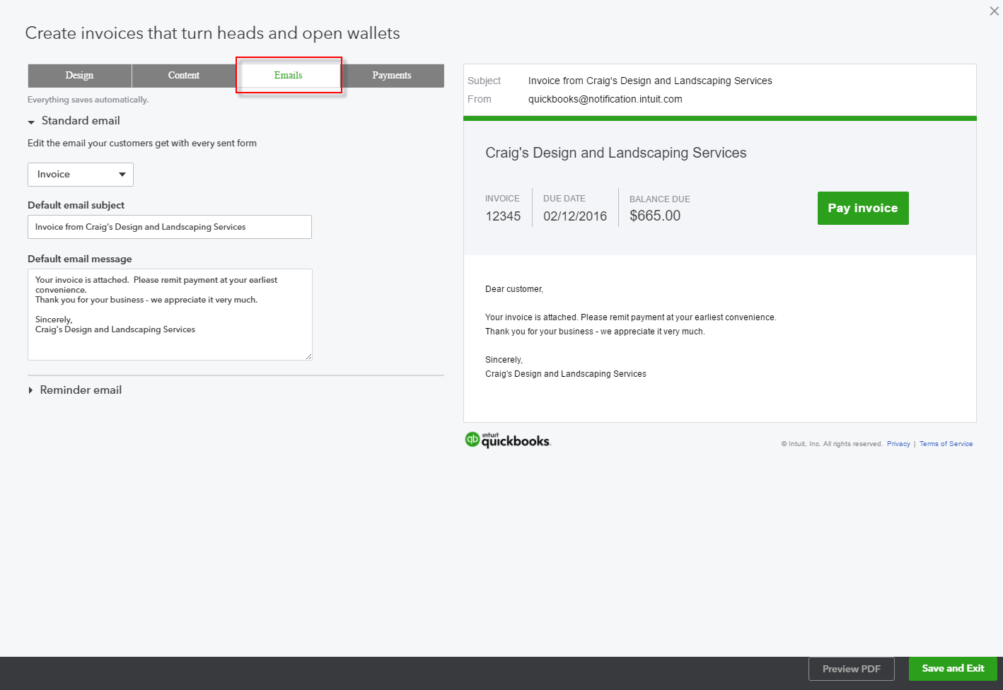

The Payments tab lets your customers pay online by bank transfer (free) or by credit card (fees apply).
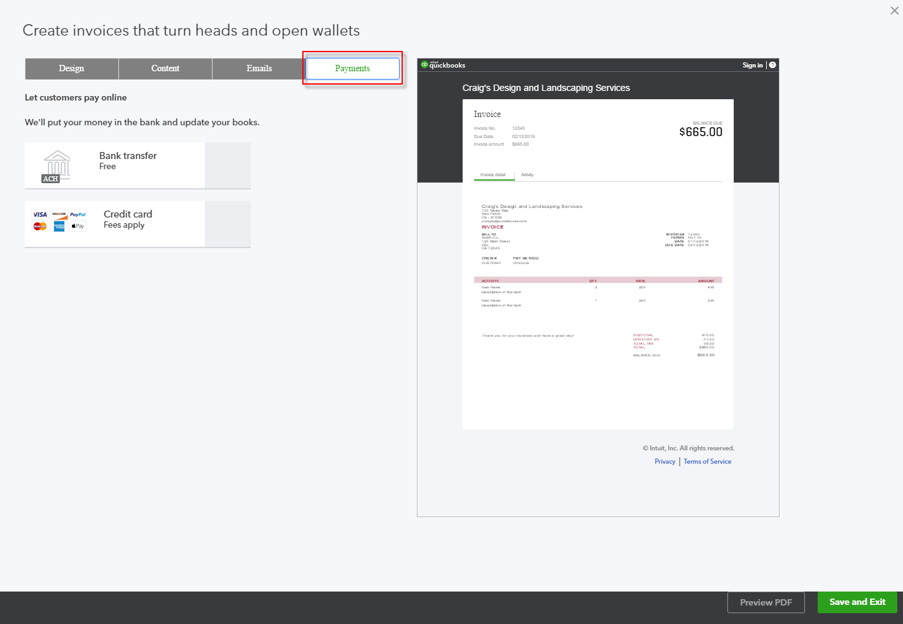

Sales Form Content
This section of the Sales tab of Account and Settings allows you to set options such as preferred invoice terms and delivery method, which can be changed on an actual sales form. It’s setting defaults. You can also decide to add additional line items such as shipping, discounts or deposit fields.
When you customized the forms previously, you had the ability to add up to three custom fields to the transactions. That preference is turned on in the Sales form content and the fields can be set up here or on the Content tab when you customize an invoice. Note the Sales form content section is where you indicate if you want the custom fields to be internal, public or both.
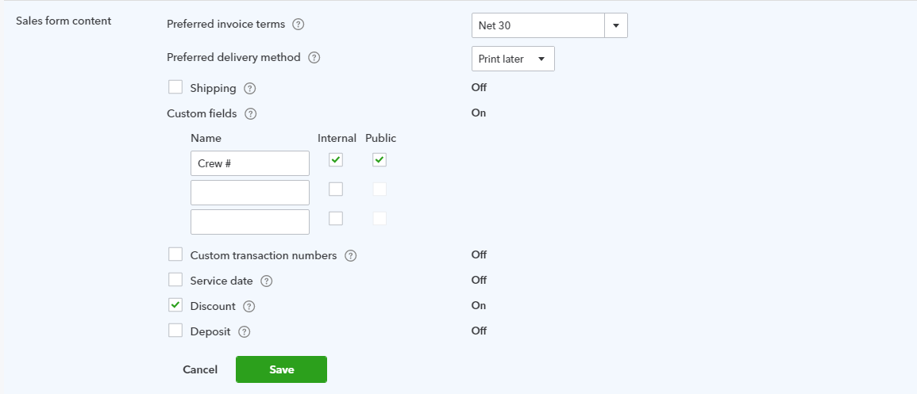

Products and Services
In this section of the Sales tab in Accounts and Settings, you identify if you want to show the Product/Service column on sales forms so the drop-down list of products and services is available. Here also is where you turn on the preference to track inventory. Inventory tracking is available only in QuickBooks Online Plus.
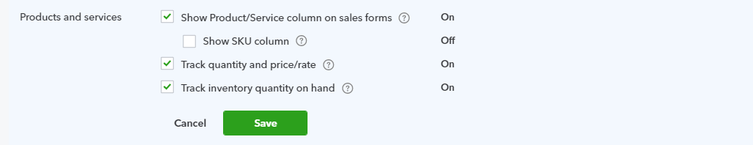

Other Sales Settings
The Messages setting allows you to create default email forms when emailing sales forms.
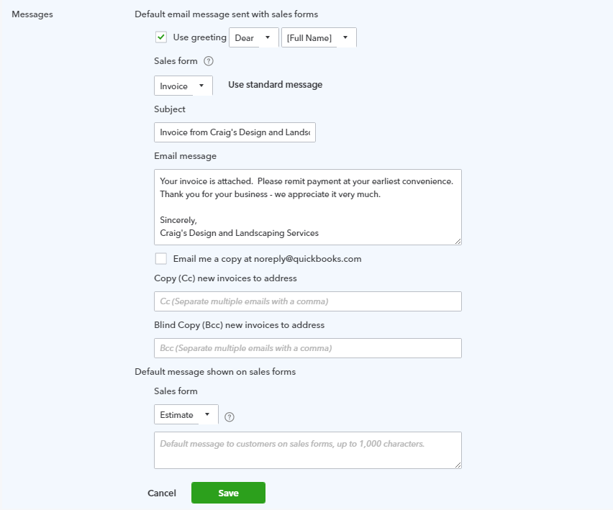
The Reminders setting, very much like the Messages setting, allows you to create default emails when sending reminders.
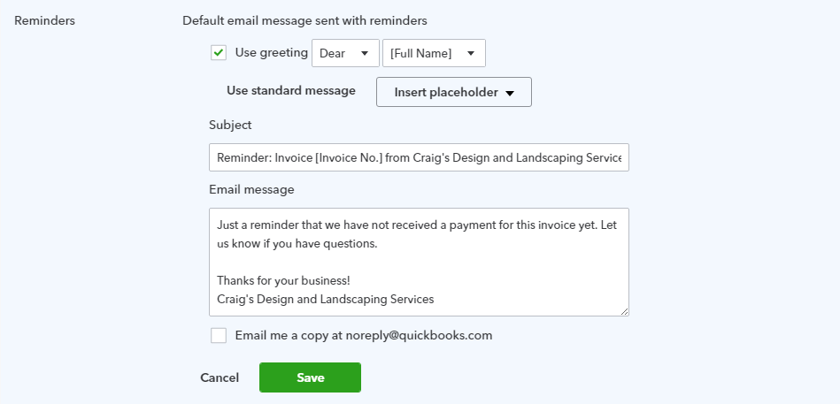
Online delivery settings relate to emailing your forms and what you want the customer to see. There are options of sending as plain text, HTML or using an online invoice.
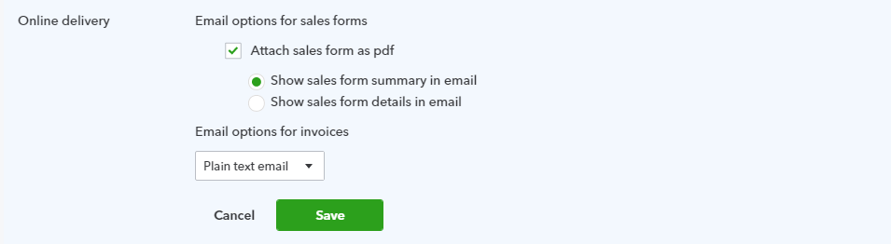
There are a couple of preferences to choose from regarding Statements.
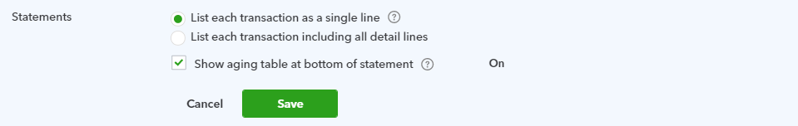

Advanced Settings
For more sales-related preferences, take a look under the Automation section of Advanced settings.
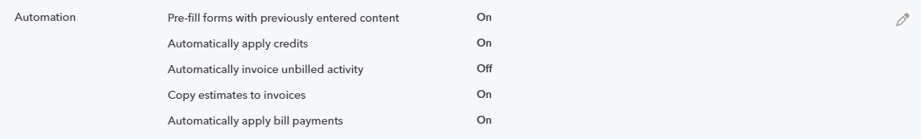
Pre-fill forms with previously entered content asks if you want QuickBooks to copy the same information from the last transaction using the same customer.
If you turn on the preference to automatically apply credits, QuickBooks will apply any available credits to the next invoice. Beware of turning on this or any other automation preference. It may be you don’t want to apply the credit to the next invoice but to some future invoice.
You can turn on a preference to Automatically invoice unbilled activity.
If you want to invoice from an estimate, you need to turn on the preference Copy estimates to invoices. You then have a choice to copy only accepted estimates or both pending and accepted estimates.
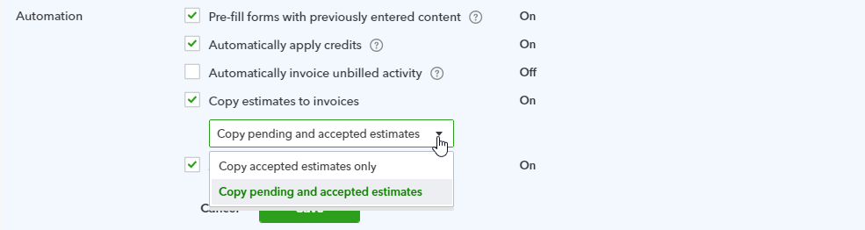
You need to understand the ramifications of the Automation preferences to know if they make sense for you. If you are having problems with accounts receivable, check these settings.

Recognize Alternative Entry Points to Enter Sales Transactions

Customer Center
The Customer Center, accessed by selecting Customers in the left navigation bar, is a dashboard for adding, editing and reviewing customers with whom your QuickBooks Online company does business. The list of customers can be printed or exported, and it can be sorted by various parameters or filtered. Beside each customer listing is a drop-down box from which to create transactions such as invoices or estimates, or to send a reminder of a balance owing or print or send a statement. In addition, batch actions can be performed for the entire list: sending or printing statements and sending emails directly from within QuickBooks Online. These emails can use your choice of web-based email or email client.

Enter Transactions from the Customer Center
- Step by Step: Create an Estimate
There are several ways to create an estimate in QuickBooks Online. To create an estimate from the Customer Center follow these steps:
- Select Customers from the left navigation bar.
- If necessary, select Clear Filter/View All above the Money bar to produce a full list of customers.
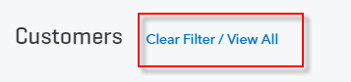

- Select the drop-down box in the far-right column for Cool Cars Create estimate.
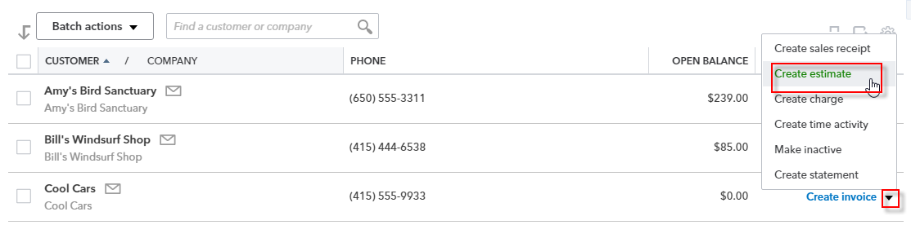
- Complete the on-screen estimate for Cool Cars with the desired date, products and services of your choosing, the quantity, description (override the description if you want) and rate (override the rate if you like) of each, the sales tax (check the Tax box for specific items then select the sales tax to be applied below in the drop-down box).
- Complete any other desired fields such as Discount and Message to the Customer.
- Select Save and close or (by clicking on the drop-down box next to Save and Send) Save and new.
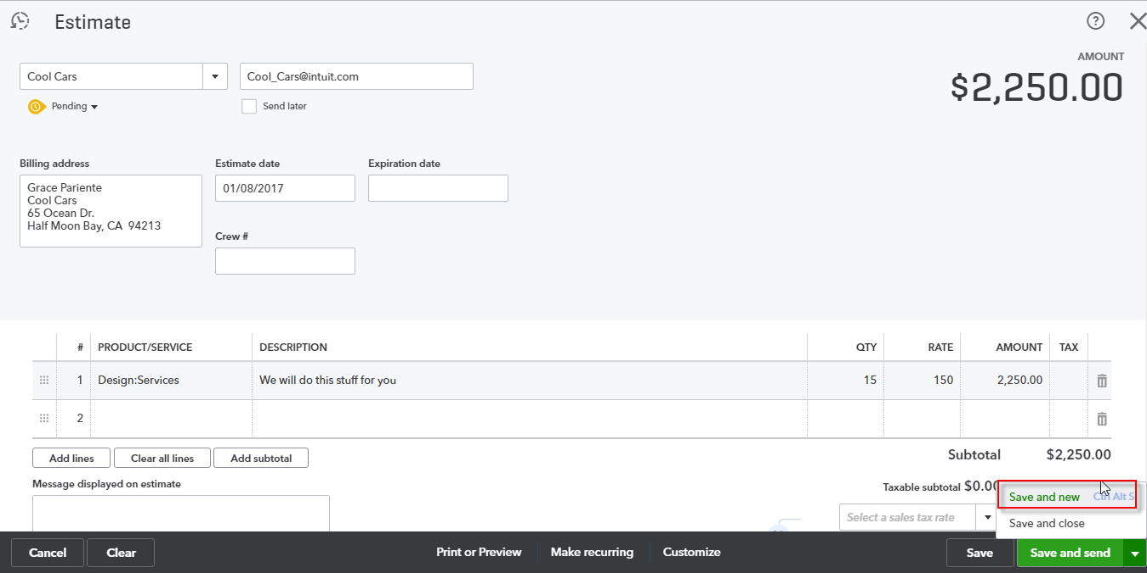

- Step by Step: Create an Invoice from an Estimate
To create an invoice from the estimate you just created, the easiest way to find that estimate is from the Money bar in the Customer Center.
- Select Customers from the left navigation bar.
- Click the Estimates rectangle in the far left section of the Money bar to display a list of open estimates.
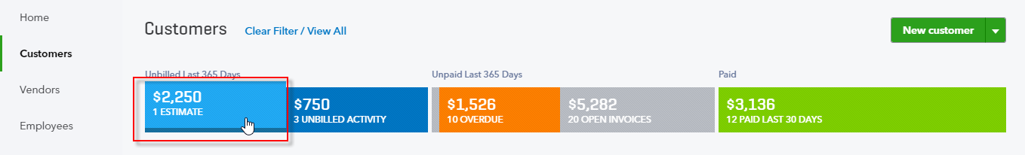
- Locate Cool Cars and click 1 open estimate.
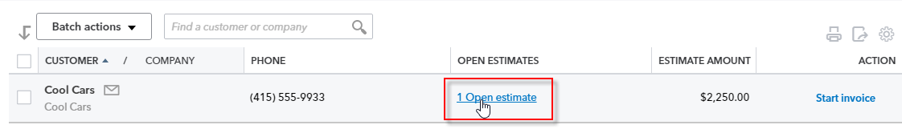
- In the Transactions list that appears find the estimate you want to turn into an invoice then select Start invoice at the far right.
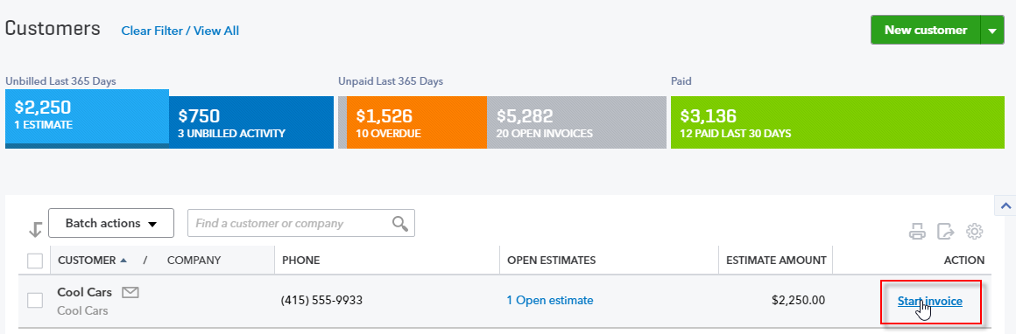

- Add the open estimate from the drawer on the right.
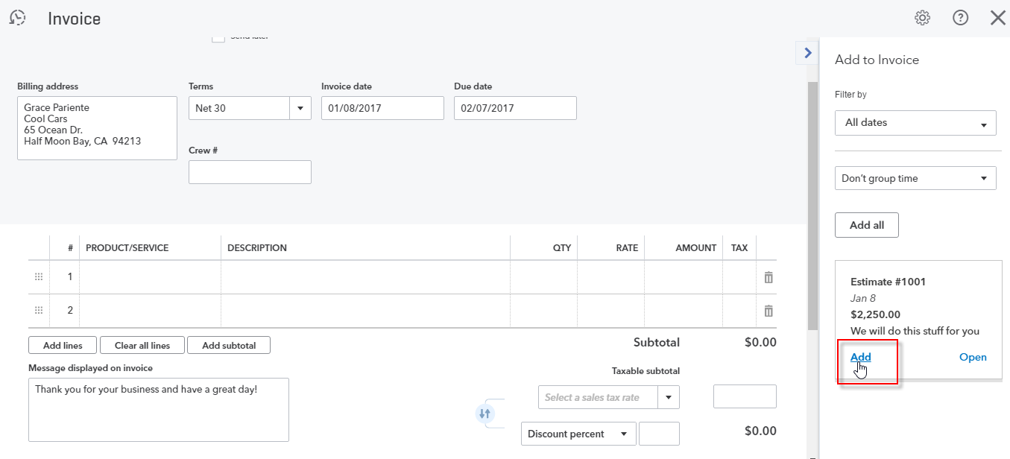
- Make changes to the already-populated invoice as required.
- Select Save and close or (by clicking on the drop-down box next to Save and Send) Save and new.
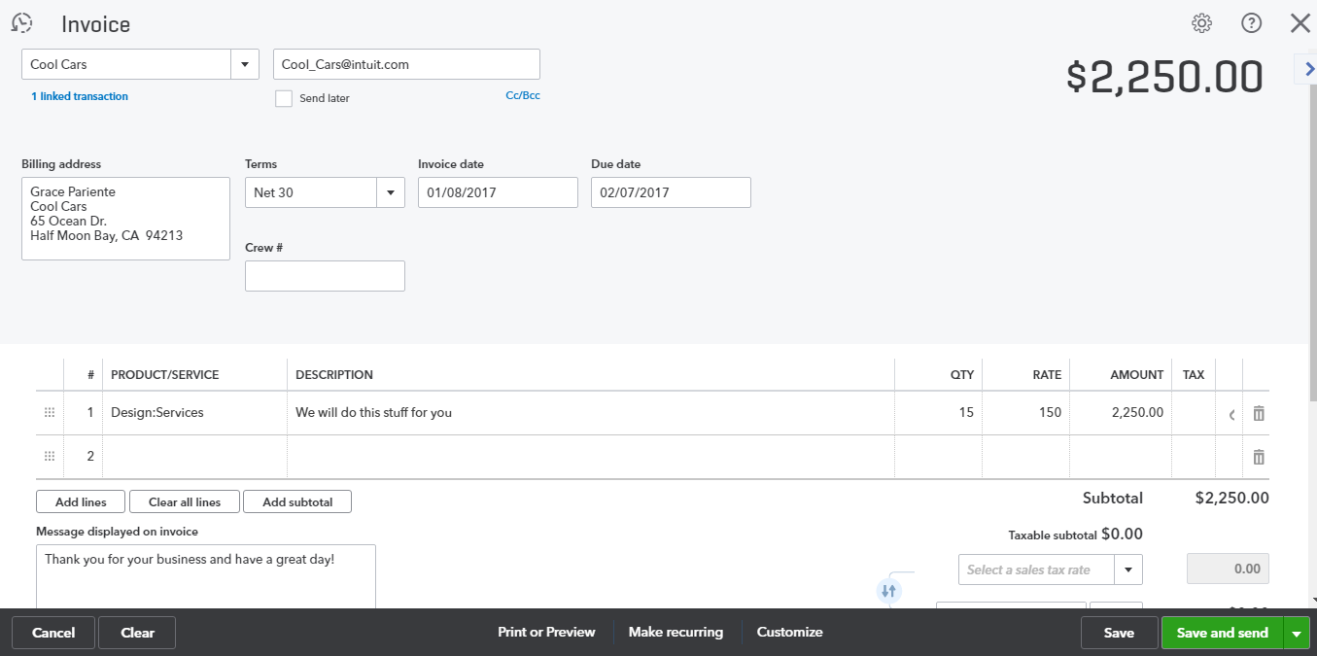
Note: If you do not want to invoice for the whole amount of the estimate, you can change the quantity or line items on the invoice. However, QuickBooks still considers the estimate fully invoiced. There is currently no progress invoicing function in QuickBooks Online.
- Step by Step: Create an Invoice for Unbilled Activity
You can also easily create invoices for any unbilled activity.
- Select Customers from the left navigation bar.
- Click the Unbilled Activity rectangle in the left section of the Money bar to display a list of unbilled activity.
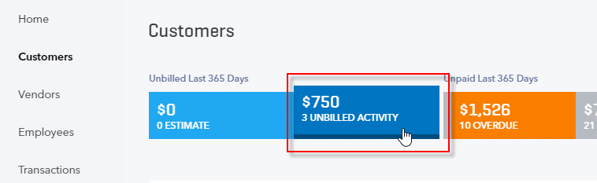
- Click Start Invoice from here or click to see the Unbilled activity. Click Unbilled activity for Amy’s Bird Sanctuary.
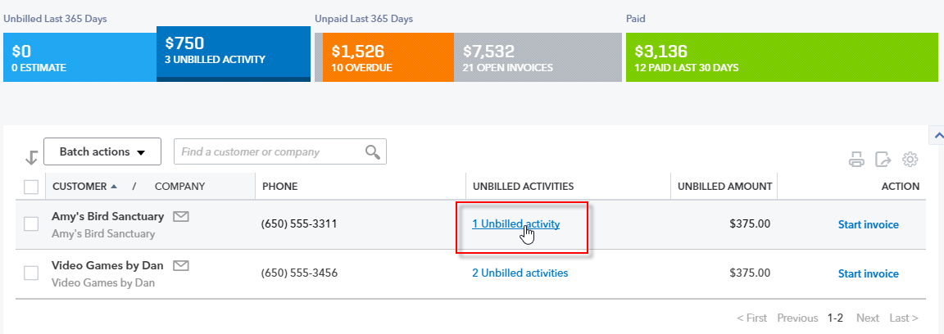
- Click Start Invoice.
Note: If you have multiple activities listed here, you can create a separate invoice for each. If you want to create one invoice for all unbilled activities, start an invoice (from various access points such as the Customer Center itself, the Sales Center or Quick Create, all to be described later) and bring unbilled activities in from the drawer on the right.
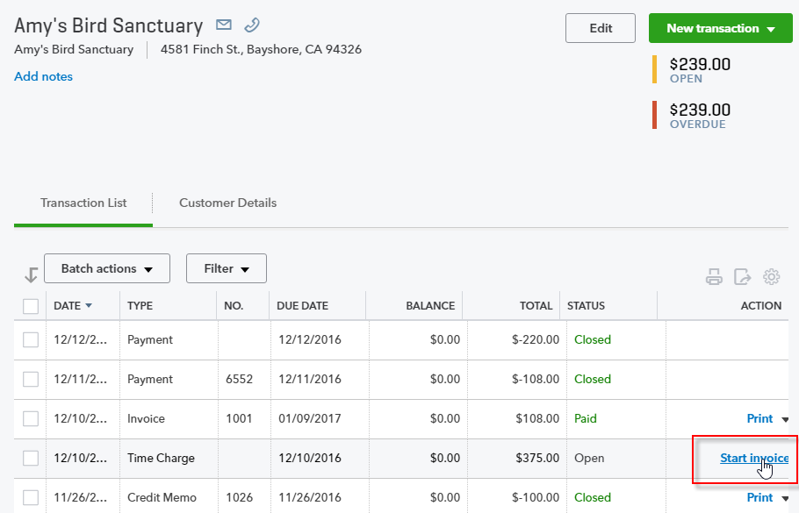

- Add any additional charges, sales tax or discounts then click Save and close.
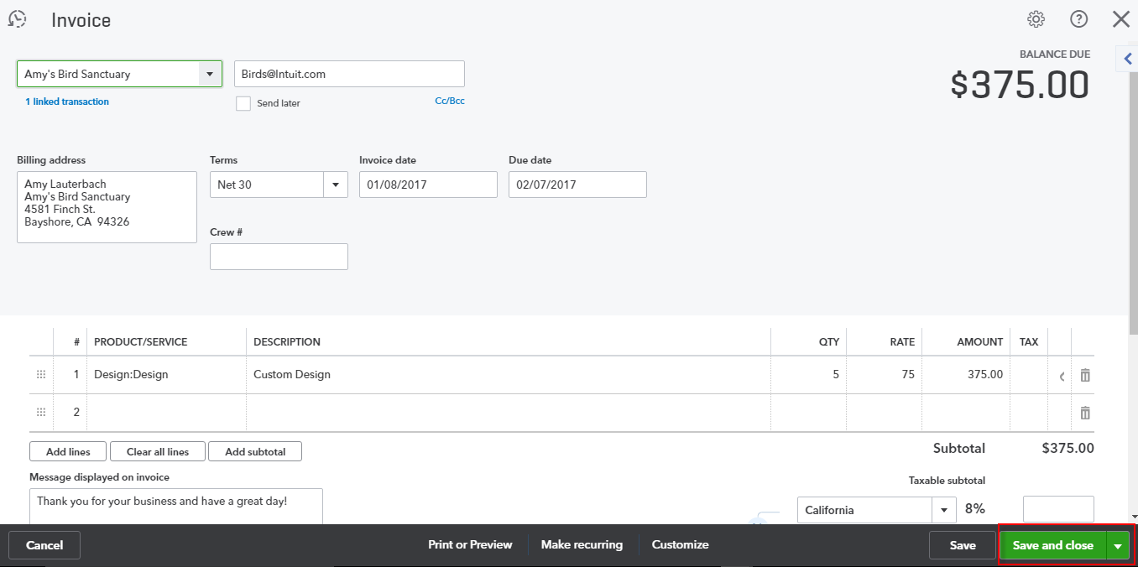

Enter Transactions from the Sales Transactions page (Sales Center)
- Step by Step: Create an Invoice
- Click Sales under Transactions on the navigation bar.
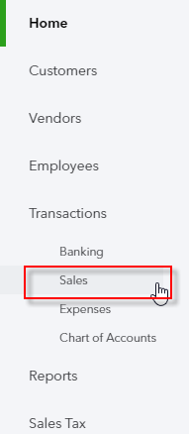

- This opens the Sales Transactions or Sales Center. Under the Action column (1) there are suggested next steps. You can filter the Money bar (2) here the same way you can in the Customer Center. You can also create New Transactions at the top right of the screen. Click Invoice (3).
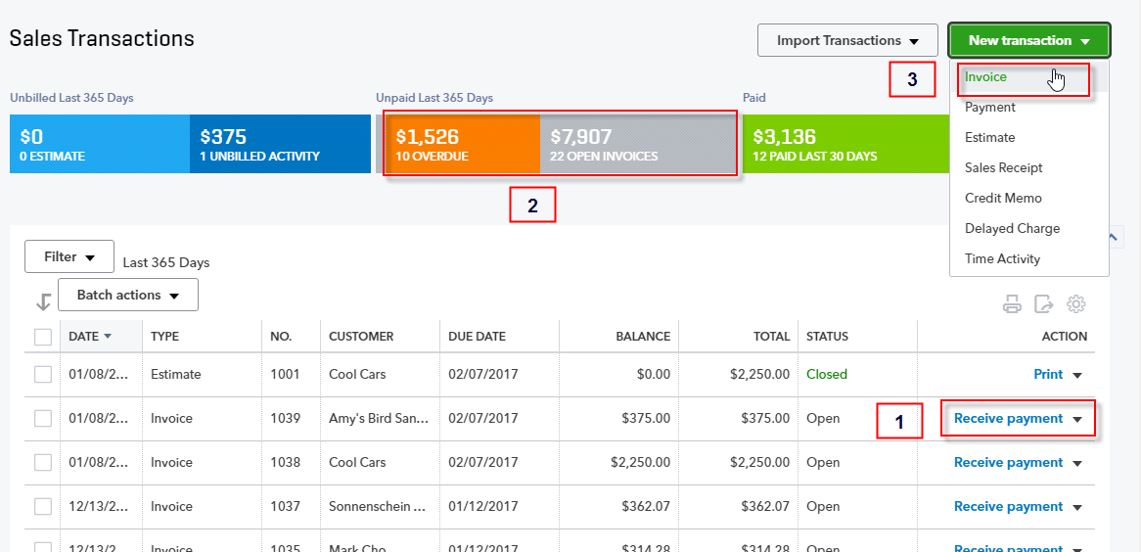

- Create a new invoice for Video Games by Dan. When you enter the customer name, QuickBooks opens a drawer on the right that shows time or expense activities that have been marked billable. You can easily add them to the invoice. The difference between creating the invoice from here (in the Sales Center) vs. creating it from the Action column for that customer or activity is that in the Sales Center you have a choice of what you are adding; whereas if you create an invoice from the Action column, it automatically puts the unbilled activity on the invoice.
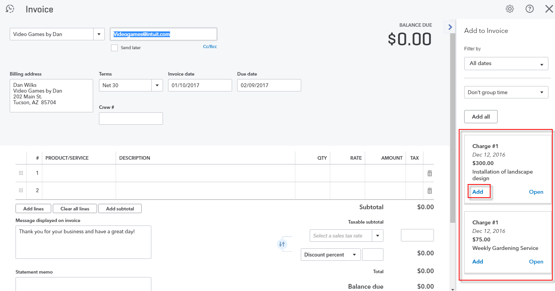

- Invoice just for the installation by clicking Add then Save and close.
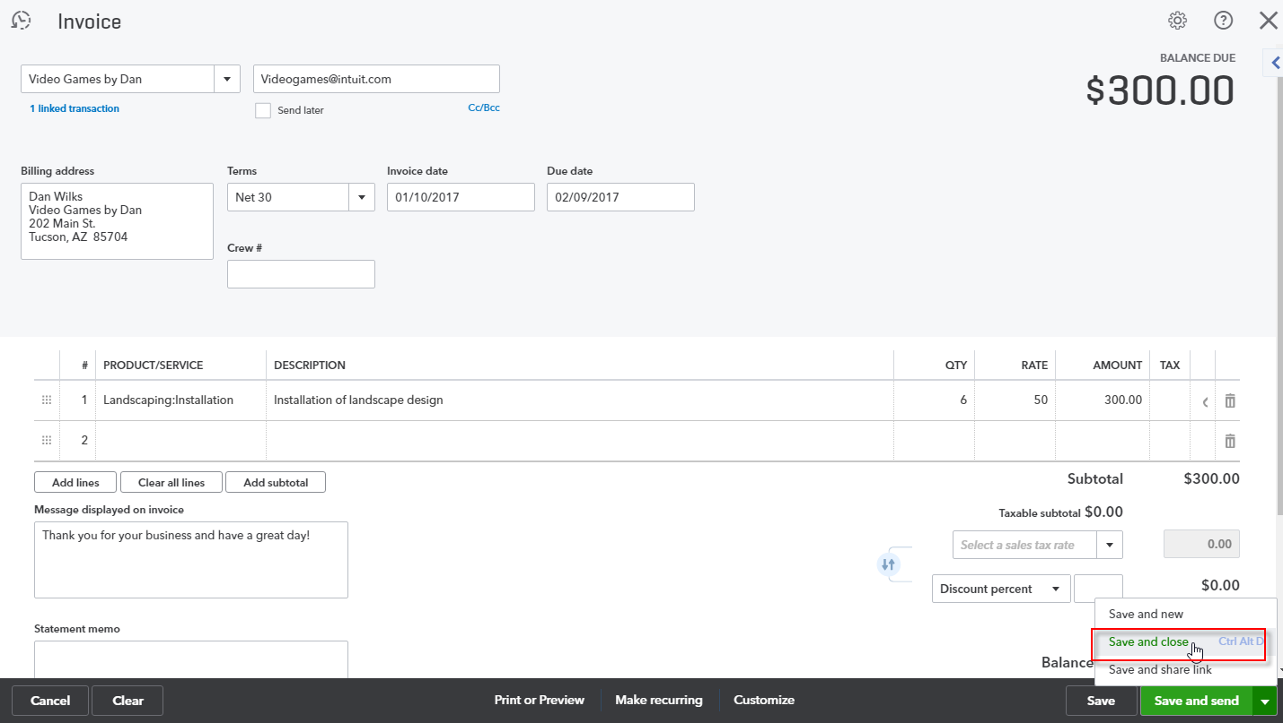

- This brings you back to the Sales Transactions list. Clear the filter, if necessary, so you can see all the transactions. Note this table is sorted by date. You can sort by any column header by clicking on the header (clicking once sorts by that parameter, clicking twice sorts it in reverse order). If you don’t see the columns you need, click the gear icon above the Action column and choose the columns you want to display.
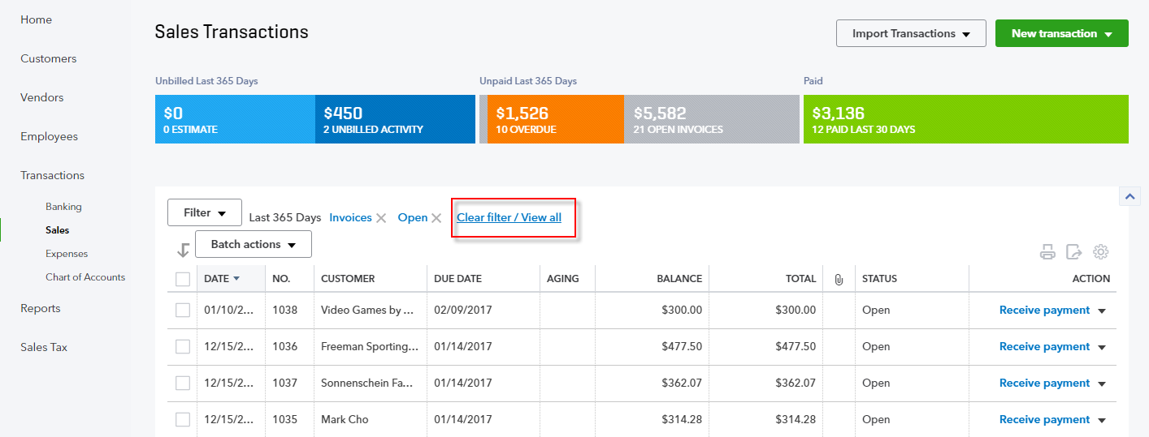
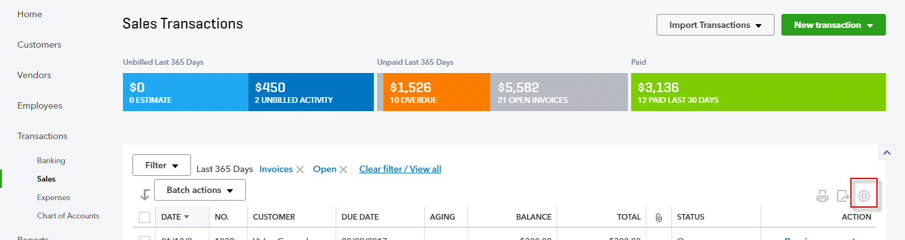

- Step by Step: Receive Payment
- The next step is to receive payment. Dan sent us a check for $300. Click Receive Payment next to his name.
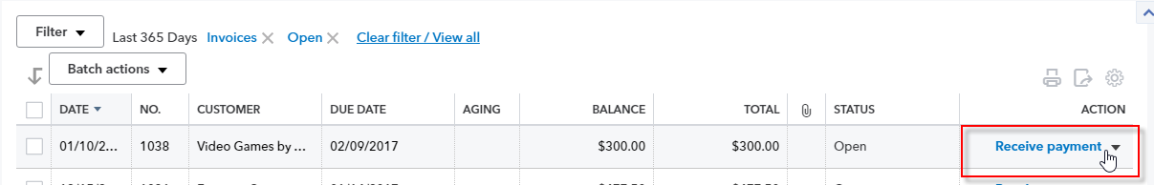
- A list of Outstanding Transactions shows up with the invoice checked. You can deposit to Undeposited Funds or directly into a bank account. If you’re signed up for QuickBooks Payments, you could process a credit card here. You’ll learn more about payments in Module 5. Choose Undeposited Funds then Save and close.
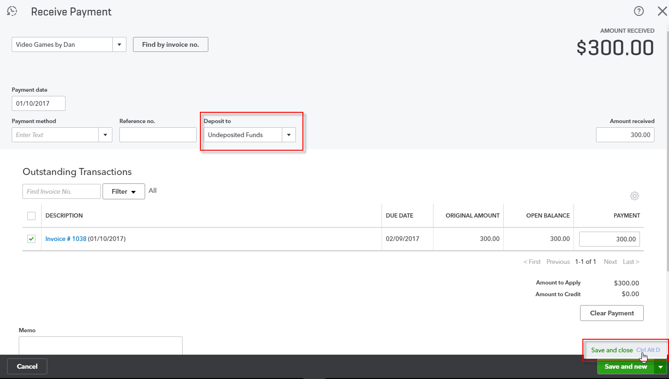
From the Sales Transactions page you can enter transactions based on the currently listed transaction (by clicking the drop-down in the Action column for that transaction), or you can create new sales transactions by clicking on the New transaction drop-down at the top of the page.

Enter Transactions from Quick Create
If you have the expanded view of Quick Create open, you can see a list of sales type transactions under the Customers column.
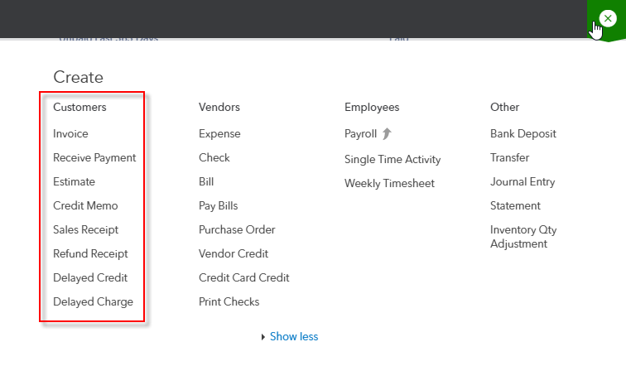

- Step by Step: Enter a Delayed Charge
- Click Delayed Charge. A delayed charge is a non-posting transaction; what you’re telling QuickBooks is you need to invoice a customer for something but don’t want to invoice for it now. Let’s say you are a landscaping service and do gardening for multiple customers. Every day you record where you gardened that day, but you invoice only once a month. You can record that activity in QuickBooks as a delayed charge and, at month end, create an invoice.
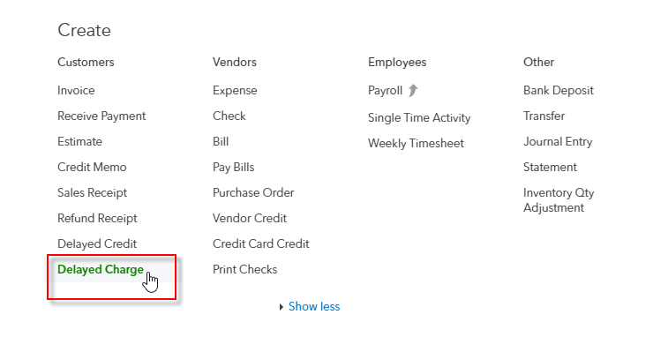

- Enter Amy’s Bird Sanctuary. In the Date field type a w to select the beginning of the currently-displayed week. Enter Gardening under the Product/Service column. Enter 4 under the QTY (Quantity) column and $35 under the Rate column. Click Save and new.
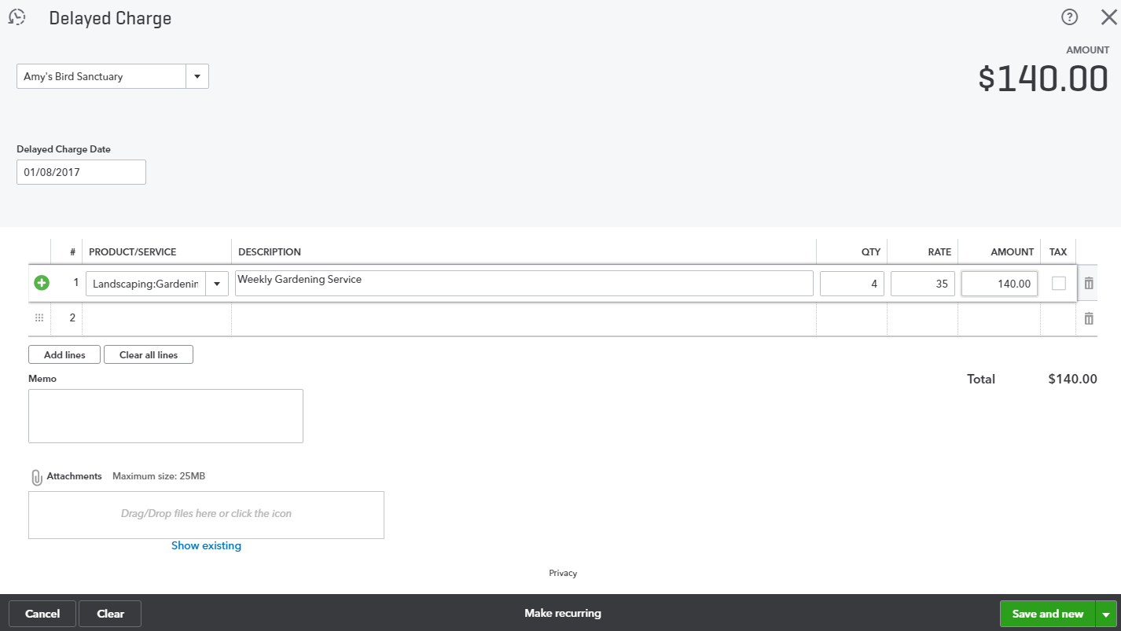

- Enter Amy’s Bird Sanctuary and in the Date field type a k and the plus key (+). K brings you to the end of this week and the plus (+) key advances a day, which brings you to the beginning of next week. Enter Gardening under the Product/Service column. Enter 3 under the QTY column and $35 under the Rate column. Click Save and close.
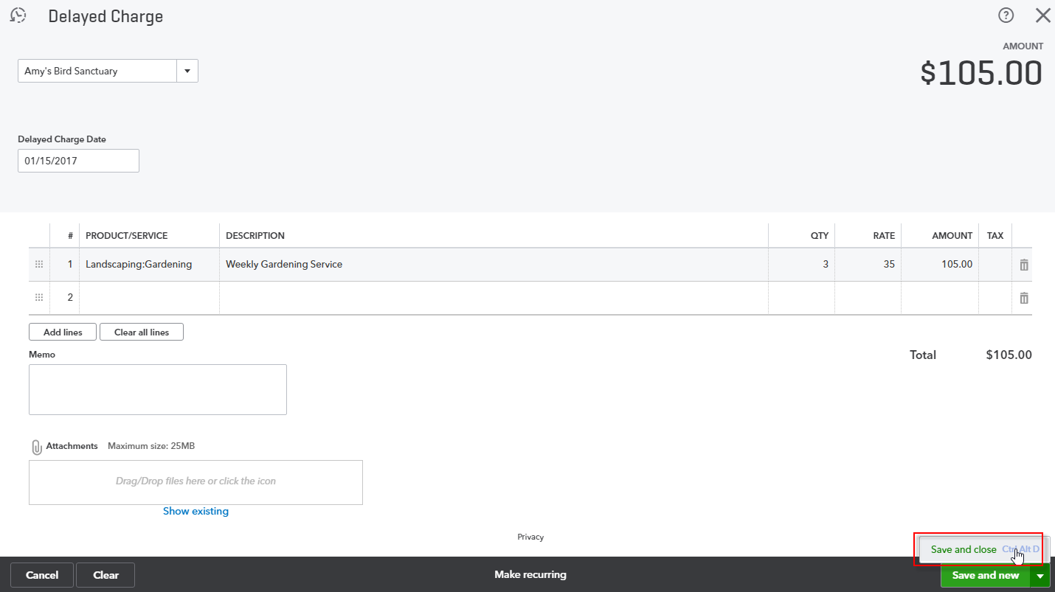

- Step by Step: Create an Invoice from Quick Create
- From Quick Create choose Invoice.
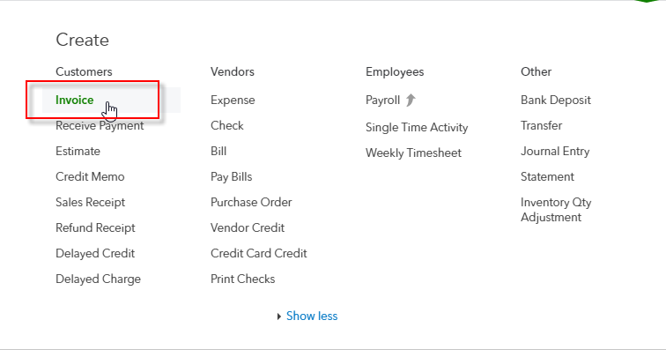

- Enter Amy’s Bird Sanctuary. As soon as you enter the customer name, if there are any unbilled (delayed) charges or unbilled time, a drawer opens on the right so you can easily add them to the invoice.
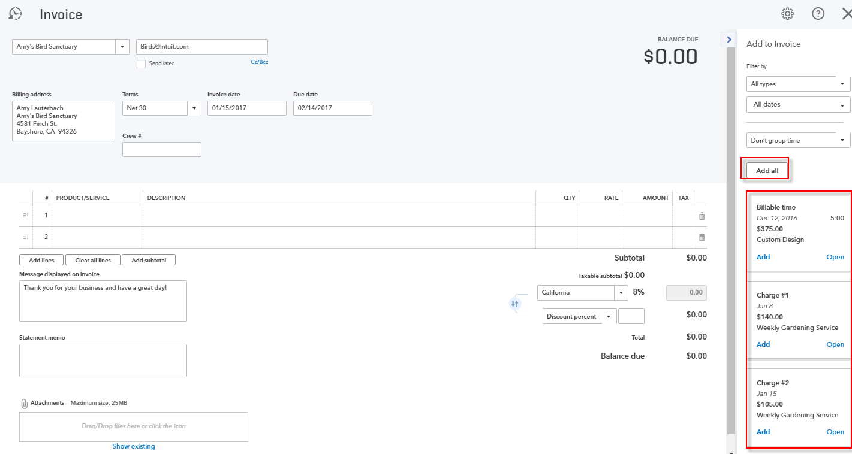

- Click Add all then Save and close.
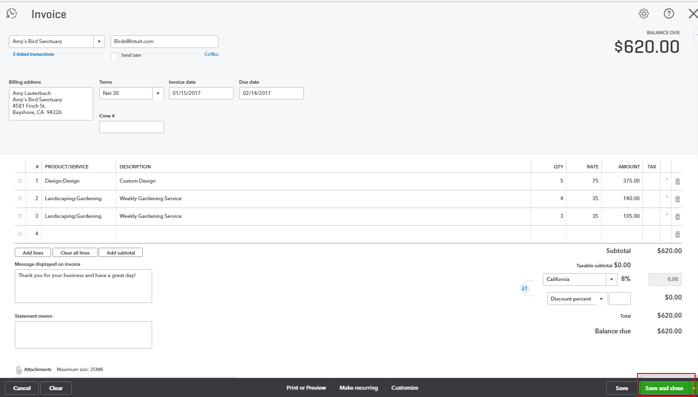

- Step by Step: Recurring Transactions
What happens if you have monthly recurring charges and you don’t want to have to remember to enter them? Even better, you’d like QuickBooks to create an invoice automatically and email it to your customers. Use the Recurring Transactions feature. Most transactions (sales, purchases and journal entries) can be made recurring.
- From Quick Create click Invoice.

- Type Bill’s Windsurf Shop and choose Pest Control under Product/Service. Leave the quantity at 1 and the rate at $35.00. At the bottom of the screen click Make recurring.
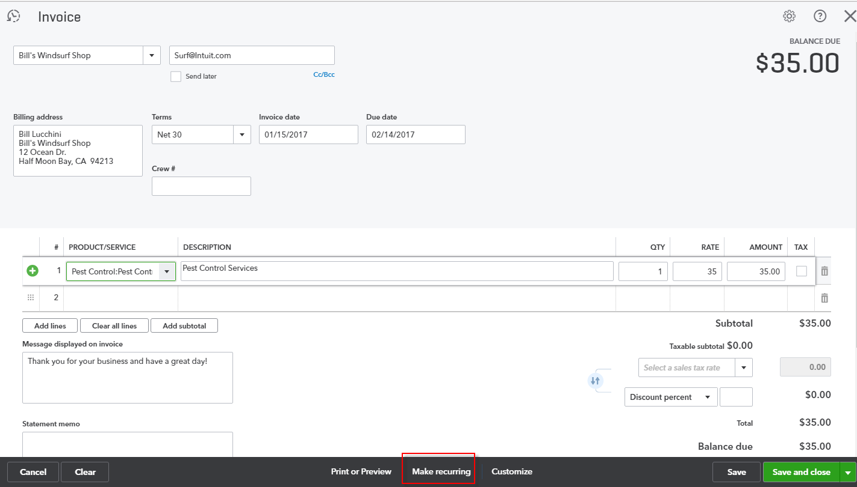

- This opens a screen where you can create a recurring invoice template. You can name the template, say whether or not you want it automatically entered, choose to automatically send an email and, if scheduled, set up the schedule. Click Save template.
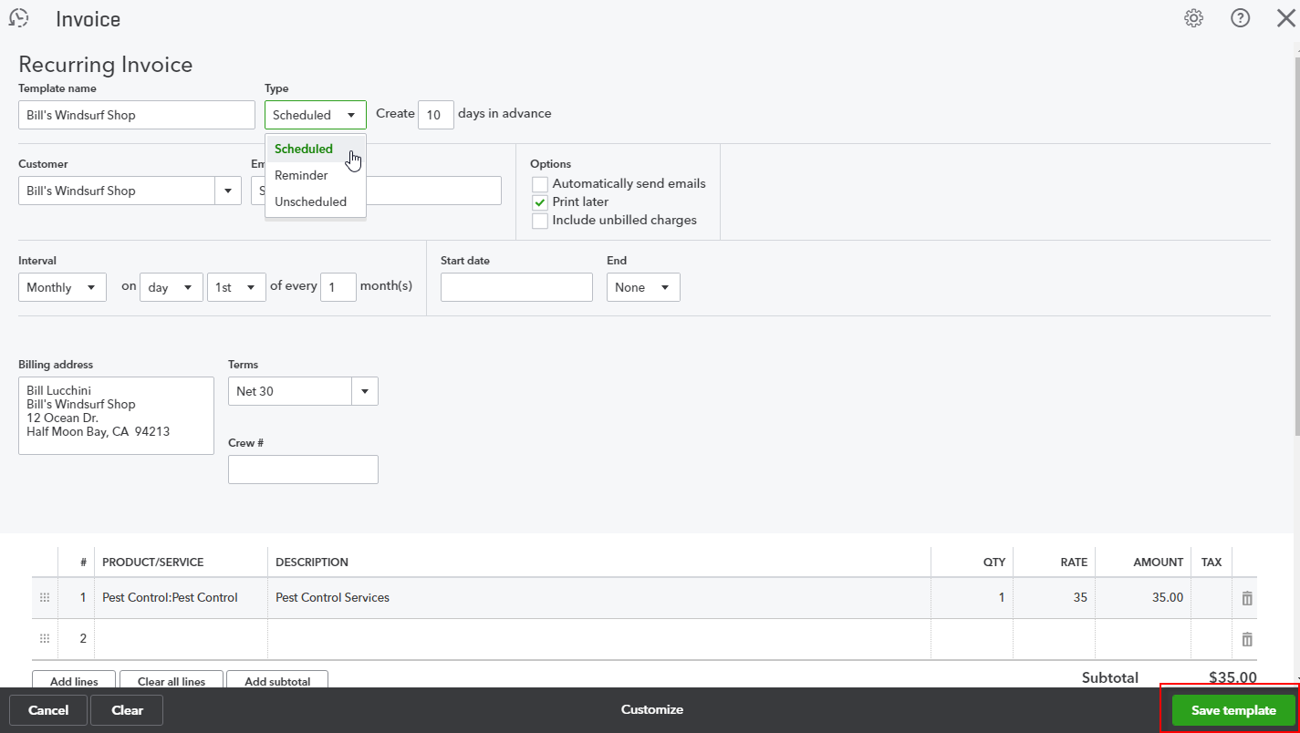
You have a lot of flexibility when creating a template. Experiment with it in the sample file. Note that if you have an already-recorded transaction and want to make it recurring, you can open it up and click Make recurring at the bottom of the screen. Remember that most transactions can be made recurring.

- Step by Step: Recurring Transaction List
- To see a list of recurring transactions, click the gear icon and open Recurring Transactions under Lists.
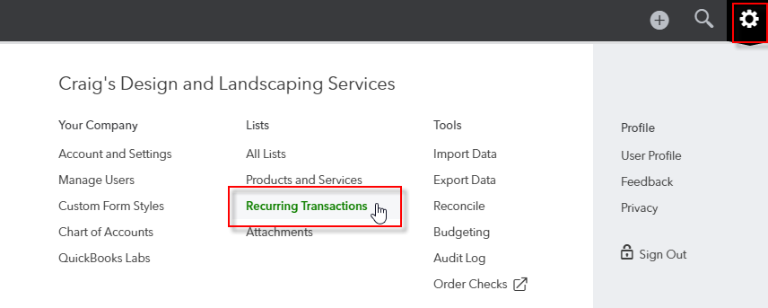
- From here, you can add new templates, edit an existing template, use an existing template, duplicate it (as a good starting point for a new template) or delete it.
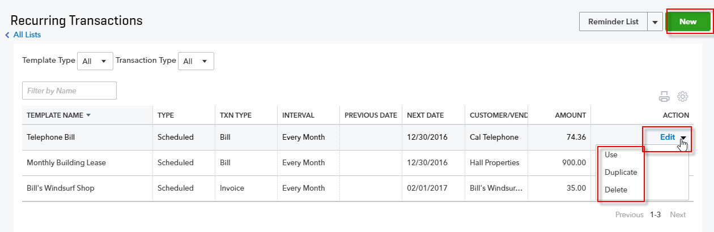

Topic 2: Expense & Purchase Transactions
Whenever you set up a new area of QuickBooks, you need to review the Account and Settings related to that area. Before you go into the Account and Settings, you need to make sure you understand the different types of expense and purchase transactions.
- Bill is a transaction you enter when you receive a bill from a vendor but don’t want to pay it until later. This is available in Essentials and Plus only.
- Expense is a way (using one window only) to enter cash, check or credit card purchases
- Checks are a way to enter transactions that reduce your bank account. If the transaction is truly a check, you can print checks.
- Bill payment is a transaction used to pay the bills entered. This is available in Essentials and Plus only.
- Purchase order is used to tell a vendor you want to order goods or services. This is available in Plus only.
- Vendor credit is used to record either a refund or return from a vendor. This is available in Essentials and Plus only.
- Credit card credit is a transaction that records a credit card refund from a vendor.
All these transactions relate to monies going out. Some of these transactions can be launched from more than one access point, whereas others can be launched only from one.

Determine Appropriate Expense-related Settings

Account and Settings
Click the gear icon and choose Account and Setting under Your Company.
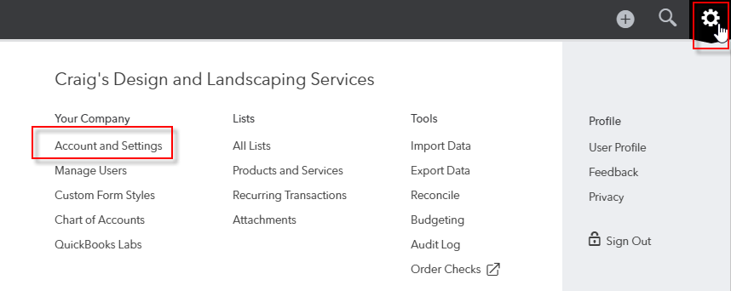

There are four tabs along the left-hand side to set the preferences as to how QuickBooks Online behaves in this company file. There is a separate tab for Expenses, but there are also expense-related settings included in the Advanced tab.
Click Expenses. The Bills and expenses preferences allow you to use items on expense and purchase forms (in addition to general ledger accounts), track purchases by customer and mark them billable. You can also define the default bill payment terms.
You can turn on the ability to use purchase orders here and turn on the ability to copy estimates to purchase orders here as well.
There is also a place to set up the default email message sent with purchase orders.
Note: Your subscription level determines whether or not you can use some of these features. For example, purchase orders can be used only in QuickBooks Online Plus.
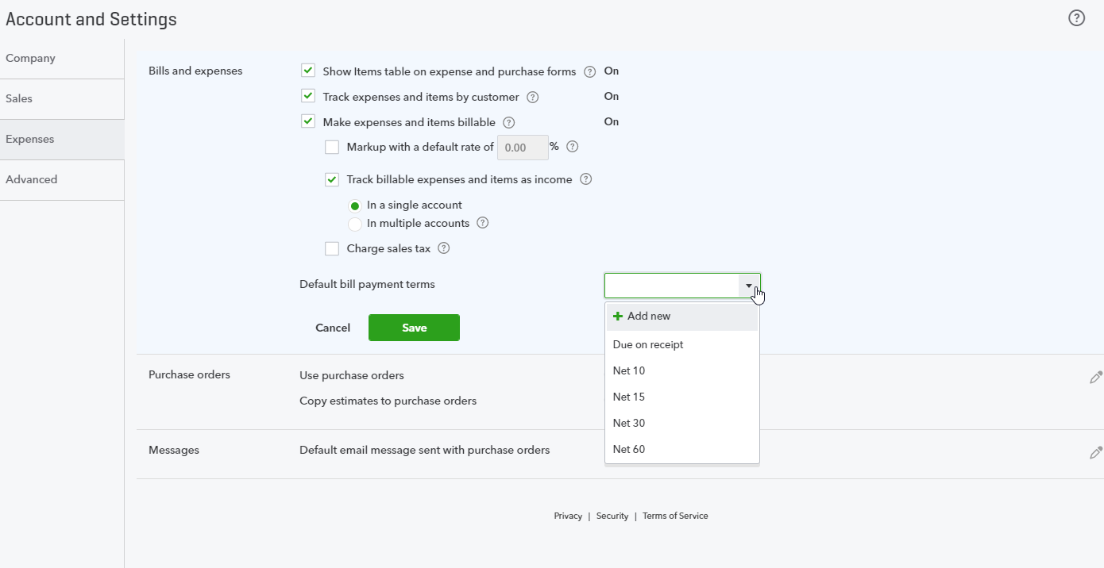

Click Advanced. You’ll see the same types of automation choices you saw with customers. Do you want QuickBooks Online to apply bill payments automatically? Think about it before you turn it on.
Under the Other preferences section, it’s a good idea to turn on the duplicate check and bill warnings.
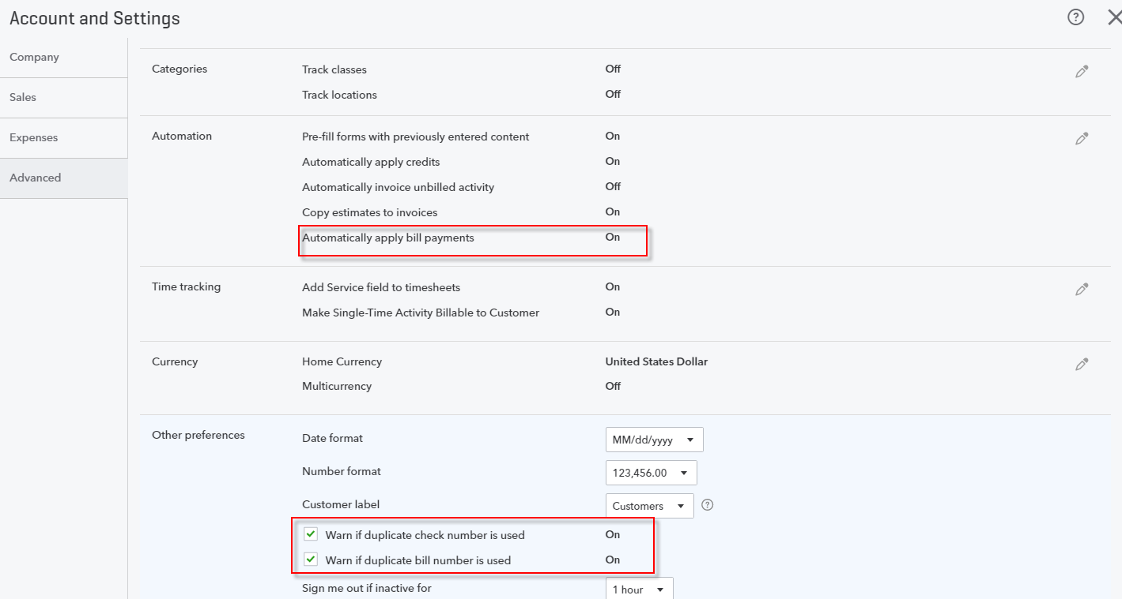

Recognize Alternate Entry Points to Enter Purchasing Transactions

Vendor Center
The Vendor Center, accessed by selecting Vendors in the left navigation bar, is a dashboard for adding, editing and reviewing vendors with which your QuickBooks Online company does business. The list of vendors can be printed or exported, and it can be sorted by various parameters (using the column headers, similar to how the column headers in the Customer Center behave) or filtered. Next to each vendor listing (in the far right column) is an Action column which has a drop-down box from which to create transactions such as bills or checks, or to make a vendor inactive. In addition, you can email vendors in batch by using the Batch Actions drop-down list at the top of the list of vendors in the left corner. These emails can use your choice of web-based email or email client.

Enter Transactions from the Vendor Center
- Step by Step: Create a Bill
- Go to Action Create bill for Bob’s Burger Joint.
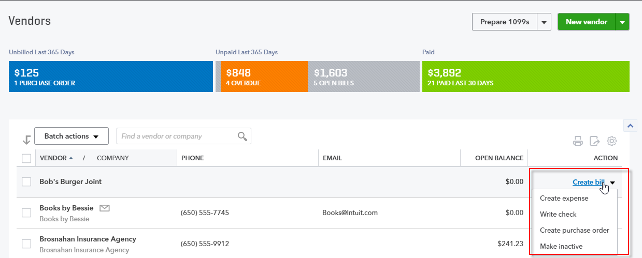
Note: Because of the setting Show items table on expense and purchase forms (in the Expenses tab of Account and Setting), you have the choice to assign the detail portion of bills directly to one or more accounts on the Chart of Accounts, or use one or more items from the Products and Services list, or use a combination of the two functionalities.
- Assign a bill number 1234. Under Account details enter Advertising for $2,500.00, billable to customer Amy’s Bird Sanctuary.
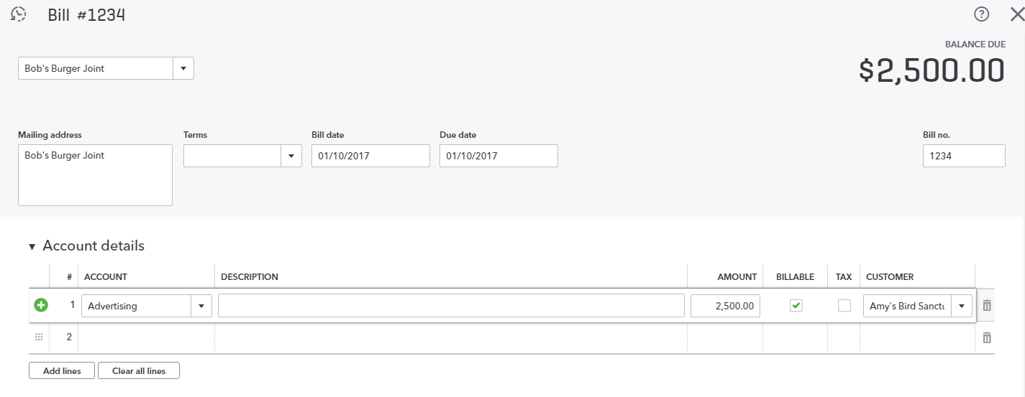
- Use the keyboard shortcut Ctrl + Alt + s to save this bill and open a new bill entry screen.
- Enter a second bill #1333 for Bob’s Burger Joint for Meals and Entertainment, $250.00 then Save and close. (Note that because the Company Setting Pre-fill forms with previously entered content is turned on under Advanced and Automation, you’ll have to overwrite the Advertising account that appears with Meals and Entertainment; you’ll also have to change the amount of the expense from $2,500.00 to $250.00.
Notice that when you used your keyboard shortcut to save bill 1234, QuickBooks saved the transaction and assumed you wanted to enter an additional transaction of the same type. But QuickBooks does not assume you want to use the same vendor. Therefore, in this case, you needed to enter Bob’s Burger Joint as the vendor in the second bill.
Now you see Bob’s Burger Joint has $2,750.00 as an Open Balance in the Vendor Center:
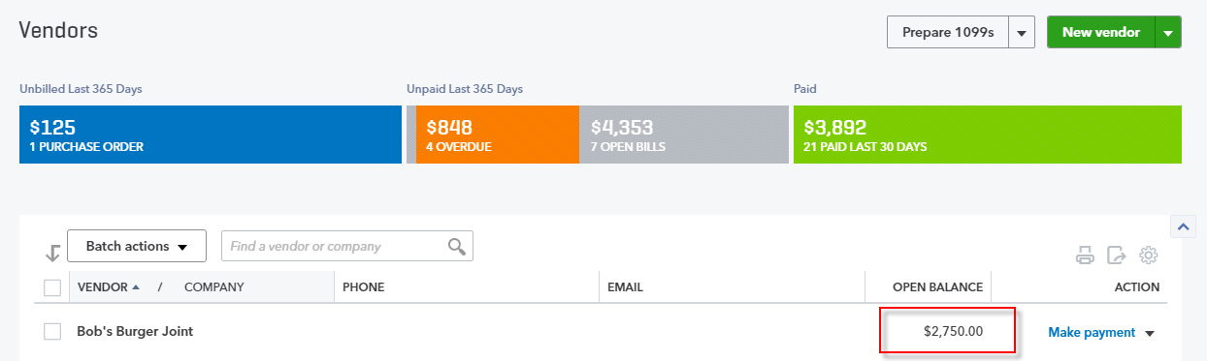
If you were to click Bob’s Burger Joint in the Vendor Center, you would see the two open bills adding up to $2,750.00. You would then be able to make a payment on one bill at a time by clicking on Make payment in the far right Action column.
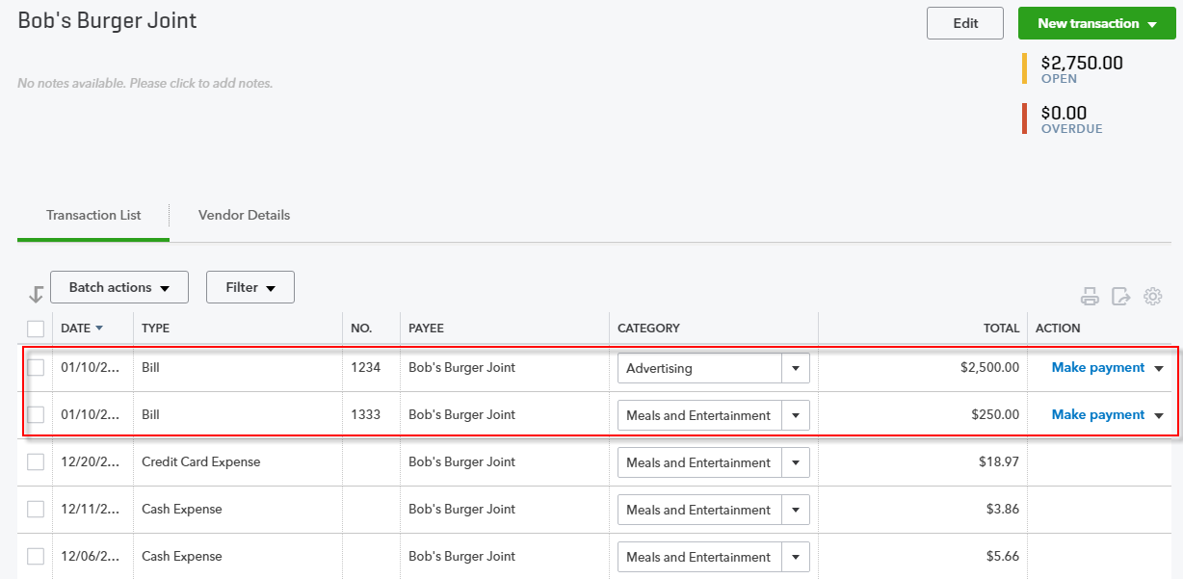

- Step by Step: Pay Bills
- Go back to the Vendor Center if you have left it. From the Action column click Make payment next to Bob’s Burger Joint.
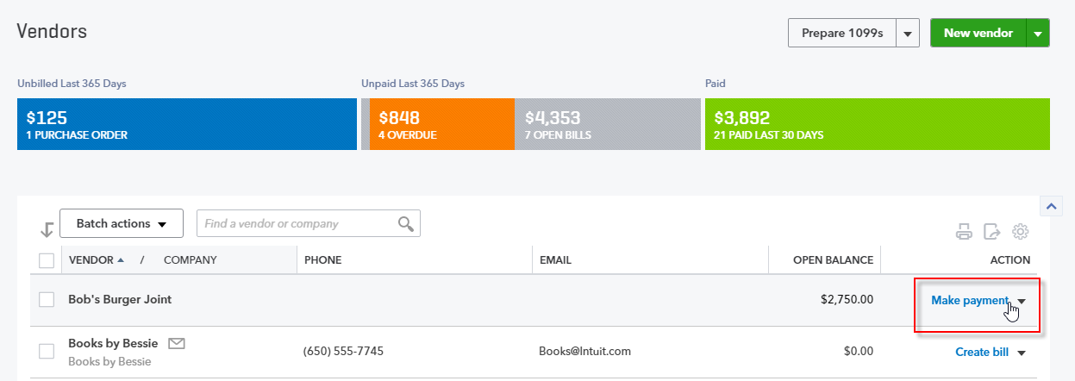
- QuickBooks opens the Bill Payment screen with that vendor’s outstanding bills listed and already checked for you to pay. At the top of the screen you can choose to pay via a bank account or credit card.
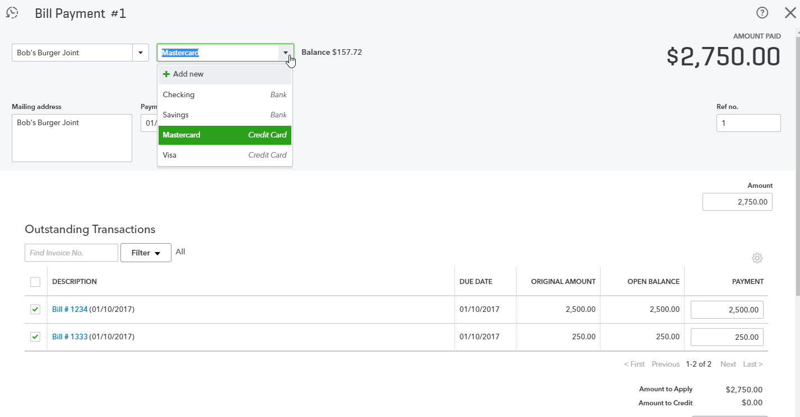
- At the bottom of the screen click Save and close.
As with the Customer Center, you can drill down on the vendor name and get a list of transactions on which you can take action, or create new transactions from the drop-down list on the right.
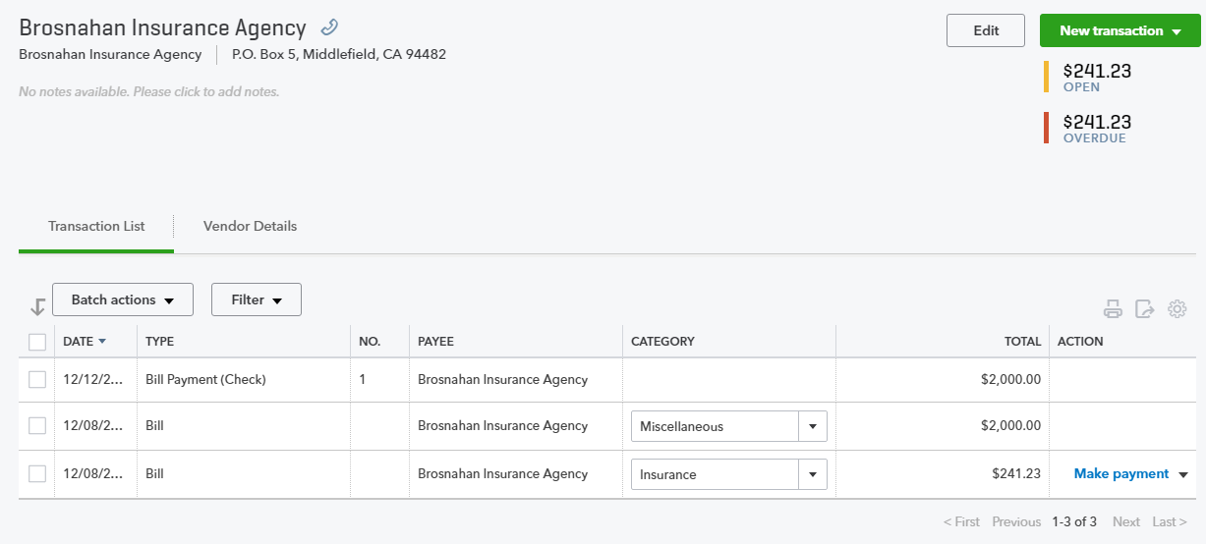

Enter Transactions Expenses
If you click Expenses under Transactions in the left-hand navigation bar, QuickBooks opens a list of the last 365 days of Expense Transactions. This screen can be filtered to modify the view. You can drill down on any transaction. You can also enter a new transaction or print checks.
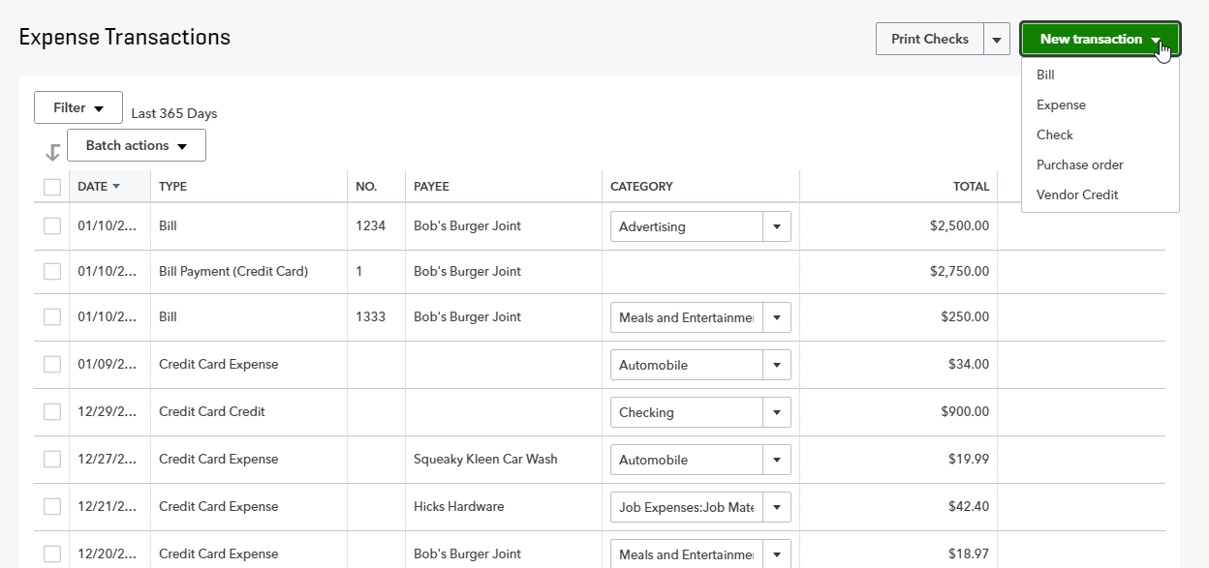
- Step by Step: Enter an Expense Type of Transaction
- From the New Transaction drop-down menu choose Expense. To recap what was said earlier, an expense type of transaction allows you to either reduce your bank account (including cash) or increase your credit card payable for a purchase made for the company. An expense transaction is a good transaction type to use when inputting a backlog of receipts that have been collected but not sorted by payment type. With the expense transaction, there is no need to sort the receipts first by credit card, check, other bank account or cash. Rather than having to sort through them and put them into piles by payment type, you can enter it on this one Expense screen by specifying the account (bank account, petty cash or a particular credit card) at the top.

- Enter an expense for the vendor Books by Bessie. It was paid with a MasterCard and was for Dues & Subscriptions for $10.
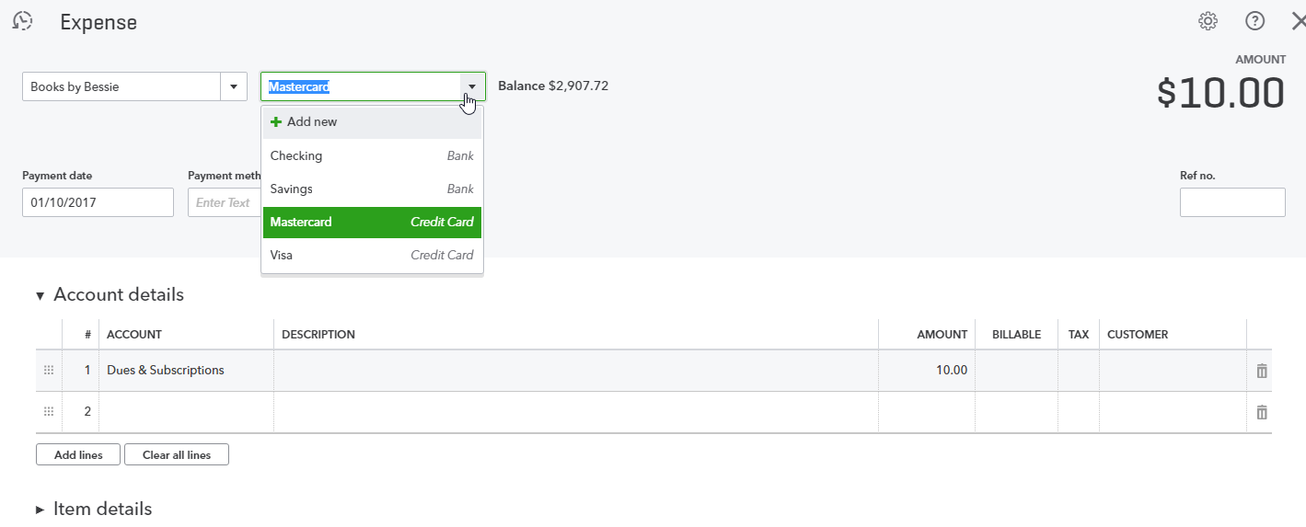
- At the bottom of your screen click Save and new.
- Enter a transaction for Computers by Jenni. It was paid out of Checking with manual check #32. It was for Commissions and Fees for $100. Save and close.
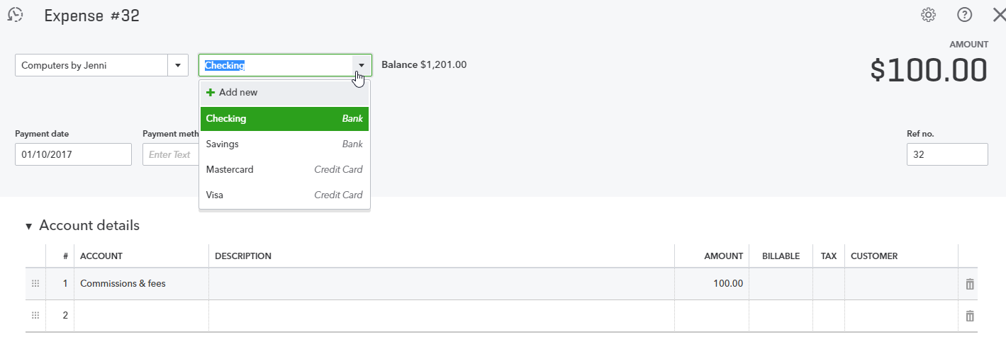

On the Expense Transactions page, both expenses show up but one affected the bank account (Checking) and the other a credit card account (MasterCard). If you are entering all checks, use the Check feature rather than the Expense transaction.
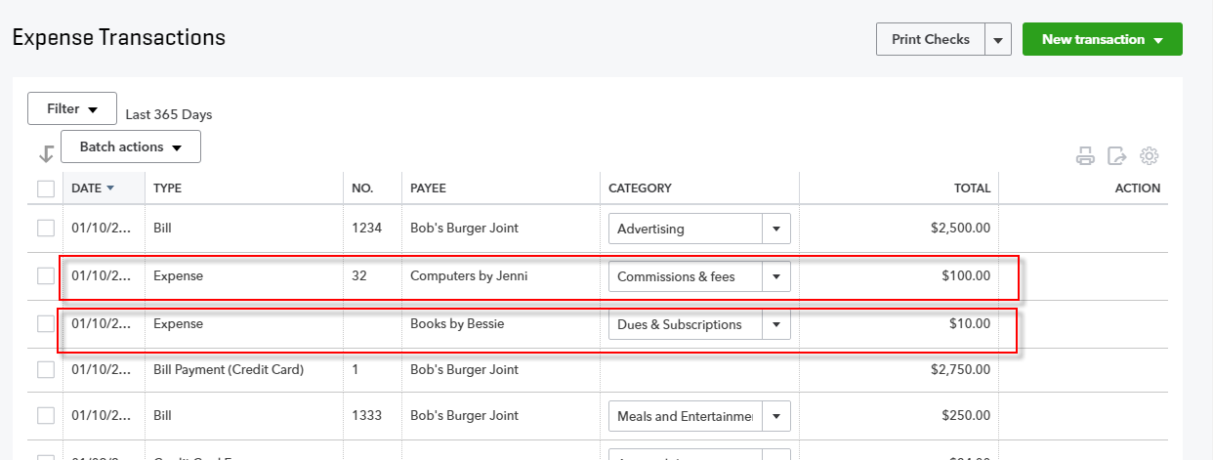

Enter Transactions from Quick Create
Previously you learned how to pay one or more bills from the Vendor Center. (You could pay only one bill at a time by clicking on the vendor name and choosing Make Payment next to one bill, or you could find the total outstanding in the Vendor Center’s list of vendors and select Make Payment under the Action column to pay one or more bills for that one vendor. If you want to pay multiple bills for multiple vendors at one time, you need to access Pay Bills from Quick Create.
- Step by Step: Pay Multiple Bills
- Under Quick Create select Pay Bills.
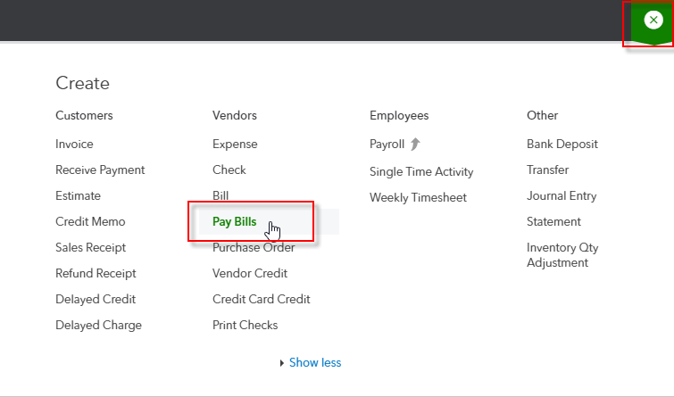

- Select Checking as the Payment account.
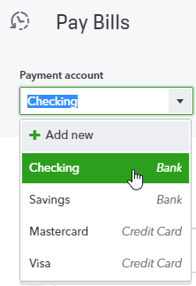

- Select which bills to pay, enter the Payment date and (instead of specifying a starting check no. for manual checks) check the box next to Print Later. If you are going to pay less than the open balance on a bill, enter that amount in the Payment column. Note that by clicking on the column headers (as in the Customer Center and Vendor Center), you can sort how you want to see the bills listed. Click Save and print.
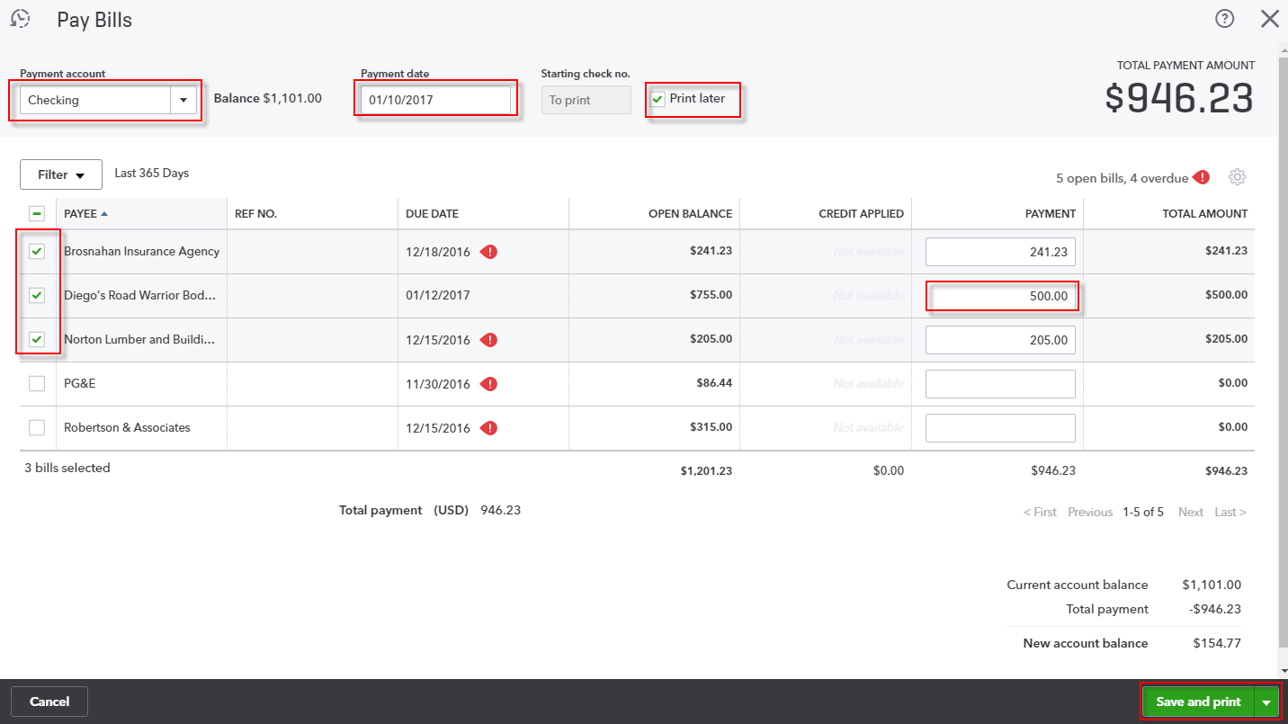
When you click Save and print, QuickBooks will give you a list of bills paid as well as print the bill payment checks. Because you chose the payment method of Printed Check but didn’t print them now, they can be batch printed, which you’ll learn about shortly.

- Step by Step: Create a Check (write a check to pay a bill)
- Click on Quick Create then, under Vendors, select Check.
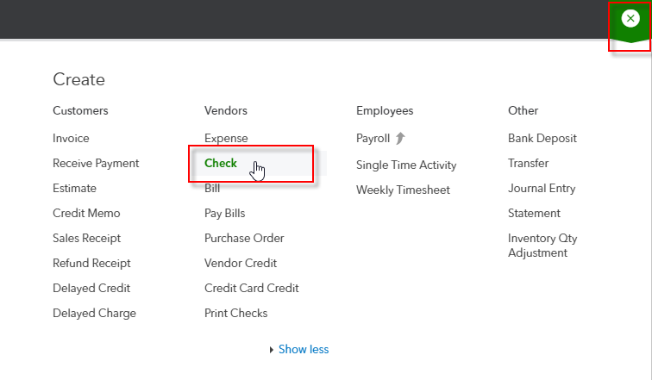

- Enter the vendor Diego’s Road Warrior Bodyshop. If you enter a vendor name and there is an outstanding bill related to that vendor, a drawer opens on the right-hand side of the page which allows you to add the bill to the check. The accounting effect is to decrease the bank account balance and decrease accounts payable. This feature will help prevent you from making the mistake of writing a check for a bill already entered and posting it to an expense account, thereby double-counting the expense and never clearing the payables.
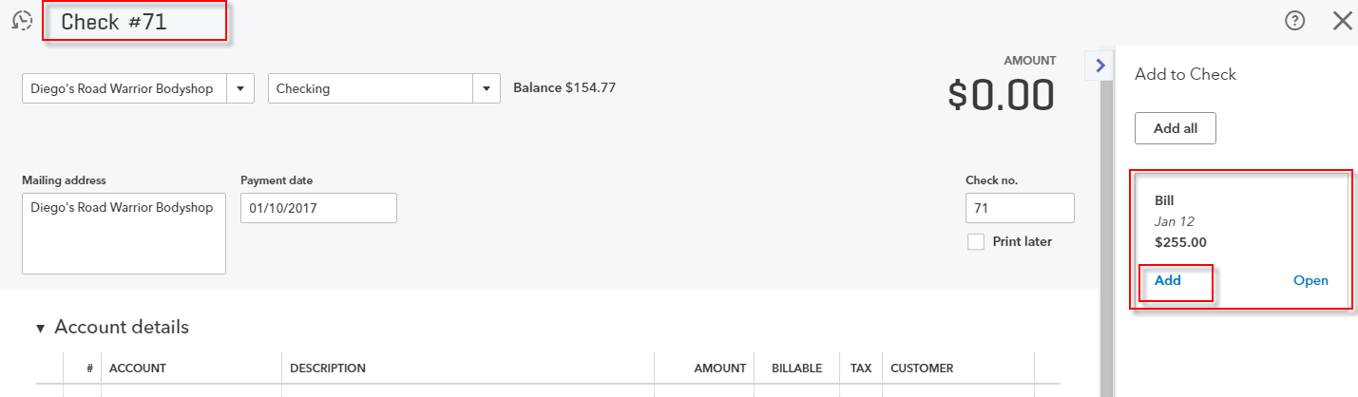
- Click Add to add the bill to the check. This changes the transaction type from Check to Bill Payment. (Note that Check #71 changed to Bill Payment #71 in the top left corner of the transaction.) Click Save and close.
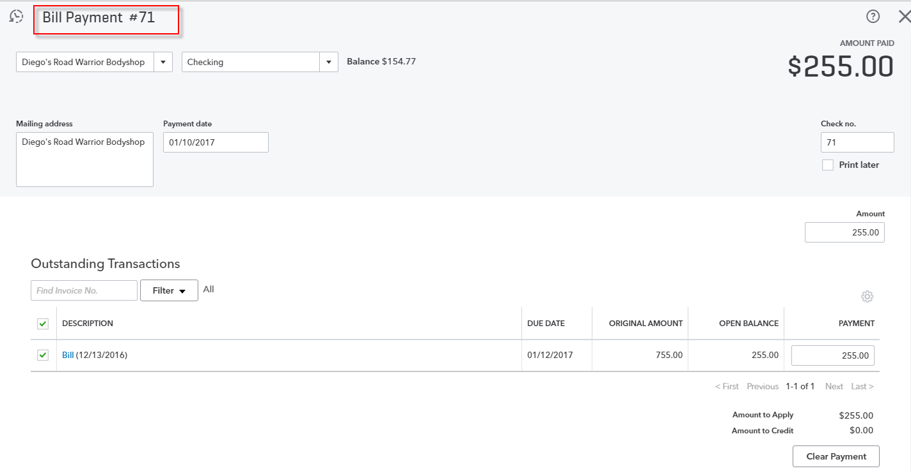
If this check wasn’t to pay an outstanding bill, don’t add anything from the drawer, even if there is a bill there, and enter the account or item details in the body of the check.
- Step by Step: Print Checks in Batch
- Click Quick Create then, under Vendors, select Print Checks.
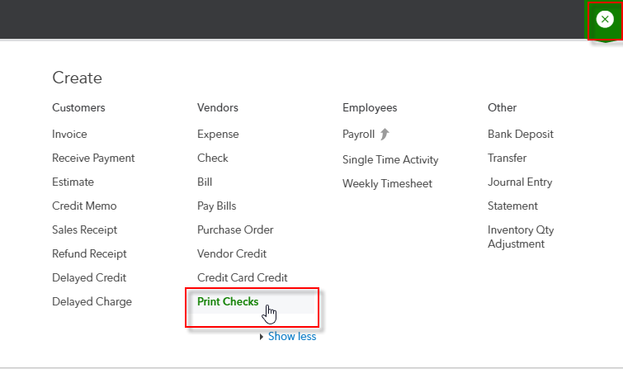
- The first time you click Print Checks, you must make sure your checks align correctly. Once you have done that, all checks marked to be printed later appear.
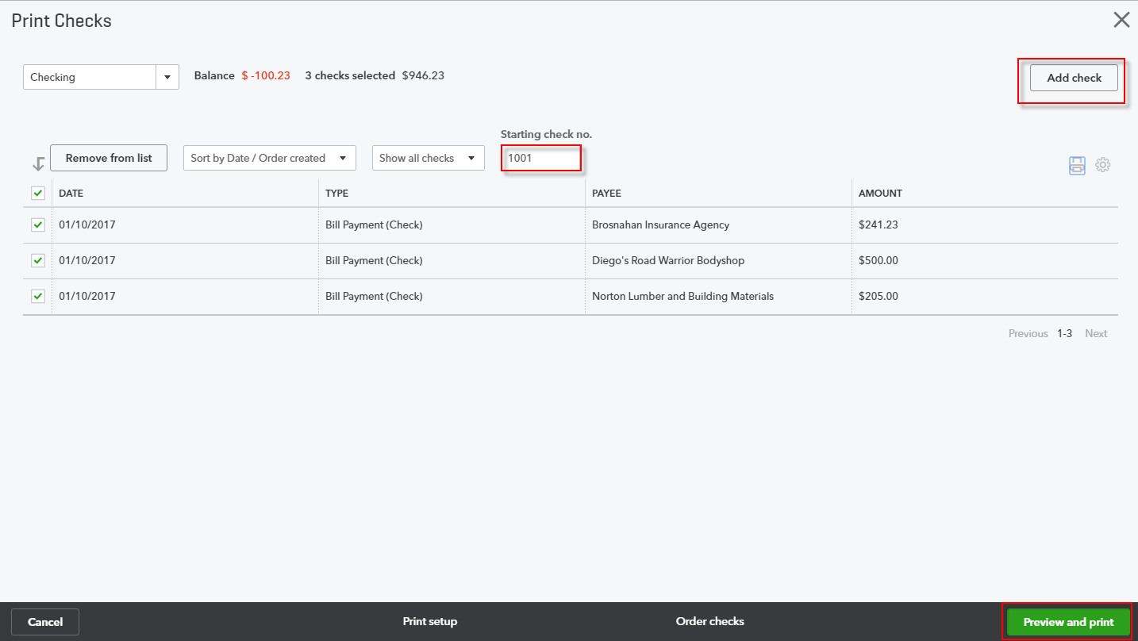
- You can create a new check and add it to this Print Checks screen by clicking Add check in the top right corner. (You can also return to the Print setup screen for proper alignment with your printer by clicking Print setup at the bottom.)
- Place a checkmark in the box next to each check you wish to print then select Preview and Print. Before you do that, you need to make sure the starting check number is correct.

Transactions Banking
The Banking Center allows you to link your bank and credit card accounts to QuickBooks. Once that is done, QuickBooks automatically downloads transactions nightly, though you can download manually by clicking on Update in the upper right-hand corner.
- Step by Step: Use the Banking Center
- Under Transactions in the left-hand navigation bar, click Banking.
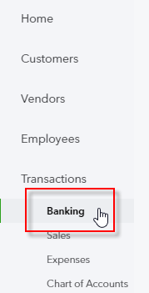

- At the top of the screen, the linked bank and credit card accounts are displayed, as well as the number of transactions that have been downloaded and need to be either entered or matched. Although QuickBooks automatically downloads transactions nightly, you can click Update to import the latest transactions
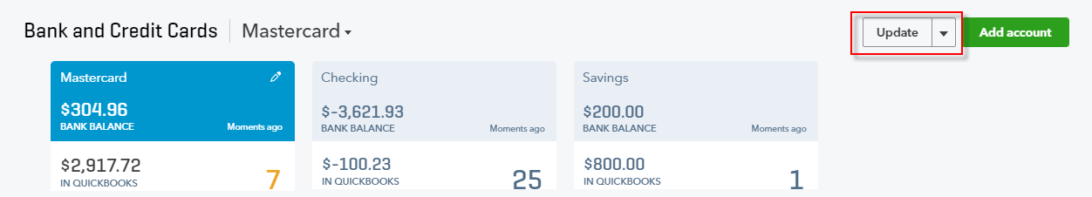
If your bank account does not connect to QuickBooks, the drop-down under Update allows you to import CSV, QFX, QuickBooks Online or OFX formatted files. You can also add accounts by clicking Add account next to Update.
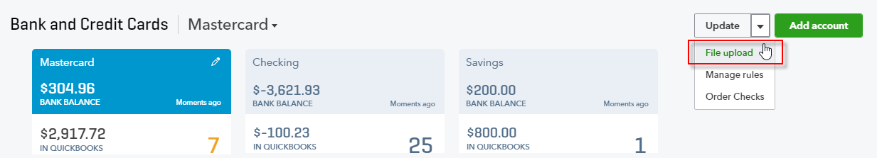
Another option on the Update drop-down menu allows you to create and manage rules. You’ll do that after you understand the different parts of the Banking Center.
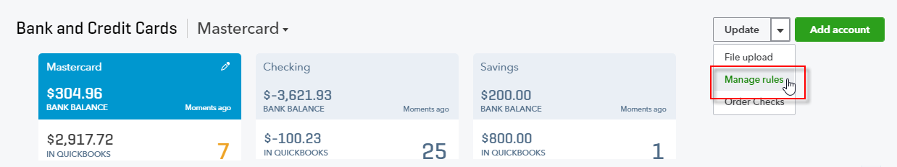
- At the top of the screen, click on MasterCard to ensure you are reviewing that account.
- Further down the page for Banking, there are three tabs: For Review, In QuickBooks and Excluded.
- For Review – These are the newly downloaded transactions. They are the ones upon which you need to take action.
- In QuickBooks – These are transactions that have been matched or added from the New Transactions tab. Although there are none in the sample file, once you start using the Banking Center in a live file, you will see many transactions listed there.
- Excluded – These are downloaded transactions you have decided not to enter into QuickBooks. Typically it is because they’ve already been entered and reconciled. Already reconciled transactions will not show up as a match. This typically occurs when you first use the Banking Center.
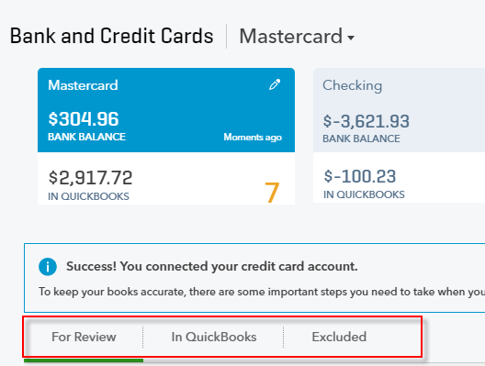
- A list of downloaded transactions shows up on the next part of the page. The default is to show all downloaded transactions, but you may see a tab for Recognized transactions. These are transactions that are either matched from the bank download to entries already in QuickBooks, or QuickBooks has guessed how you want to enter based on past transactions and rules. You might want to take care of those first, just to clean up the list.
- Notice to the far right there is a printer icon and a gear icon. You can print the list of transactions.
- Click the gear icon. You can set preferences as to which columns you want to see and how many rows you want to see in the Banking Center. You can also elect to see a compact display.
- If it’s not selected already, check Copy bank detail to memo.
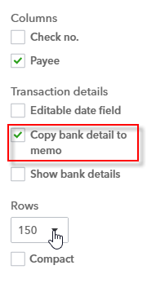
This feature tells QuickBooks to copy the bank’s transaction description to the Memo field automatically. The Memo field can show up on reports. It’s also useful for troubleshooting entries. You can edit the memo before adding to QuickBooks.
The transactions can be sorted by any column parameter by clicking on the column header (clicking on it twice sorts it in reverse order). As you scroll down, notice in the Category or Match column that QuickBooks has already matched several transactions.
- Click the column header Category or Match.
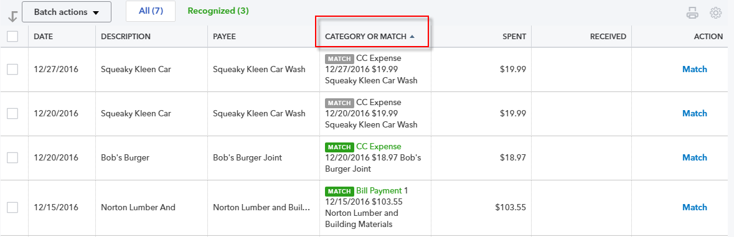
QuickBooks automatically looks for a match. The match could be against a check, bill payment, deposit, payment received from customer, etc. If upon a quick review you agree, you can match each one individually by clicking Match under the Action column. Alternately, if you want to enter several transactions at one time, select the first transaction you want to enter, hold your shift key down and click the last transaction you want to enter. Click the down arrow next to Batch actions then click Accept Selected. That matches the selected downloaded transactions against transactions that were already entered into QuickBooks.
- Click the selection box for Bob’s Burger Joint. Hold your Shift key down and click the selection box for Tania’s Nursery.
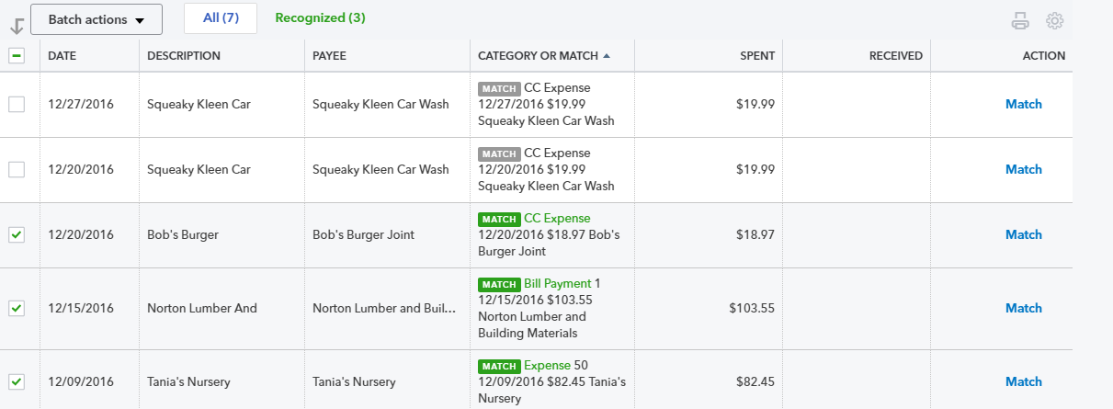
By holding down your Shift key, QuickBooks selects all the transactions between Bobs Burger Joint and Tania’s Nursery.
- Click the Batch Actions drop-down list then choose Accept Selected.
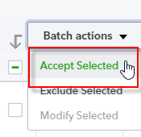

Those transactions move from the For Review tab to the In QuickBooks tab.
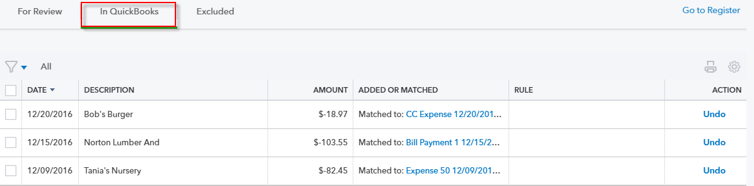
- At the top of the screen click on Checking to ensure you are now reviewing that account.
- Go to the For Review tab and click the column header twice for Description.
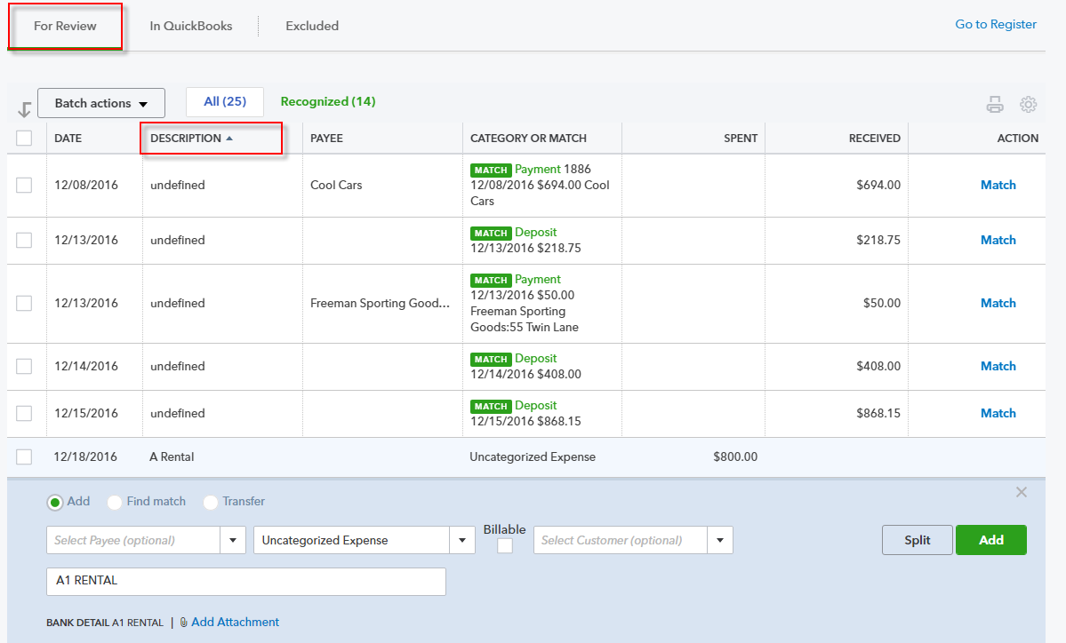
There are two expense transactions for A Rental (one for $1,200 and one for $800). QuickBooks does not know the vendor name or the account to use.
- Type A1 Rental in the Payee field. There is no name in QuickBooks for A1 Rental. Add it on the fly as a new vendor.
- Choose Equipment Rental as the posting account.
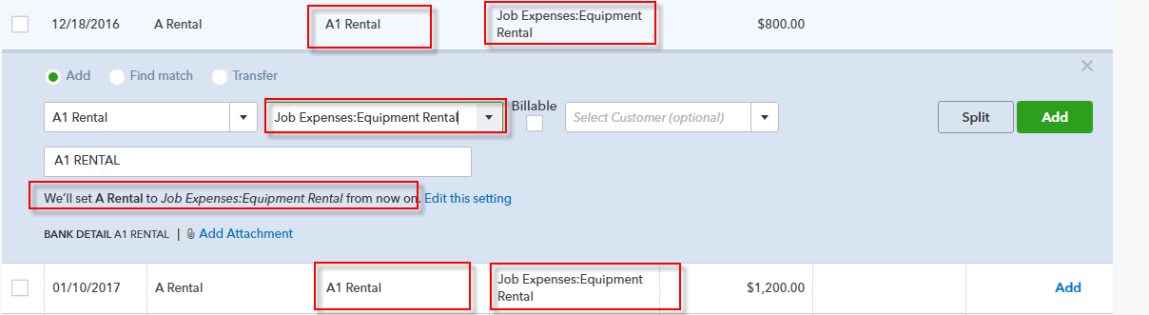
As soon as you do that, QuickBooks assumes you want the second transaction for A Rental to use the A1 Rental vendor and post to Equipment Rental.
You could click Add to add each transaction individually, or click the selection boxes and under Batch Actions and choose Accept Selected as you did earlier in this exercise.
If you need to split a transaction, you can do so by clicking Split.
- Locate Hicks Hardware, an uncategorized expense for $24.38. QuickBooks does not know where to post this transaction.
- Click the Update drop-down and choose Manage rules.
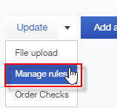
- Click New rule.
- Enter Hicks Hardware as the rule name and also enter it as the contents of the Description condition field.
- Select Hicks Hardware as the Payee and Supplies as the Category.
- If you like, add something like “**Entered by Rules**” in the Memo field.
- Check the box next to Automatically add to my books.
- Click Save.
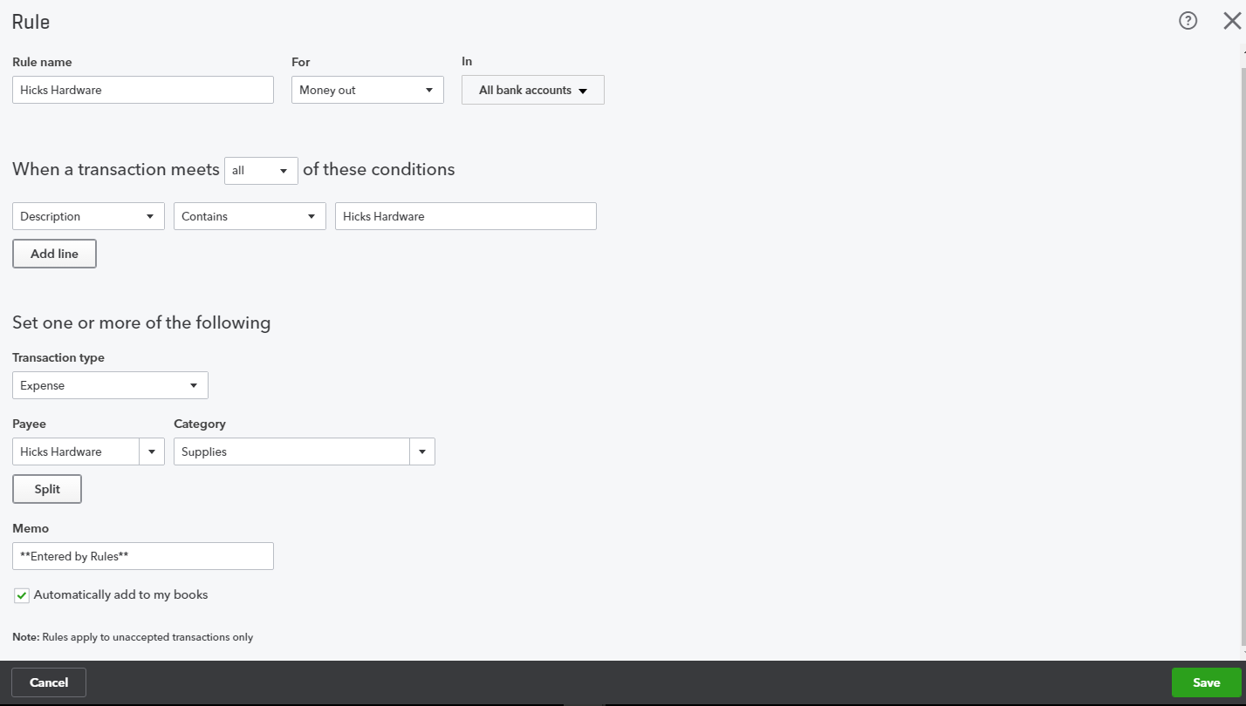
- Back in the Rules window, click Bank and Credit Cards.
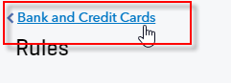

- Click the In QuickBooks tab. Hicks Hardware transactions now appear in this tab and indicate this posting was set by a rule. It also indicates, by the green plus sign inside a picture of a document, that the rule added these transactions to the books automatically without the need for further work by the user. (If we had not checked the box next to next to Automatically add to my books, you could see these transactions in the For Review tab, available to you to add one at a time or via Batch actions.)
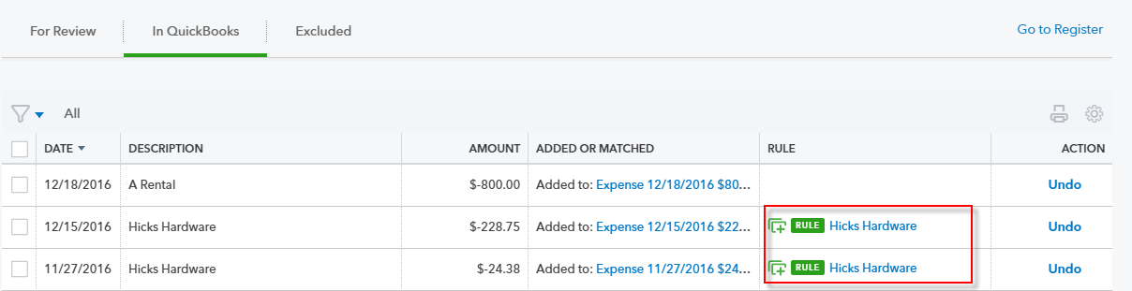
- If you click on each posting, you’ll see that Supplies was the posting account. You would also see **Entered by Rules** in the description of each added transaction.
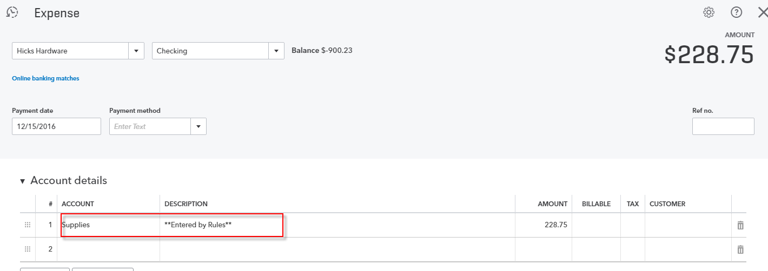
This rule was very simple. You can create some complex rules. For example, if Hicks Hardware is less than $500, post to Supplies. Then create a second rule that states if Hicks Hardware is greater than $500, post to Equipment.

You can also create rules for splits. For example, Cal Telephone transactions should be split 40% to Internet and 60% to Telephone.
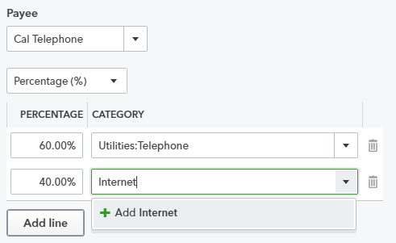
When you click a transaction in the Banking Center, there are three radio buttons: Add, Find Match and Transfer.
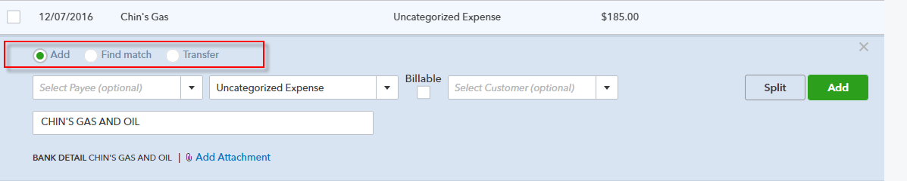
You’ve been working with Add. If you think there should be a match, change the radio button to Find match and QuickBooks Online will try and find matching transactions. If you can’t find it, perhaps that is because the transaction was already reconciled in QuickBooks Online. If that’s the case, and you don’t want to enter that transaction because it’s already in QuickBooks Online, check the box next to this transaction then, under the Batch Actions, click on Exclude Selected.
The Transfer button is used to indicate that this transaction is a transfer between two accounts in this QuickBooks company file.

Topic 3: Additional Transaction Types

Identify Additional Transactions Initiated Using the Quick Create Menu
There are other transaction types that can be accessed from the Quick Create function. An example of a transaction that can be accessed only from the Quick Create function is time tracking. Time can be tracked using the Single Time Activity or the Weekly Timesheet function. This feature can be used even if you are not signed up for QuickBooks Online Payroll.
- Step by Step: Fill out a Single Time Activity
- Select Quick Create (+) at the top of the QuickBooks Online window.
- If necessary, select Show More.
- Under Employees, select Single Time Activity.
- Enter the name of the employee or vendor whose time is being tracked.
- Enter the date for which the time is being tracked.
- Enter the customer for whom the time is being tracked.
- Enter the service being rendered during this time.
- If the Billable preference is turned on, check if the time is billable and the billing rate.
- Enter the time tracked as, for example, 3.5 hours, either in HH:MM format (3:30) or in decimal format (3.5). Or, check the box next to Enter Start & End Times then fill in the fields for Start Time and End Time.
- Enter a description of the work done.

- Select Save and close or (by clicking the drop-down box next to Save and Close) select Save and new.
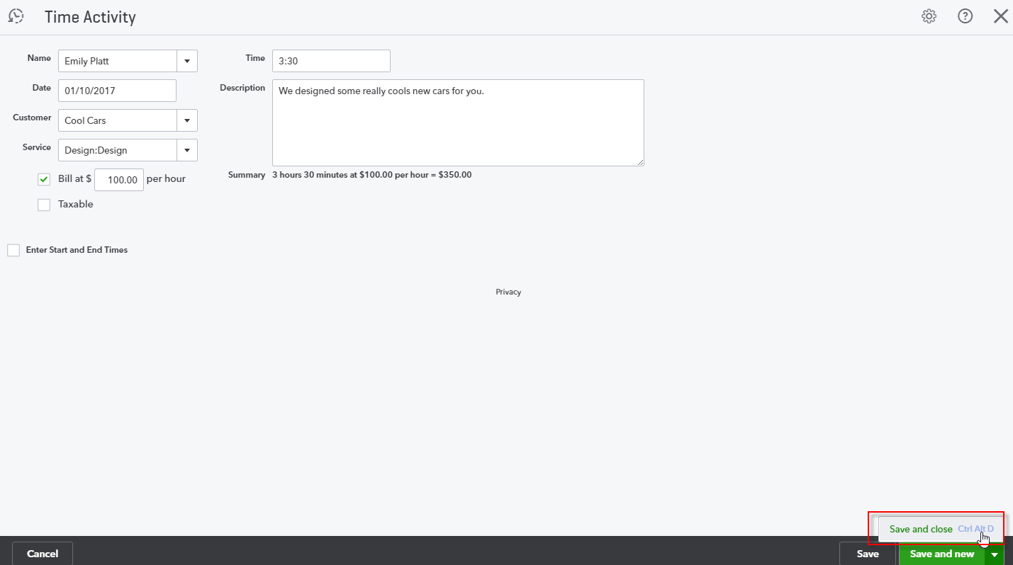

- Step by Step: Fill out a Weekly Timesheet
- Select Quick Create (+) at the top of the QuickBooks Online window.
- If necessary, select Show More.
- Under Employees, select Weekly Timesheet.
- Enter the name of the employee or vendor whose time is being tracked.
- Enter the work week for which the time is being tracked (the preferred first day of a work week for this company is determined in the Account and Settings for Time Tracking).
- In each row of the Weekly Timesheet grid, enter the customer for whom this individual’s time is being tracked, the service being rendered during this time, and the time tracked day by day during the week, either in HH:MM format (3:30) or decimal format (3.5). If necessary for invoicing purposes, enter the Bill @ rate and the Taxable status as well.
- Select Save and close or (by clicking the drop-down box next to Save and close) select Save and new.
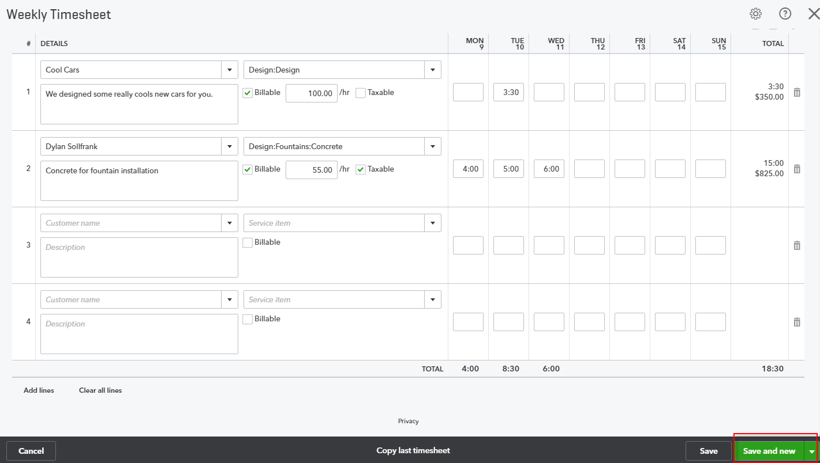

- Step by Step: Make a Bank Deposit
- Select Quick Create (+) at the top of the QuickBooks Online window.
- If necessary, select Show More.
- Under Other, choose Bank Deposit.
- Select which bank account you are using for the deposit.
- Fill in the deposit date.
- If there are any monies in Undeposited Funds, they will show up on the top part of the screen under Select Existing Payments.
- Select any of the existing payments if they are part of the deposit.
- In the Add New Deposits area, add any other payments received, which are typically not sales-related transactions such as shareholder loans or insurance premium rebates.
- If you are taking cash back from the deposit, click in the posting account, (i.e., Petty Cash or Owner’s Draw) and the amount of cash be taken.
- Click Save and close or Save and new.
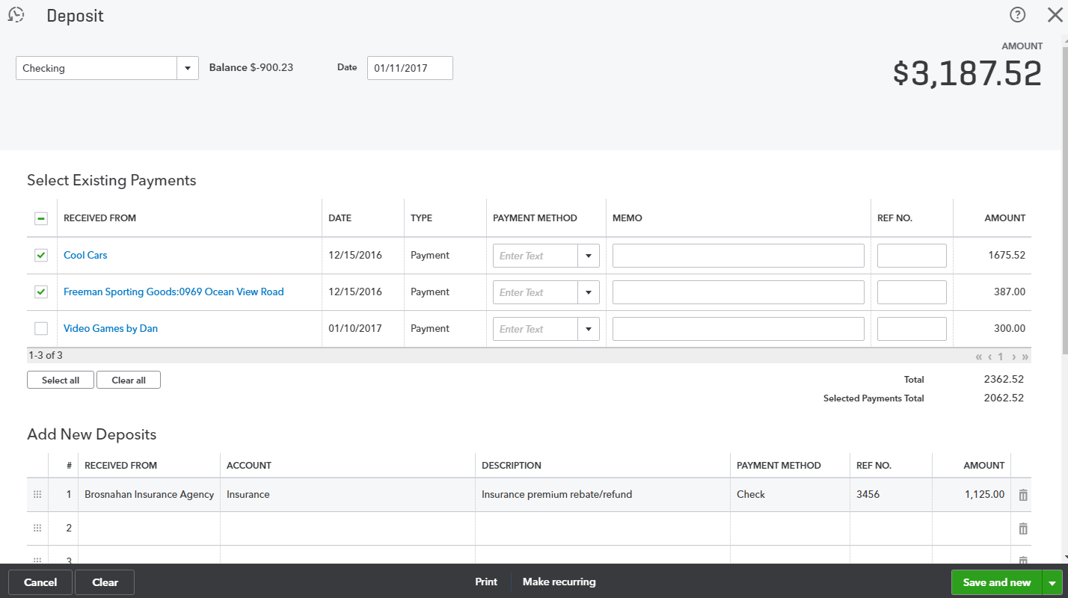
By clicking Print at the bottom of the deposit form, you can also print a deposit slip and summary using preprinted deposit slips. You can also print a summary only on plain paper. This area is also used for setting up and aligning these forms to be printed.
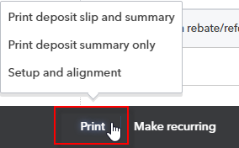

- Step by Step: Transfer Funds
Transfers are used to move monies between two company accounts. You could transfer funds from one bank account to another bank account or from a bank account to a company credit card account. You don’t use the Transfer feature to transfer from your bank account to your vendor’s bank account.
- Select Quick Create (+) at the top of the QuickBooks Online window.
- If necessary, select Show More.
- Under Other, choose Transfer.
- Select your source account in Transfer Funds From.
- Select your destination account in Transfer Funds To.
- Fill in the Amount of the transfer.
- Fill in the Date of the transfer.
- Enter a Memo if desired.
- Click Save and close or Save and new.
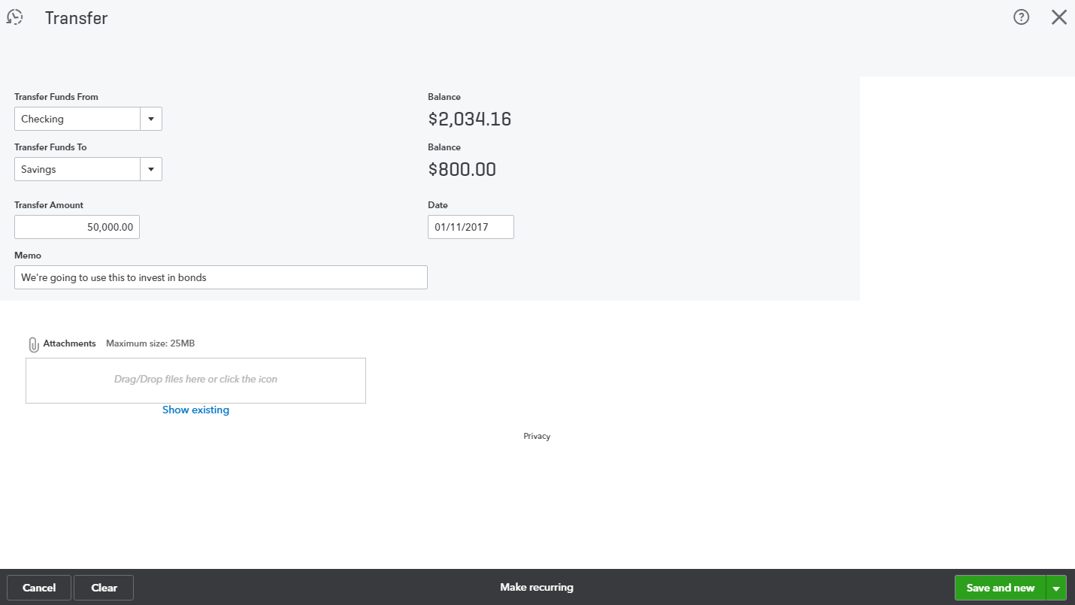
- Step by Step: Record a Journal Entry
- Select Create (+) at the top of the QuickBooks Online window.
- Under Other, choose Journal Entry.
- Enter a Date.
- Enter or accept the journal number.
- Select an account and enter a debit amount.
- Enter a description if required.
- Continue until you are done.
- On the next row select another account and enter a credit amount.
- Enter a description with the journal entry. Debits must equal credits.
- Select Save and new or (by clicking the drop-down box next to Save and New) select Save and close.
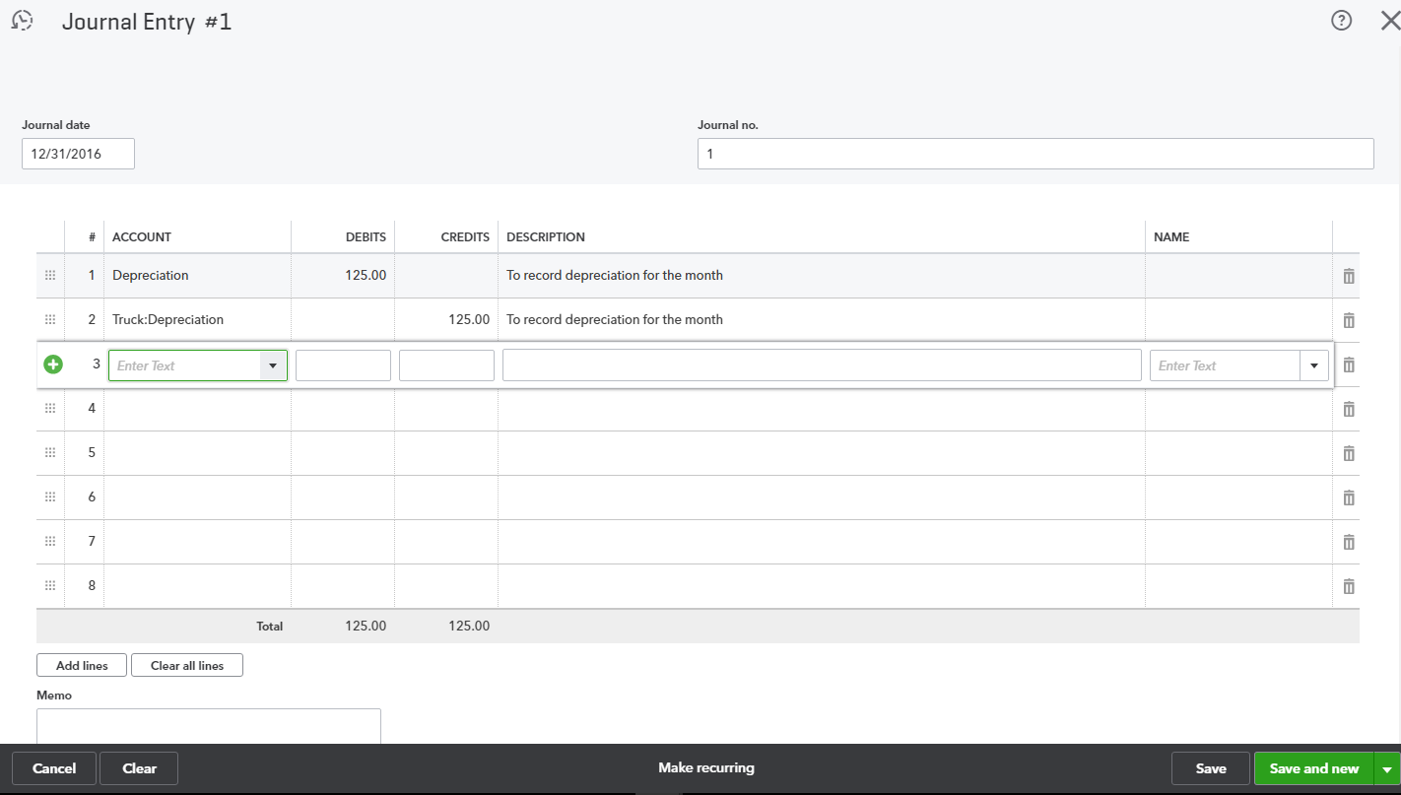
In QuickBooks Online you can include multiple accounts receivable and accounts payable lines in a journal entry. This works well, for example, if you want to trade a balance between a customer who is also a vendor.
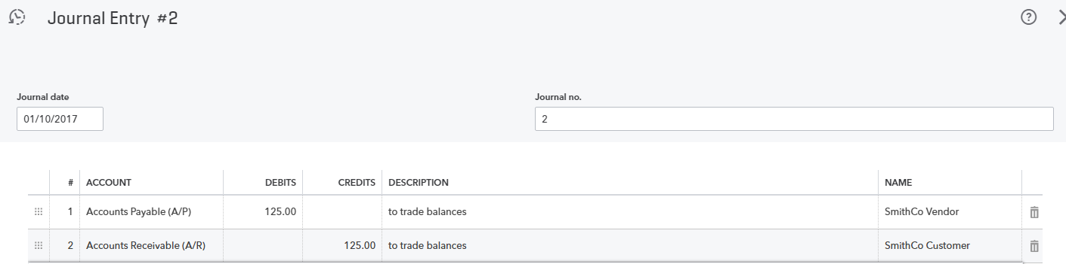

Topic 4: Other Tools
QuickBooks has tools that are especially helpful to maintain the accuracy of your QuickBooks Online data. In this part you will learn where to access those tools and specifically learn about two tools:
- Reconciliation history and Undo bank recs tool
- Set the closing date
- Step by Step: Bank Reconciliation History and Tools
- Click the gear icon and choose Reconcile from the Tools column.
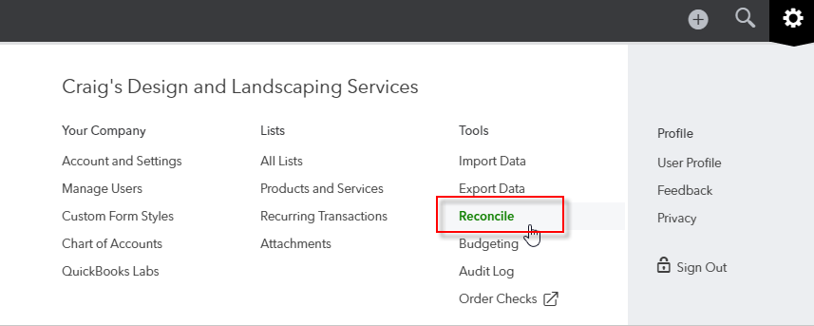
- There are no reconciliations in the sample file so click Reconcile Now.
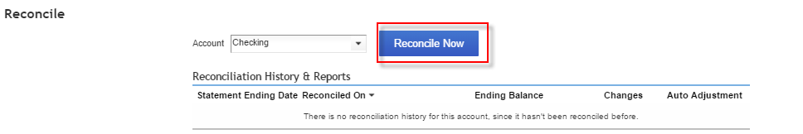
- Enter Statement Ending Date 12/31/2016 and Ending Balance $1,871.37 and click OK.
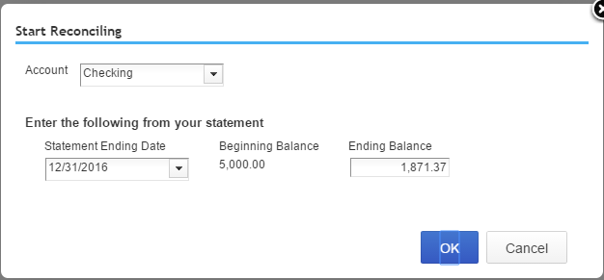
- Make sure there is a checkmark next to Hide transactions after the statement’s end date then mark all the Deposits and Other Credits on the right side, as well as the first 32 Checks and Payments on the left side as cleared. You can clear every transaction in a column by clicking a checkmark in the box at the top of that column rather than in each individual box. Therefore, clearing the first 32 would be best done by clearing all 35 then scrolling to the bottom to un-check the last three.
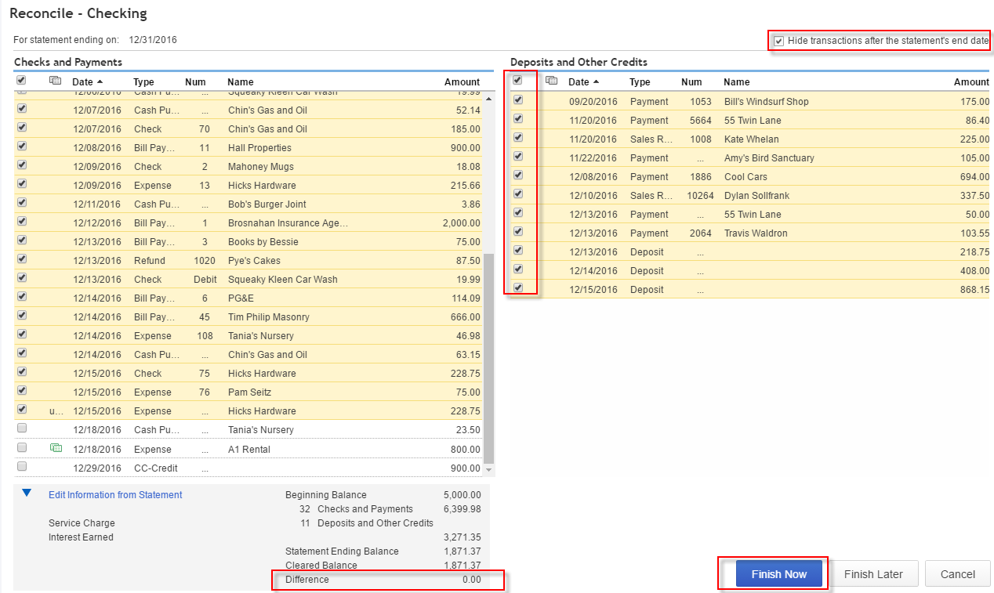
- When the difference between the Statement Ending Balance and the Cleared Balance is 0.00 (and only when it is zero), click Finish Now.
- Warning: if you click Finish Now with a non-zero difference, you will be creating an Auto Adjustment transaction for the difference to be posted to the Reconciliation Discrepancies account, and you will require your accountant user (who has access to QuickBooks Online Accountant and its exclusive tools) to fix your problem. This may entail undoing one or more reconciliations, which can only be done with access to QuickBooks Online Accountant. If you cannot finish reconciling to the point where you have a zero difference, click Finish Later and come back to your reconciliation when you are fresher.
- Warning: if you reconcile an account then change an amount on a cleared transaction (something you should never do), that will also require someone with QuickBooks Online Accountant access to fix the problem.
- Step by Step: Set the Closing Date
There is no formal closing in QuickBooks. It’s a perpetually running system.
QuickBooks knows, by what month you set as the first month in your fiscal year in the Account and Settings, when to roll up last year’s income into Retained Earnings for reporting purposes. However, when you have completed your review of the accounting records or sent the information off to the accountant to complete the tax returns, you should protect any prior period data from changing.
You do this by setting the closing date.
- Click the gear icon then click on Account and Settings.
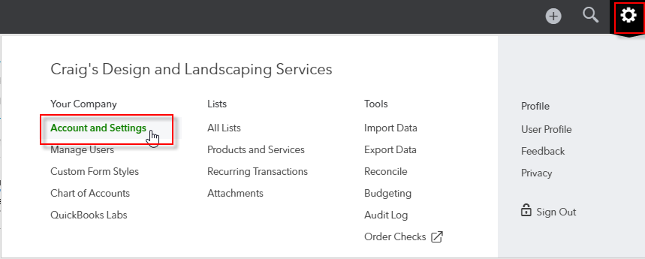
- Click on the Advanced tab. Click the pencil in the Accounting settings or click Close the books.
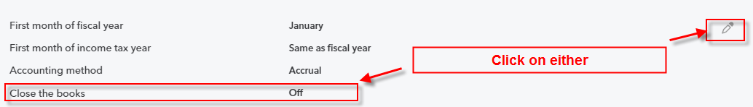
- Put a checkmark next to Close the books and set a Closing date of 12/31/16. On the drop-down list, choose Allow changes after viewing a warning and entering a password.
- Enter a closing date password, confirm it and select Save.
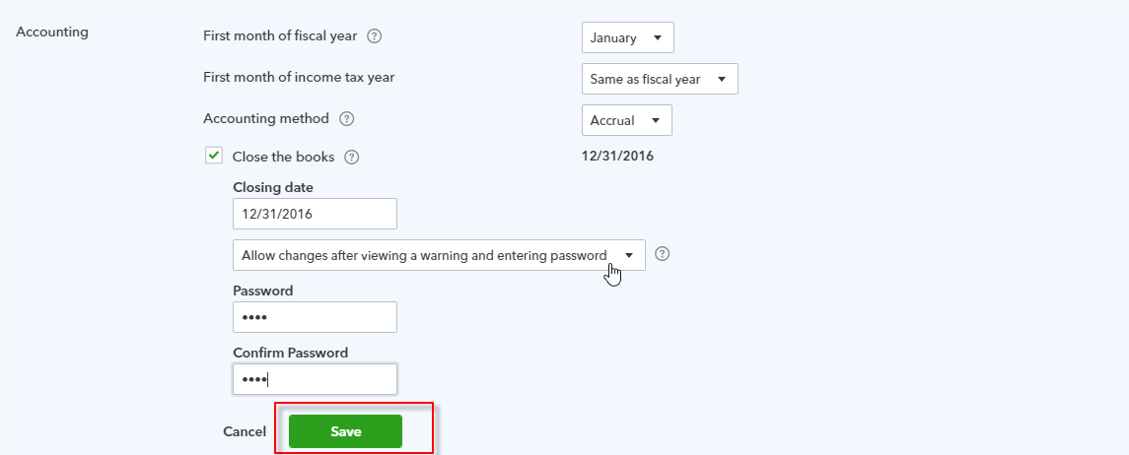
It is a best practice to protect the information by setting a closing date password. When setting up users in QuickBooks Online, there is no place in the user permissions to restrict users from changing transactions before the closing date. If someone does change a transaction before the closing date, you can use the Audit Log to try and find what was changed.

Course Conclusion
You have just covered Course 3 – Recording Transactions in QuickBooks Online. This course has been developed to help you train your clients on how to use QuickBooks Online successfully.
By completing this module, your client should understand:
- Sales & Revenue Transactions
- Expense & Purchase Transactions
- Additional Transaction Types
- Other Tools

