QuickBooks Online Client Training
Course 2
Navigating QuickBooks Online

Copyright
Copyright 2017 Intuit, Inc. Intuit, Inc.
All rights reserved. 5601 Headquarters Drive
Plano, TX 75024

Trademarks
©2017 Intuit, Inc. All rights reserved. Intuit, the Intuit logo, Intuit ProLine, Lacerte, ProAdvisor, ProSeries and QuickBooks, among others, are trademarks or registered trademarks of Intuit, Inc. in the United States and other countries. Other parties’ marks are the property of their respective owners.

Notice to Readers
The publications distributed by Intuit, Inc. are intended to assist accounting professionals in their practices by providing current and accurate information. However, no assurance is given that the information is comprehensive in its coverage or that it is suitable in dealing with a client’s particular situation. Accordingly, the information provided should not be relied upon as a substitute for independent research. Intuit, Inc. does not render any accounting, legal or other professional advice, nor does it have any responsibility for updating or revising any information presented herein. Intuit, Inc. cannot warrant that the material contained herein will continue to be accurate nor that it is completely free of errors when published. Readers should verify statements before relying on them.

Table of Contents
About the Author 2
Training at a Glance 3
QuickBooks Online Test Drive 3
Topic 1: Best Practices 4
Identify Best Practices when Using QuickBooks Online 4
Topic 2: Navigating 7
Company Home Page 7
Customer Center 12
Vendor Center 14
Transactions Tab 16
Quick Create 21
Course Conclusion 22

About the Author
Esther Friedberg Karp, MBA
Advanced Certified QuickBooks ProAdvisor
President, EFK CompuBooks Inc.
Esther Friedberg Karp is an internationally-renowned trainer, writer, business consultant and speaker who was named one of the Top 10 QuickBooks ProAdvisors in the world, with the title Top International ProAdvisor.
Based in Toronto, Canada, Esther has the unique distinction of holding ProAdvisor certifications in the United States, Canada and the United Kingdom. She is advanced certified in both QuickBooks Desktop and QuickBooks Online. Esther has authored materials and delivered educational and certification courses for Intuit in all those countries, as well as Australia where she conducted live QuickBooks Online training. She has spoken at Scaling New Heights, QuickBooks Connect and other conferences, as well as those of various accounting and professional organizations and written countless articles for Intuit Global.
Esther counts among her clients companies from around the world, as well as accounting professionals who seek her out on behalf of their own clients for her expertise in various countries’ editions of QuickBooks Desktop and Online, and for her talent in customizing QuickBooks usage for different industries.
Esther holds a BSc from the University of Toronto in Actuarial Science and Mathematics, and an MBA in Marketing in Finance from York University’s Schulich School of Business.
She can be reached at esther@e-compubooks.com or 416-410-0750.

Training at a Glance
Use this as a guide to selecting specific activities you want to cover.

Topic | Content
BEST PRACTICES | - Browser Functionality  - Keyboard Shortcuts
NAVIGATING | - Client Home  - Left Hand Navigation Tabs  - Quick Create

QuickBooks Online Test Drive
Exercises contained inside this handbook can be completed using a QuickBooks Online “test drive” file. The test drive uses a sample company file called Craig’s Design & Landscaping Services. It can be accessed through the following link:
Craig's Design & Landscaping
You don’t have to create an account or sign in to access the test drive file; just complete the security validation and click Continue.
This test drive is designed for you to explore and try out new things without worrying that you will break something or make a mistake. It is not designed to retain any changes you make. Once you close this QuickBooks Online test drive company, it is completely refreshed, so please remember to allow sufficient time to complete each activity. But don’t worry if you have to close the test drive before you are finished! You can always begin again.

Topic 1: Best Practices

Identify Best Practices when Using QuickBooks Online

Browser Tips
The tips below are based on Google’s Chrome browser, but many of them work in other browsers:
- Log in to your QuickBooks Online company (including the Test Drive company), right-click your browser tab, left-click Duplicate. Now you have two tabs logged in to the same QuickBooks Online Company.
- Pull one tab out of the window and you can work in QuickBooks Online on two different screens side-by-side. You can work on these two windows independently of each other. Repeat, as needed!
- Chrome allows you to create different Users (Customize Settings People). If you have two different QuickBooks Online companies, you can log in to each of them using a different Chrome User and operate each account simultaneously. (Or you can log in using two different browsers, such as Chrome and Firefox, or log in as an incognito user.)
- Log in as a separate Chrome user for your QuickBooks Online companies. Open up the screens that you use most often and bookmark them (click on ) to create a QuickBooks Online icon bar to be used with multiple QuickBooks companies.
- If a specific company has special screens that you use regularly, create a folder on the Chrome bookmark bar and bookmark those screens and save in the folder
- Right-click the back arrow on the browser to display a recent history of the screens you were on previously. Left-click the one you want to return to and resume working.
- If you are getting unexpected results when working in QuickBooks Online or are having problems logging in, make sure to clear your cache and cookies in Chrome (Customize History History Clear browsing data).
- CTRL+ and CTRL – allow you to zoom in and out quickly
Note: This browser functionality works best in a Chrome browser and is useful because many accounting professionals use two (and sometimes three) monitors. (Internet Explorer also allows the user to right-click on a tab and select Duplicate. Other browsers, namely Firefox and Safari, do not necessarily have the ability to select Duplicate by right-clicking a tab. However, it is possible to highlight the entire URL of the tab, right-click and select Copy, and then open a new tab in the same browser window, right click and select either Paste, or Paste & Go depending on the browser being used.) All the browsers mentioned do feature the ability to drag a tab off to open in another separate instance of a browser window.

QuickBooks Online Tips

Keyboard Shortcuts
You may be used to working with keyboard shortcuts when using desktop programs, whether QuickBooks Desktop, Word, Excel or other programs. There are also keyboard shortcuts when working in QuickBooks Online. Some common keyboard shortcuts can be found by clicking Ctrl + Alt + /. If you’re on a Mac, use Option + CTRL + /. Notice that the same shortcut key acts differently depending on the screen in which you find yourself.
For example, Ctrl + Alt + c opens up the Customer Center as long as you are not on a transaction. If you are on a transaction, it cancels the transaction. If you’re using a Mac, substitute Command + Alt + letter.
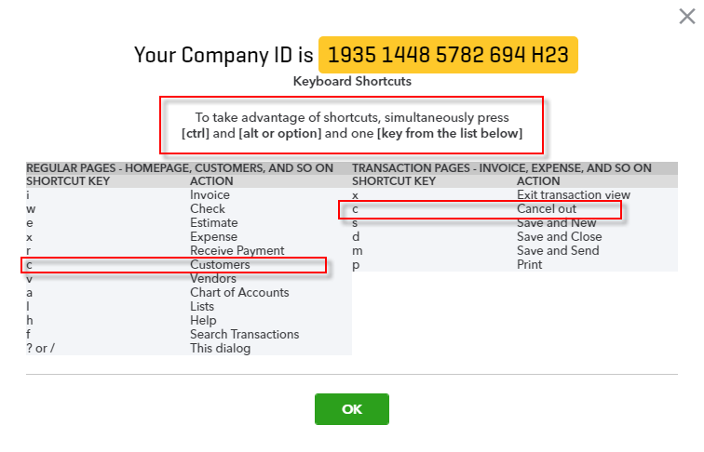
This screen also is one place where you can find your Company ID, which you might need if you have to call technical support.
Other keyboard shortcuts you may be interested in are the date shortcuts. When you are in a date field, you can move forward and back a day at a time by using your + and – keys. To go to today, use the letter t. Here are some other date shortcuts:
- w for first day of the week
- k for the last day of the week
- m for the first day of the month
- h for the last day of the month
- y for the first day of the year
- r for the last day of the year
Are you seeing a pattern? As long as you can spell those words, use the first letter to go to the beginning and the last letter of the word to go to the end of the time period related to the date that is currently displayed.
Also, the ESC key will cancel the current transaction being entered/edited.

Calculations
There’s a simple calculator available directly on the rate or amount fields of a transaction. Enter your first number and then use your keyboard to add (+), subtract (–), multiply (*) or divide (/). The beauty of this feature is the results are entered directly into the transaction by moving to the next field, either with your mouse or the Tab key; no retyping of numbers is necessary.
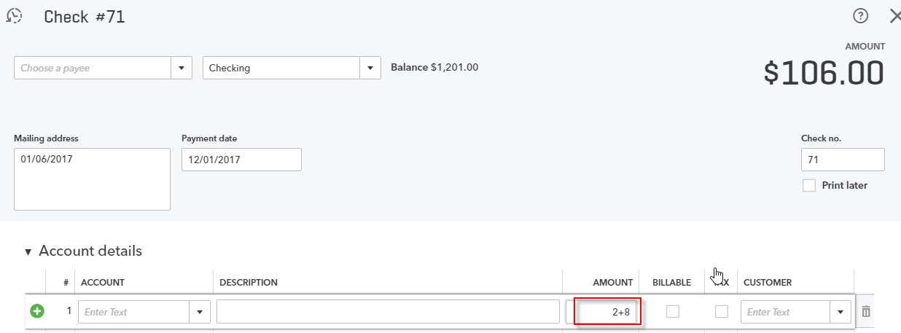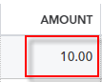

Topic 2: Navigating
In this topic, we discuss navigating around QuickBooks Online. It’s important to understand the interface and also to know the options of entering information so you can figure out the correct workflow for your business.

Company Home Page
When you log into QuickBooks Online, the Home page is the first screen that appears. The top of the screen shows the name of the QuickBooks Online company (helpful when you are running more than one company in QuickBooks Online). Xxx hide the welcome information??
You'll see Setup guide at the top of the Home page which can guide you through such steps as invoicing and getting set up by a pro. Clicking on Hide will collapse this guide so that you have more screen real estate available on this Home page.
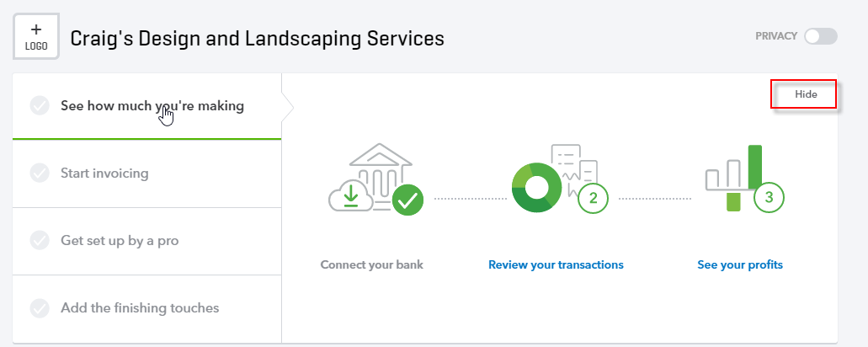
Once it’s collapsed, you can click on Show in the guide to expand it again.

Below the Setup guide, you’ll see a graph related to your Profit and Loss, as well as an Expenses graph giving you a breakdown of types of expenses. You can change the date range for these areas. As you hover over any of the sections of these graphics, you will get more information about that section and you can drill down to get either a detail report related to totals or to an actual transaction.
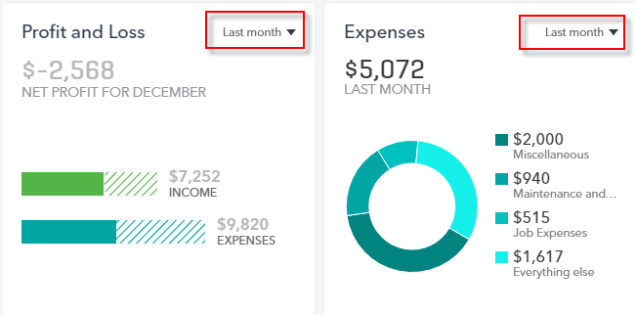
Notice further down that there is an Income bar on the Home page showing you open invoices and which of them are overdue, as well as what was paid in the last 30 days.
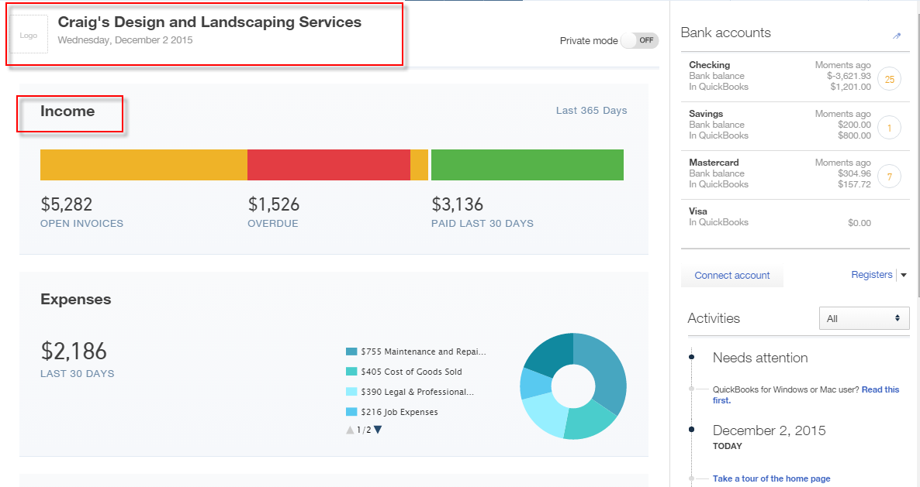
On the right hand side of the Home page, there is a listing of bank and credit card balances, and, if those accounts are connected with the banks, you get information as to current bank or credit card balance versus the QuickBooks Online balance for each account, how many transactions have been downloaded and have not been matched or entered into QuickBooks Online. There is also a direct link to connect a bank or credit card account to its QuickBooks Online counterpart, as well as a drop-down to take you directly to the register for the bank or credit card account of your choice.
This section of the Home page acts as a reminder to review the bank feeds on a timely basis. You’ll learn more about the Banking Center later in this training.
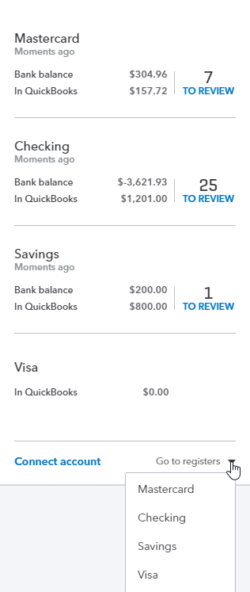
Lastly, you’ll find a Tips area which you can browse in a carousel-like fashion by clicking on the sideways arrows.
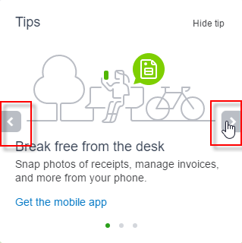
At the top of the screen is a switch called Privacy. When you turn on Privacy, QuickBooks basically hides all the financial numbers on the screen to protect this sensitive information from anyone walking by your computer. This is really helpful if you’re working in QuickBooks Online and you’re in a public place such as an airport or a coffee shop.
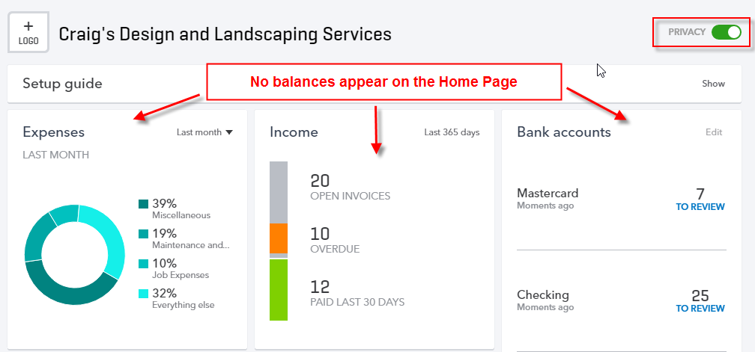
On the left hand side of any QuickBooks Online company is the Navigation bar. You will learn more about this as you go through this module.
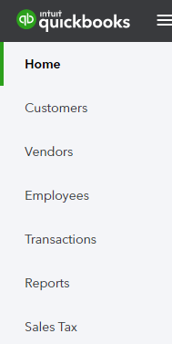
Because the Home page automatically opens when you open up QuickBooks Online, it directs the small business owner to review key metrics about their business. This is a good thing. Too often, small businesses enter transactions but don’t really look at their results until tax time. And that could be too late.

Customer Center
The Customers tab on the Navigation bar opens the Customer Center.
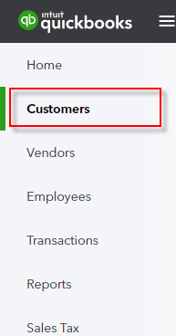
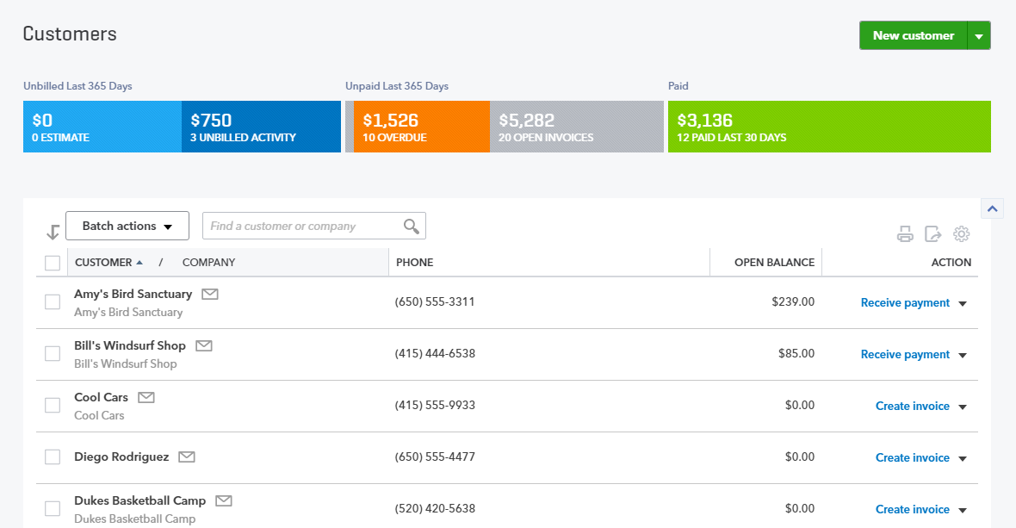
- The colorful Money bar at the top of this center is a visual representation of unbilled estimates and time & expenses, receivables (including overdue invoices), as well as invoices paid in the last 30 days. You can drill down on any color block of the Money bar to get to the underlying list, and ultimately, to transactions for reviewing, editing or deleting.
- The New Customer button in the top right corner creates a New Customer right in the Customer Center, as opposed to creating one on-the-fly in the Customer field of a transaction, which you can always do
- You can also click on the drop-down next to New Customer and choose to Import customers here
- The visible columns of the Customer Center can be set by selecting the Grid gear icon (in the top right corner of the customer list, above the Action column) to show the address and/or the email column, as well as how many rows of the Center to display on a page, and whether or not to include inactive Customers. This setting is “sticky,” which means that the next time you open the Customer Center, QuickBooks Online will remember your preference.
- Click on the customer name to view or edit the customer details (i.e. profile) information for this customer, see a listing of transactions or create new transactions
- Clicking on the envelope icon next to a customer name in the Customer Center launches your native email client to send them an email
- Above the Customer list, you can easily find a customer by typing part of the name in the search box
- You can sort the customer list (or a transaction list for a customer, if you’ve clicked on the customer name or a color block of the Money bar) forwards and backwards by several parameters, simply by clicking on the column header for that parameter, either once or twice, to specify forward or backwards
- Once in the transaction list for a customer (or if you’ve clicked on Open Invoices or Overdue Invoices in the Money bar), create invoices, receive payments, send a reminder or print a statement for an individual customer under the Actions column
- Clicking on a hyperlink for pending invoices takes you to those invoices
- You can perform batch actions related to statements and email for more than one customer by clicking on the appropriate customers in the Customer Center and choosing from the Batch Actions drop down menu

Vendor Center
The Vendors tab on the Navigation bar opens the Vendor Center.
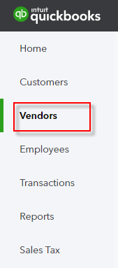
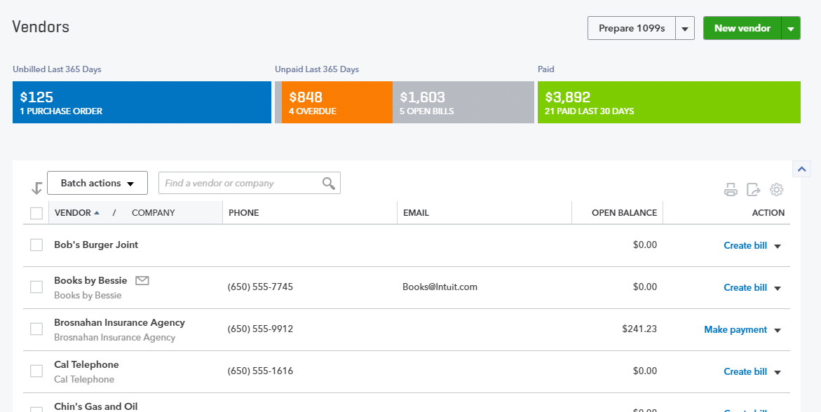

It is very similar to the Customer Center except it’s related to vendors, not customers.
- The colorful Money bar at the top of this center relates to potential expenses (open purchase orders), unpaid and overdue bills and what has been paid in the last 30 days
- If you click on any of these color blocks, QuickBooks will display the underlying list of transactions that pertain to that section for reviewing, editing or deleting
- Although you can always create a new vendor “on the fly” in transactions by simply typing a new vendor name in the Vendor field, the New Vendor button in the Vendor Center also allows you to create a new Vendor
- If you click on the drop-down next to New Vendor, you can import vendors here
- The Prepare 1099s button allows you to — you guessed it — prepare 1099s. Note that 1099s are available only in QuickBooks Online Plus. Also, note that Accounts Payable is available only in QuickBooks Online Essentials and Plus.
- Otherwise the editing columns, individual transactions, batch transactions, emailing and viewing the vendor in the Vendor Center work that same as what we just saw in the Customer Center

Transactions Tab
There are four ways to enter transactions in the Transactions tab of the left navigation bar: Banking, Sales or Expenses.
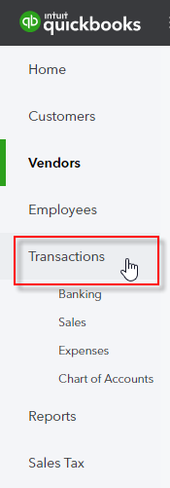
- Banking – This opens the Banking Center. If you have connected your bank and/or credit card accounts to QuickBooks, you’ll see those accounts listed across the top of the page and a listing of transactions that need to be either matched or added to QuickBooks. You will learn about that in Topic 4 of this training.

- Sales – This opens up the Sales Center where there is a Sales Money bar that shows potential revenue, unpaid/overdue invoices and what has been paid in the last 30 days
- As opposed to the Customer Center which shows a Customer list, the Sales Center shows a listing of transactions that can easily be filtered
- New transactions can be easily added from the top right corner of the screen by clicking on New transaction
- Next to the New transaction button, there is an Import Transactions button which allows you to import sales transactions from Square, if you have that set up
- The Action column shows suggested next steps as well as other choices related to that transaction in the drop-down menu
- As in the other centers, you can check multiple transactions and perform batch actions of printing or sending
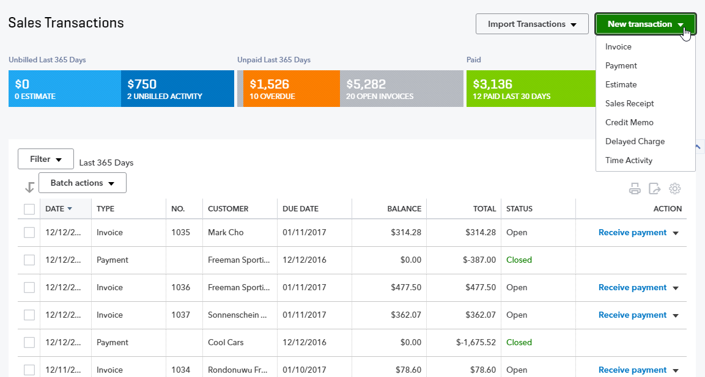

- Expenses – Here is a listing of recent expense transactions, which, like other centers, can be easily filtered
- Click on the transaction in the list to open that original transaction
- The types of transactions that can be entered from here are: bills, expenses, checks, purchase orders or vendor credits
- You can also print checks from this screen
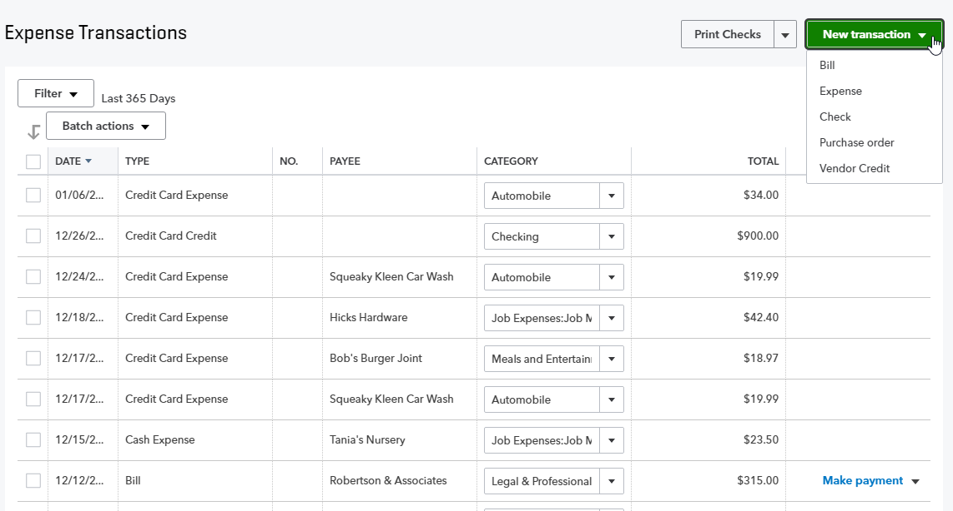

- Chart of Accounts – Here you see a listing of your general ledger accounts. You can double-click on the account or select View register to open the register for any Balance Sheet account (with the exception of Retained Earnings)
- If you click on the drop-down in the top left corner of a bank account register you’ve opened, you can add many types of transactions that affect a bank account:
- Check
- Deposit
- Sales Receipt
- Receive Payment
- Bill Payment
- Refund
- Expense
- Transfer
- Journal Entry
- The types of transactions that are available from the drop-down will vary depending on the type of balance sheet account being viewed in the register
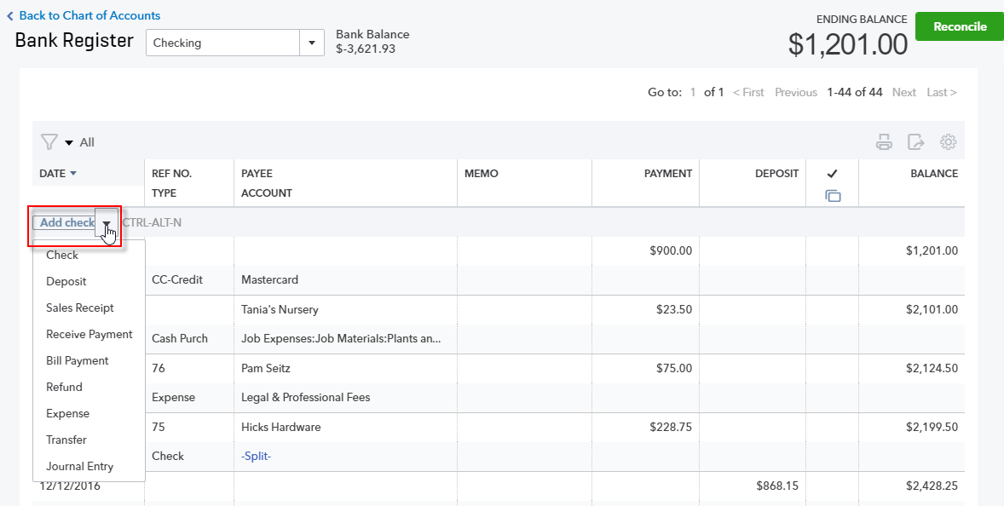

If you click on the drop-down next to View Register you can:
- Edit the account
- Delete the account (which actually makes it inactive)
- Run a report (an Account QuickReport)
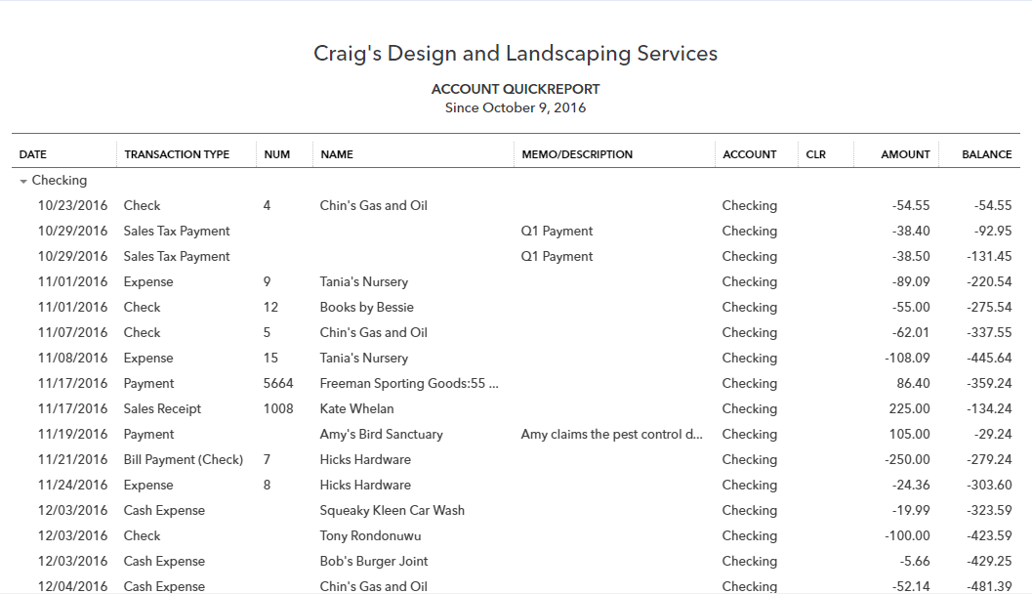
To summarize, the Navigation bar in general, and the Transactions tab specifically, are places to go to enter transactions.
However, there is one other place to launch all transactions and we are going to cover it next.

Quick Create
The Quick Create icon is at the top right of the QuickBooks Online page. It’s the + key that spins into an X when you click on it! This is your one-stop shop for creating new transactions.
There are two views of Quick Create. There’s a condensed view that just shows the common transactions of Invoice, Estimate, Expense and Check and a Show More view that lists all transactions in QuickBooks sorted by the different areas of the company: Customers, Vendors, Employees and Other.
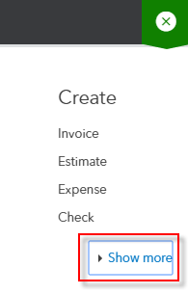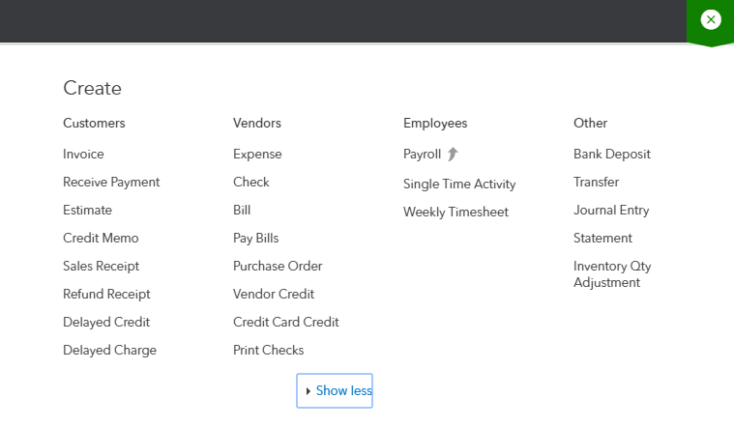

Course Conclusion
You have just covered Course 2 – Navigating QuickBooks Online. This Course has been developed to help you train your clients on how to use QuickBooks Online successfully.
By completing this module, your client should understand:
- Best practices in QuickBooks Online
- How to navigate around QuickBooks Online

