QUICKBOOKS ONLINE Client Training
Course 1
Getting Started

Copyright
Copyright 2017 Intuit, Inc. Intuit, Inc.
All rights reserved. 5601 Headquarters Drive
Plano, TX 75024

Trademarks
©2017 Intuit, Inc. All rights reserved. Intuit, the Intuit logo, Intuit ProLine, Lacerte, ProAdvisor, ProSeries and QuickBooks, among others, are trademarks or registered trademarks of Intuit, Inc. in the United States and other countries. Other parties’ marks are the property of their respective owners.

Notice to Readers
The publications distributed by Intuit, Inc. are intended to assist accounting professionals in their practices by providing current and accurate information. However, no assurance is given that the information is comprehensive in its coverage or that it is suitable in dealing with a client’s particular situation. Accordingly, the information provided should not be relied upon as a substitute for independent research. Intuit, Inc. does not render any accounting, legal or other professional advice, nor does it have any responsibility for updating or revising any information presented herein. Intuit, Inc. cannot warrant that the material contained herein will continue to be accurate nor that it is completely free of errors when published. Readers should verify statements before relying on them.

Table of Contents
About the Author 2
Training at a Glance 3
QuickBooks Online Test Drive 4
Topic 1: Product Overview 5
Know the Features of Your QuickBooks Online Subscription 6
Topic 2: Importing Data 8
Identify Steps to Import Data into QuickBooks Online 8
Topic 3: Setting Up Your Company 14
Recognize the Steps to Set up and Modify Lists and Users 14
Recognize the Steps to Manage Company Settings 18
Guide Conclusion 26

About the Author
Esther Friedberg Karp, MBA
President, EFK CompuBooks Inc.
Esther Friedberg Karp is an internationally-renowned trainer, writer, business consultant and speaker who was named one of the Top 10 QuickBooks ProAdvisors in the world, with the title Top International ProAdvisor.
Based in Toronto, Canada, Esther has the unique distinction of holding ProAdvisor certifications in the United States, Canada and the United Kingdom. She has authored materials and delivered educational and certification courses for Intuit in all those countries, as well as Australia where she conducted live QuickBooks Online training. She has spoken at Scaling New Heights, QuickBooks Connect and other conferences, as well as those of various accounting and professional organizations and written countless articles for Intuit Global.
Esther counts among her clients companies from around the world, as well as accounting professionals who seek her out on behalf of their own clients for her expertise in various countries’ editions of QuickBooks Desktop and Online, and for her talent in customizing QuickBooks usage for different industries.
Esther holds a BSc from the University of Toronto in Actuarial Science and Mathematics, and an MBA in Marketing in Finance from York University’s Schulich School of Business.
She can be reached at esther@e-compubooks.com or 416-410-0750.

Training at a Glance
Use this as a guide to selecting specific workflows to be covered.
Topics | Step by Step Workflows
product overview | - Benefits of using QuickBooks Online  - Know the features of your QuickBooks Online subscription
importing data | - Export QuickBooks Desktop data to QuickBooks Online  - Become familiar with importing lists into QuickBooks Online
setting up your company | - Explore how to add users to QuickBooks Online  - Explore the Products and Services list  - Print a transactions report for a selected account directly from the chart of accounts  - Print the chart of accounts  - Connect a bank account to the bank feed  - Become familiar with the Company tab in global Company Settings  - Enter contact information, Employer ID, and Tax form in Global Company Settings  - Specify terminology for Customers in Global Company Settings  - Become familiar with the Sales tab in global Company Settings  - Become familiar with how to turn on inventory global Company Settings  - Become familiar with the Expenses tab in global Company Settings  - Explore how to turn on Purchase Orders in global Company Settings  - Become familiar with the Advanced tab in global Company Settings  - Explore how to close the books in Global Company Settings  - Explore how to show account numbers in Global Company Settings  - Explore how to enable auto-recall on forms in Global Company Settings  - Change settings for automatic signing out after a period of inactivity

QuickBooks Online Test Drive
Exercises contained inside this handbook can be completed using a QuickBooks Online “test drive” file. The test drive uses a sample company file called Craig’s Design & Landscaping Services. It can be accessed through the following link:
Craig's Design & Landscaping
You don’t have to create an account or sign in to access the test drive file; just complete the security validation and click Continue.
This test drive is designed for you to explore and try out new things without worrying that you will break something or make a mistake. It is not designed to retain any changes you make. Once you close this QuickBooks Online test drive company, it is completely refreshed, so please remember to allow sufficient time to complete each task.

Topic 1: Product Overview
QuickBooks Online has many features and advantages that QuickBooks Desktop does not offer. Once you make the change to QuickBooks Online, it is important to understand the features available to you by being in the cloud and the feature availability based upon your subscription level. Let’s take a look at some advantages that QuickBooks Online has:
- Access to data easily across multiple platforms, PC or Mac
- Mobile access
- Access to data from multiple devices, browser or tablet. QuickBooks Online mobile access is included with QuickBooks Online subscriptions at no additional cost.
- No need to transfer data files since everyone logs in to the same account to access the same data
- QuickBooks Online developers are always releasing new functionality to QuickBooks Online. There is no need to install “new versions” of QuickBooks Online as you always get the latest and the greatest.
- All the data is hosted, backed up and secured by Intuit’s servers
- Automatically create invoices and send them to clients, including delayed customer charges for unbilled time and costs
- Tracks logins, third party activity and list changes in the Activity Log
- Reports can be emailed to anyone at a scheduled frequency, even if they do not have access to QuickBooks Online or this company file
- Further organize data with both Class and Location tracking. Nomenclature can be selected for location.
- Bank transactions are automatically downloaded nightly
- Invite unlimited report reader and time tracker users
- Sync third-party apps to QuickBooks Online without opening the QuickBooks Online company, since the apps sync to Intuit’s always-accessible server. No downloading and managing third-party sync engines.
- Post to multiple Accounts Receivable and Accounts Payable lines in a single journal entry
- Track Inventory using the first in first out (FIFO) method. The only desktop edition that offers FIFO is Enterprise with Advanced Inventory.
- The list of features will continue to grow as QuickBooks Online delivers functionality its users are requesting

Know the Features of Your QuickBooks Online Subscription
QuickBooks Online is a great solution for many different types of businesses. Every company must assess their needs to find a financial accounting solution appropriate for their business. Use the QuickBooks Online subscription matrix to determine the features of your QuickBooks Online subscription: http://quickbooks.intuit.com/online/compare. You can upgrade your QuickBooks Online anytime to accommodate changes in your business.

QuickBooks Online Simple Start
- QuickBooks Online account  - Automatic data backup  - Bank-level security and encryption  - One full-access user  - Invite up to two accountant users, no additional charge  - Unlimited invoices and estimates  - Charge sales tax to customers | - Print checks and record transactions  - Download bank & credit card transactions  - Import from QuickBooks Desktop  - Import/Export lists from Excel® (customers, vendors, chart of accounts)  - Add payroll to pay W-2 employees and file payroll taxes  - 20+ reports

QuickBooks Online Essentials
For QuickBooks Online Essentials, you have access to all of the Simple Start features as well as:
- Access for three users with permission controls  - Manage and pay bills, including scheduled payments for later  - Automatic invoice creation on recurring schedule | - Compare sales profitability with industry trends  - Delayed charges and credits  - 40+ reports

QuickBooks Online Plus
For QuickBooks Online Plus, you have access to all of the Simple Start and Essentials features
as well as:
- Access for five users with permission controls (up to 25 paid users total)  - Unlimited time-tracking-only users  - Unlimited reports-only users  - Track billable hours by customer  - Purchase Orders  - Class & location tracking | - Track Inventory using the first in first out (FIFO) method.  - Prepare & print 1099-Misc  - Budgets  - Two-sided items  - Estimates  - 65+ reports

Topic 2: Importing Data

Identify Steps to Import Data into QuickBooks Online
When you first sign in to your company, you will see an area called Learn your way around QuickBooks. Clicking on each one of these Guide icons produces a pop-up window with the first step to completing that task. When you’re done with these tips, you can click on the X in the top right corner of this area to collapse it and make more room available on the Home screen.
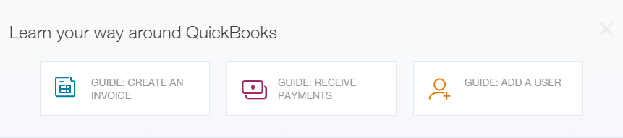
You can also click on the Help button in the top right corner to obtain access to in-product self-help resources such as overviews and videos, and how to find a local accountant and add one to your QuickBooks Online company.
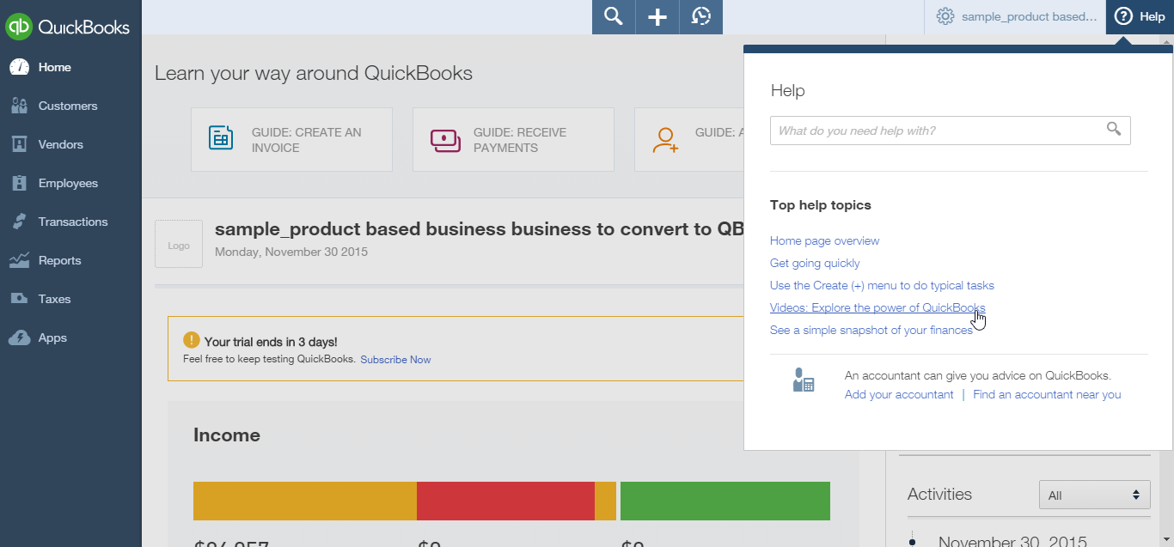
QuickBooks Online allows users to import data from QuickBooks Desktop within the first 60 days of creating the QuickBooks Online account. When this data is imported, it replaces any data in the QuickBooks Online account.
Most QuickBooks Desktop data can be imported, but there are some limitations. Because QuickBooks Online is being improved constantly, the import capabilities can change. Check the latest limitations by visiting The Survival Guide – Import to QuickBooks Online from QuickBooks Desktop. At the time of this publication these guidelines are in effect:
- You cannot import:
- Memorized transactions
- Sales form templates
- Data may be imported from QuickBooks Pro and Premier (2008 and later), Enterprise (2014 and later), and QuickBooks for Mac (2012 and later)
- Conversions from QuickBooks Windows version 2007 and prior, QuickBooks Enterprise 2013 and prior, and QuickBooks for Mac 2011 and prior require additional steps; visit The Survival Guide – Import to QuickBooks Online from QuickBooks Desktop for instructions.
- A QuickBooks Desktop file with the multicurrency preference turned on cannot be imported into QuickBooks Online’s US version at this time, although QuickBooks Online US does support multiple currencies
- International versions of QuickBooks Desktop cannot be imported into QuickBooks Online’s US version
- Payroll data imports from QuickBooks Desktop to QuickBooks Online as checks, not paychecks
- You can import your QuickBooks Online data back to QuickBooks Desktop, with limitations
- You must use Internet Explorer to export data from QuickBooks Online back to Desktop

- Step by Step: Export QuickBooks Desktop Data to QuickBooks Online
These steps are for exporting a QuickBooks Desktop (Pro or Premier, 2008 or later) company to QuickBooks Online. Furthermore, these steps can be followed using a QuickBooks Desktop sample company to try out the process. There are different steps for converting from QuickBooks Enterprise Solutions or QuickBooks for Mac to QuickBooks Online; visit The Survival Guide – Import to QuickBooks Online from QuickBooks Desktop for instructions.
Although a QuickBooks Online file can be set up (by the client or by using the accountant creating a QuickBooks Online file on behalf of the client) ahead of time, it is possible to follow these steps without having created a QuickBooks Online company first.
- Open the QuickBooks Desktop company data file as the Admin user.
- The file cannot have more than 350,000 targets. To view the size of your file, press the F2 key. If the file has more than 350,000 targets, you can still import lists.
- Navigate to File Utilities (or Maintenance) Verify Data. Correct any errors in the QuickBooks data before proceeding to the next step, and if necessary, perform Step 3 and repeat Verify.
Navigate to File Utilities (or Maintenance) Rebuild data. A backup must be created before QuickBooks Desktop runs the Rebuild action.
Navigate to Company Export Company File to QuickBooks Online. The wizard will provide the steps to sign in with a pre-existing Intuit user ID or a prompt to create one.
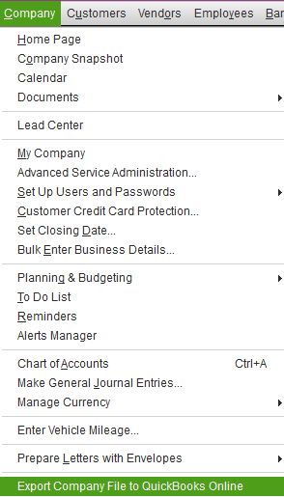
- If you are using a pre-existing Intuit user ID, you will be given the opportunity to create a new QuickBooks Online company or overwrite any of the companies (60 days old or newer) associated with that ID. You will also see prompts to start tracking inventory in the QuickBooks Online company as of a date you specify, if the QuickBooks Desktop company had been tracking inventory.
- WARNING: Be very careful with this step as it will overwrite all data in the QuickBooks Online account you select, if it has been created already and is 60 days old or newer. If you are practicing this process, create a new QuickBooks Online company that can be cancelled.
- Once complete, wait for confirmation that the QuickBooks Desktop file has been successfully imported.
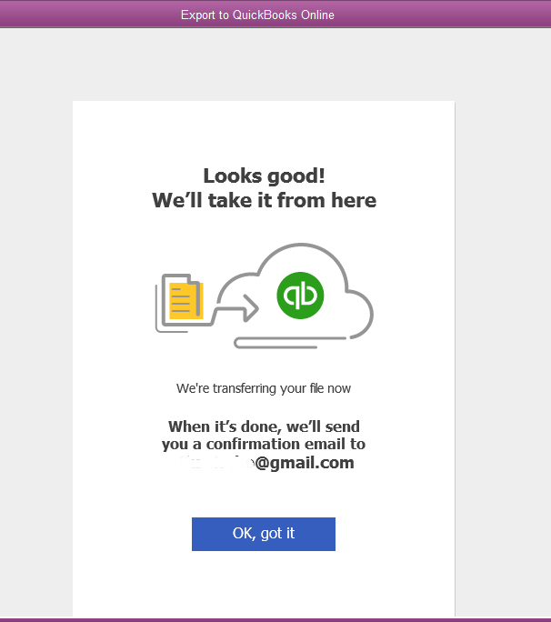
An email will be sent within 24 hours (however, often the conversion is very quick and email confirmation is received almost immediately) notifying you that your QuickBooks Online company is ready.
Verify that the data was imported correctly. Create a Balance Sheet and Profit & Loss report in both QuickBooks Online and Desktop. Customize the date range to All Dates. Set the accounting method to Accrual. Compare the balances, looking for any inconsistencies.
You can re-import data into QuickBooks Online for 60 days from the creation date of the QuickBooks Online Company. It is important to note that re-importing data will overwrite any existing data in the QuickBooks Online Company.

- Step by Step: Become Familiar with Importing Lists into
QuickBooks Online
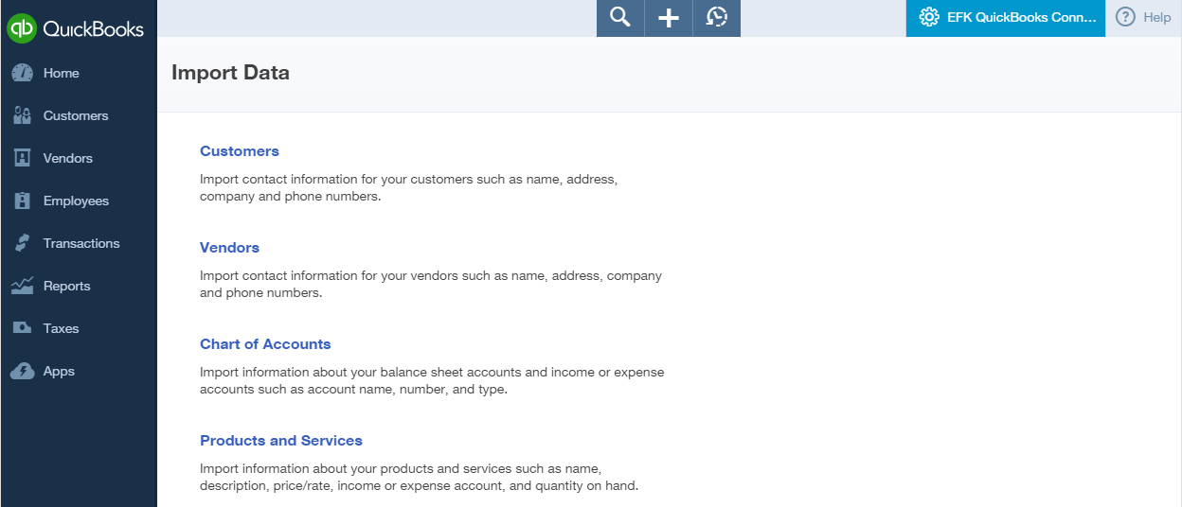
- Open the QuickBooks Online demo (“test drive”) account.
Navigate to the gear icon Import Data (under the Tools section).
List data may be imported at any time into QuickBooks Online such as customers, vendors, chart of accounts, or products and services. Banking information can be imported by connecting an online bank or credit card account to the appropriate account on the Chart of Accounts by navigating to the left navigation bar and selecting Transactions Banking then selecting Add account.
Each option has a downloadable template to ensure that data is properly formatted before import.
Note: When importing a chart of accounts, it does not replace a pre-existing chart of accounts; it adds any new accounts in your spreadsheet (that are not already in QuickBooks Online) to the pre-existing accounts in QuickBooks Online.

Topic 3: Setting Up Your Company

Recognize the Steps to Set up and Modify Lists and Users
QuickBooks Online account lists and users can be managed from the gear icon in the top right. Managing lists is an important component of QuickBooks Online. From the gear icon all lists should be reviewed to make sure they are appropriate for the Company. This includes Chart of Accounts, Recurring Transactions, Products and Services, Classes and Locations.
- Step by Step: Explore How to Add Users to QuickBooks Online
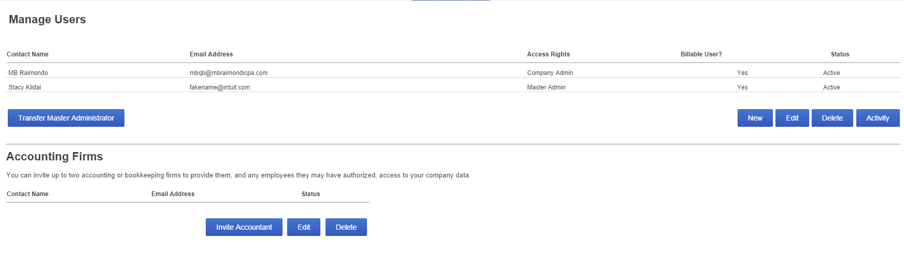
- Open the QuickBooks Online account.
- Navigate to the gear icon Manage Users (under the Your Company section).
- Click New to add users.
- Choose type of user.
- Next.
- Set user’s access rights.
- Next.
- Set user’s administrative rights.
- Next.
- Enter user’s email address and name.
- Next.
Click Finish.
- Step by Step: Explore How to Add Accountant Users to QuickBooks Online
- Open the QuickBooks Online company.
- Navigate to the gear icon Manage Users (under the Your Company section).
- Click Invite Accountant under the Accounting Firms section.
- Enter accountant’s email address and name.
- The accountant receives an email that contains a link for signing into the client’s company.
- Next.
Click Finish
- Step by Step: Explore the Products and Services List
- Open the QuickBooks Online company.
- Navigate to the gear icon Products and Services (under the Lists section).
- The Products and Services list appears. Notice that it lists the name, description, account, price/rate, whether the item is subject to sales tax, and a quantity if the item is set up as an inventory item.
- To edit an item locate the item to be changed and click Edit in the far right column for that item. Make the necessary edits. Save and Close.
- To add an item, click New.
- Select a Type for this product/service (Inventory, Non-Inventory, or Service).
- The Product/Service information window appears; if you selected the wrong type of product/service, select Change type and correct your selection.
- Enter the item Name, SKU, and whether it is a sub-product/service.
- Upload a picture for this item if desired.
- For Inventory items in new companies that have no history of transactions in QuickBooks Online, specify the Quantity on Hand and the As of date. For any Inventory items, select the Inventory asset account.
- Fill in the sales information and purchasing information with the corresponding sales description, unit price, taxable status, purchase description, unit cost, income account, and expense account. Save and close or Save and new.
- To delete (or deactivate) an item, locate the item to be deleted (or deactivated), click on the drop-down arrow next to Edit and click Make inactive.
Click Yes to confirm. Notice that items are merely deactivated and not deleted. Transactions for deleted (deactivated) items are not deleted.
- Step by Step: Print a Transactions Report for a Selected Account
Directly from the Chart of Accounts
- Open the QuickBooks Online company.
- Click on the gear icon Chart of accounts (under Settings).
- Select an account and in the drop-down next to View Register, click Run report.
- The Account QuickReport for that one account will display.
Change the Transaction Date range, if necessary, and click Run Report.
- Step by Step: Print the Chart of Accounts
- Open the QuickBooks Online company.
- Click on the gear icon Chart of accounts (under Settings).
- Click on the Printer icon in the upper right hand side.
- The Chart of accounts will display in print preview format. In the left column, select your printer and print settings, if necessary, and select Print.

- Step by Step: Connect a Bank Account to the Bank Feed
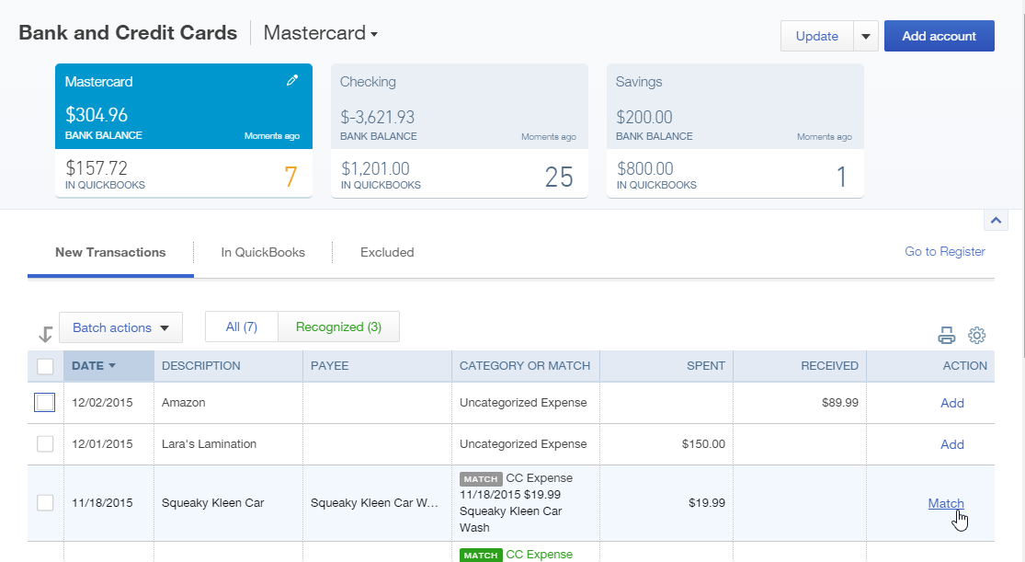
- Open the QuickBooks Online company.
- From the left navigation bar, click Transactions Banking.
- Click Add Account in the top right hand corner.
- Follow the wizard to connect an account to the bank feed.

Recognize the Steps to Manage Company Settings
Company settings control much of the functionality in the QuickBooks Online account. They are the foundation for a successful and efficient QuickBooks Online experience.
The Company Settings screen organizes the account’s global preferences into these sections:
- Company
- Sales
- Expenses
- Payments
- Advanced
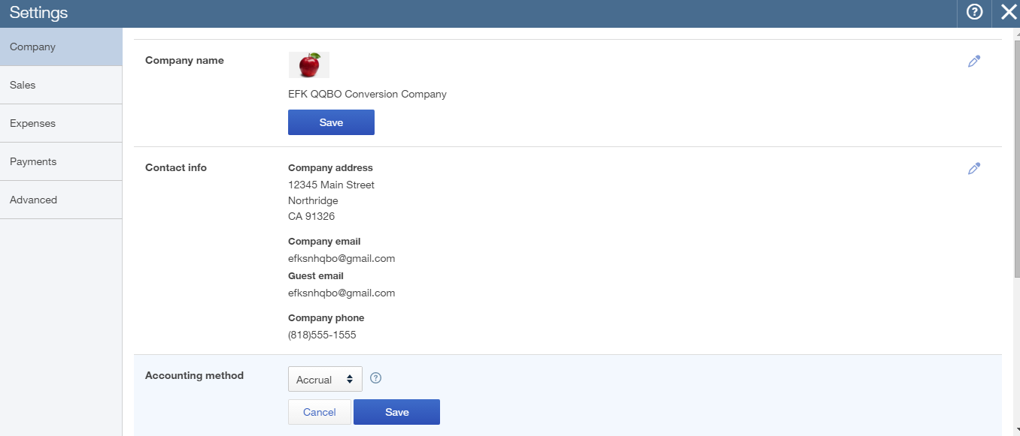

- Step by Step: Become Familiar with the Company Tab in Global
Company Settings
- Open the QuickBooks Online company.
- Navigate to the gear icon Company Settings.
- On the Company Settings page, click the Company section on the left.
- Notice on the right that the settings that can be updated by clicking on Edit (the pencil icon) on the right.
- Company Name
- Contact info
- Accounting method
- Employer ID (EIN)
- Tax form
- Categories (classes, locations)
- Customer labels
- Step by Step: Enter Contact Information, Employer ID, and Tax Form
in Global Company Settings
- Open the QuickBooks Online company.
- Navigate to the gear icon Company Settings.
- On the Company Settings page, click the Company section on the left.
- Find the Contact info settings on the right and click on Edit (the pencil icon) on the right to enter or edit the company contact information.
- Click Save.
- Follow the same steps to enter Employer ID and Tax form information.
- Click Done.
- Step by Step: Specify Terminology for Customers in Global
Company Settings
- Open the QuickBooks Online company.
- Navigate to the gear icon Company Settings.
- On the Company Settings page, click the Company section on the left.
- Find the Customer label settings on the right and click on Edit (the pencil icon) on the right to enter or edit the label you wish to assign to customers (Clients, Customers, Donors, Guests, Members, Patients, or Tenants).
- Click Save.
- Click Done.
- Step by Step: Become Familiar with the Sales Tab in Global
Company Settings
- Open the QuickBooks Online company.
- Navigate to the gear icon Company Settings.
- On the Company Settings page, click the Sales section on the left.
- Notice on the right that the settings that can be updated by clicking on Edit (the pencil icon) on the right.
- Customize look and feel of forms for customers
- Sales form content
- Products and services
- Messages
- Online delivery
- Statements

- Step by Step: Become Familiar with How to Turn on Inventory Global
Company Settings
- Open the QuickBooks Online company.
- Navigate to the gear icon Company Settings.
- On the Company Settings page, click the Sales section on the left.
- Find the Products and services area and click on Edit (the pencil icon)
- Click on the box next to Track quantity and price/rate (so that these fields appear on sales forms).
- Click on the box next to Track quantity on hand (so that inventory is tracked).
- Click Save.
- Click Done.
- Click on the gear icon on the upper right.
- Click Products and Services.
- Select New to create a new product or select Edit to alter an existing product.
- If it’s an existing product, select Change Type and choose Inventory item. If it’s a new product, choose the type Inventory item.
- Upload a picture for this item if desired.
- For Inventory items in new companies that have no history of transactions in QuickBooks Online, specify the Quantity on Hand and the As of date. For any Inventory items, select the Inventory asset account.
- Fill in the sales information and purchasing information with the corresponding sales description, unit price, taxable status, purchase description, unit cost, income account, and expense account. Save and close or Save and new.

- Step by Step: Become familiar with the Expenses tab in Global
Company Settings
- Open the QuickBooks Online company.
- Navigate to the gear icon Company Settings.
- On the Company Settings page, click the Expenses section on the left.
- Notice on the right the settings that can be updated by clicking on Edit (the pencil icon)
- Bills and expenses
- Purchase orders
- Step by Step: Explore How to Turn on Purchase Orders in Global
Company Settings
- Open the QuickBooks Online company.
- Navigate to the gear icon Company Settings.
- On the Company Settings page, click the Expenses section on the left.
- Find the Purchase Orders area and click on the Edit (the pencil icon).
- Click on the box next to Purchase Orders.
- Fill out remaining fields as needed.
- Click Save.
- Click Done.

- Step by Step: Become Familiar with the Advanced Tab in Global
Company Settings
- Open the QuickBooks Online company.
- Navigate to the gear icon Company Settings.
- On the Company Settings page, click the Advanced section on the left.
- Notice on the right that the settings that can be updated by clicking on Edit (the pencil icon) on the right.
- Accounting – to change the fiscal year or close the books
- Chart of Accounts – to turn account numbers on or off, and specify a markup income account if required
- Automation
- Time tracking
- Currency
- Other preferences
- Step by Step: Explore How to Close the Books in Global
Company Settings
- Open the QuickBooks Online company.
- Navigate to the gear icon Company Settings.
- On the Company Settings page, click the Advanced section on the left.
- Find the Accounting setting on the right. Click Edit (the pencil icon) on the right.
- Check the box to Close the books.
- Enter the closing date.
- Select one of these from the dropdown menu: Allow changes after viewing a warning or Allow changes after viewing a warning and entering a password.
- Enter a password and confirm the password (if the password option was selected).
- Click Save.
- Click Done.
- Step by Step: Explore How to Show Account Numbers in Global
Company Settings
- Open the QuickBooks Online company.
- Navigate to the gear icon Company Settings.
- On the Company Settings page, click the Advanced section on the left.
- Find the Chart of Accounts setting on the right. Click the Edit (pencil icon) on the right.
- Check the box next to Enable account numbers.
- Click the box next to Show account numbers.
- Click Save.
- Click Done.
- Click on the gear icon Chart of accounts (under Settings).
- Select the drop-down arrow next to View Register and select Edit.
- Edit the Checking account. Enter account number 10100. Save and Close.
- View the account number now showing in the Chart of accounts list.
- Navigate to Reports Balance Sheet report.
- View the account number for the Checking account appearing on the Balance Sheet.

- Step by Step: Explore How to Enable Auto-recall on Forms in Global
Company Settings
- Open the QuickBooks Online company.
- Navigate to the gear icon Company Settings.
- On the Company Settings page, click the Advanced section on the left.
- Find the Automation setting on the right. Click Edit (the pencil icon) on the right.
- Check the box to Pre-fill forms with previously entered content.
- Click Save.
- Click Done.
- Step by Step: Change Settings for Automatic Signing Out
after a Period of Inactivity
- Open the QuickBooks Online company.
- Navigate to the gear icon Company Settings.
- On the Company Settings page, click the Advanced section on the left.
- Find the Other preferences setting on the right. Click Edit (the pencil icon) on the right.
- Select 1, 2, or 3 hours from the dropdown list next to Sign me out if inactive for.
- Click Save.
- Click Done.

Guide Conclusion
You have just covered Course 1 – Getting Started. This Course has been developed to help you train your clients on how to use QuickBooks Online successfully.
By completing this module, your client should understand:
- The benefits of QuickBooks Online
- How to import data
- The parameters of setting up their company

